|  |
| --- |
| Experiment No. 2 |
| Explore User Management commands of Linux. |
| Date of Performance: 16/02/2024 |
| Date of Submission: 23/02/2024 |

**Aim:** Explore the user management commands of linux.

**Objective:** Since Linux is a multi-user operating system, several people may be logged in and actively working on a given machine at the same time. Security-wise, it is never a good idea to allow users to share the credentials of the same account. In fact, best practices dictate the use of as many user accounts as people needing access to the machine.

At the same time, it is to be expected that two or more users may need to share access to certain system resources, such as directories and files. User and group management in Linux allows us to accomplish both objectives.

**Theory:**

useradd - create a new user or update default new user information ,useradd is a low level utility for adding users.

userdel - delete a user account and related files

groupadd - create a new group , The groupadd command creates a new group account using the values specified on the command line plus the default values from the system. The new group will be entered into the system files as needed.

groupdel - delete a group , The groupdel command modifies the system account files, deleting all

entries that refer to GROUP. The named group must exist

who - show who is logged on , Print information about users who are currently logged in.

whoami - print effective userid

passwd - change user password

The passwd command changes passwords for user accounts. A normal user may only change the password for his/her own account, while the superuser may change the password for any account. passwd also changes the account or associated password validity period.

**Result:**

**useradd :**

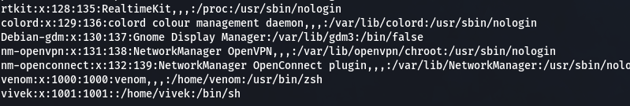

**userdel :**

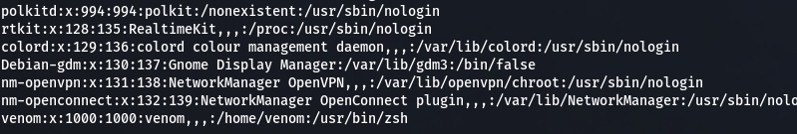

**groupadd :**



**groupdel :**

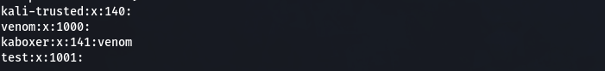

**adding user to group :**



**passwd :**

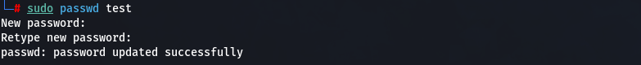

**Conclusion:**

User and group management commands in Linux play a crucial role in administering system access and permissions. Through commands like useradd, usermod, and userdel, administrators can create, modify, and remove user accounts, while groupadd, groupmod, and groupdel manage groups. These commands ensure proper organization of users and groups, control access to resources, and maintain system security. By assigning users to appropriate groups and setting permissions, administrators can effectively manage user privileges and enforce security policies within the Linux environment.