# Test Case 1

|  |  |  |  |
| --- | --- | --- | --- |
| **Requirement to test** | **Test Data Input** | **Expected Outcomes** | **Actual Outcomes** |
| Welcome Page is displayed when the program is run. | Click and launch the program | Welcome page with two buttons are displayed | Same as expected outcomes |

# 

# Test Case 2

|  |  |  |  |
| --- | --- | --- | --- |
| **Requirement to test** | **Test Data Input** | **Expected Outcomes** | **Actual Outcomes** |
| Bricks are displayed correctly | Click ‘’Play’ button | Three rows of bricks with different colors pictures are displayed after the selection of level | Same as expected outcomes |

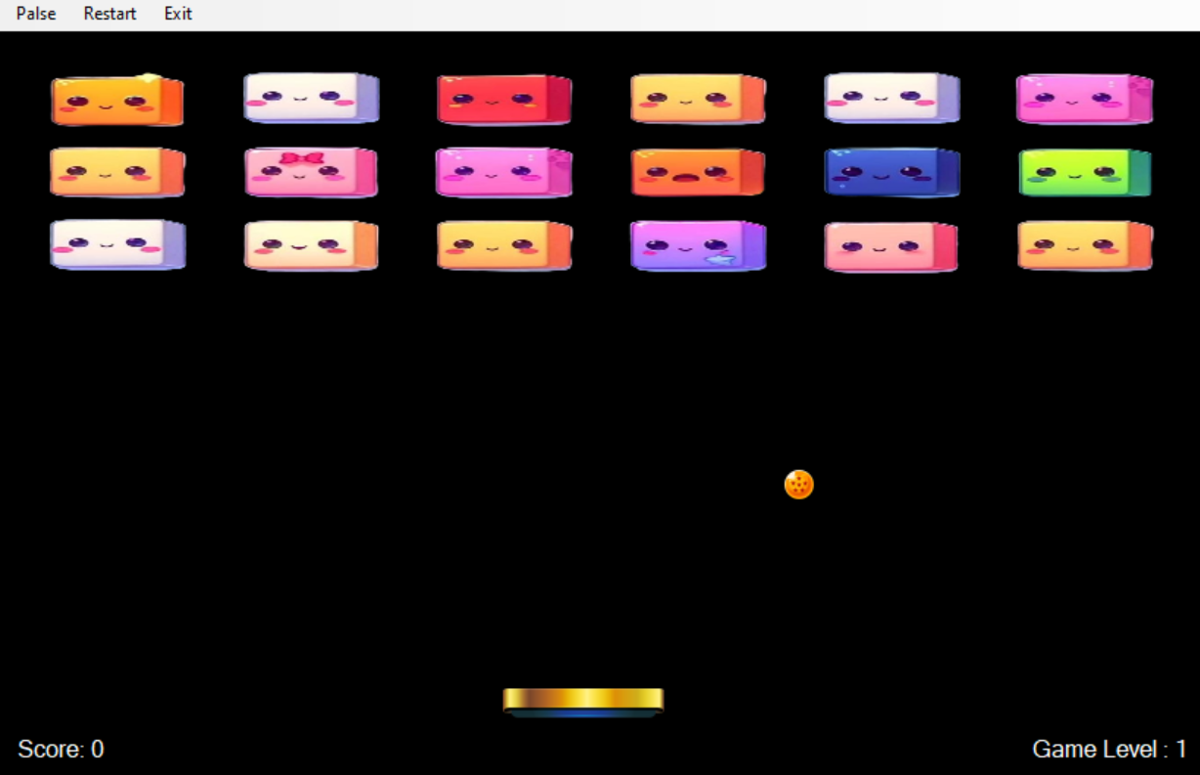

# Test Case 3

|  |  |  |  |
| --- | --- | --- | --- |
| **Requirement to test** | **Test Data Input** | **Expected Outcomes** | **Actual Outcomes** |
| Paddle is moved with key press | Press left key | Paddle moves to the left | Same as expected outcomes |

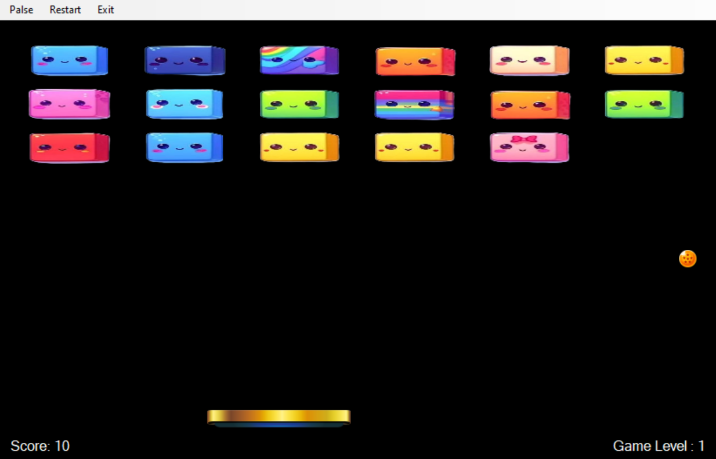

# Test Case 4

|  |  |  |  |
| --- | --- | --- | --- |
| **Requirement to test** | **Test Data Input** | **Expected Outcomes** | **Actual Outcomes** |
| The ball is moving | Click ‘’Play’ button | The ball is moving | Same as expected outcomes |

# Test Case 5

|  |  |  |  |
| --- | --- | --- | --- |
| **Requirement to test** | **Test Data Input** | **Expected Outcomes** | **Actual Outcomes** |
| The ball bounces off the paddle | Move the paddle to catch the ball | The ball bounced in the opposite direction. | Same as expected outcomes |

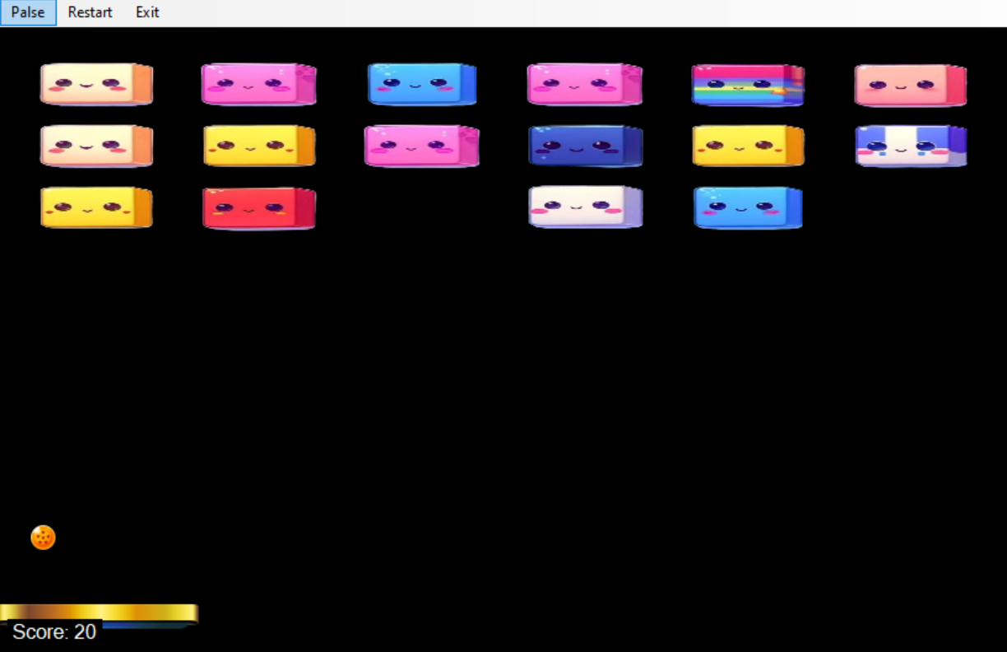

# Test Case 6

|  |  |  |  |
| --- | --- | --- | --- |
| **Requirement to test** | **Test Data Input** | **Expected Outcomes** | **Actual Outcomes** |
| The ball is makes the bricks disappear when they are hit. | The ball interacts with a brick | The brick disappears | Same as expected outcomes |

# Test Case 7

|  |  |  |  |
| --- | --- | --- | --- |
| **Requirement to test** | **Test Data Input** | **Expected Outcomes** | **Actual Outcomes** |
| Score is calculated correctly | Use ball to hit a brick | Score would add 10 each time | Same as expected outcomes |

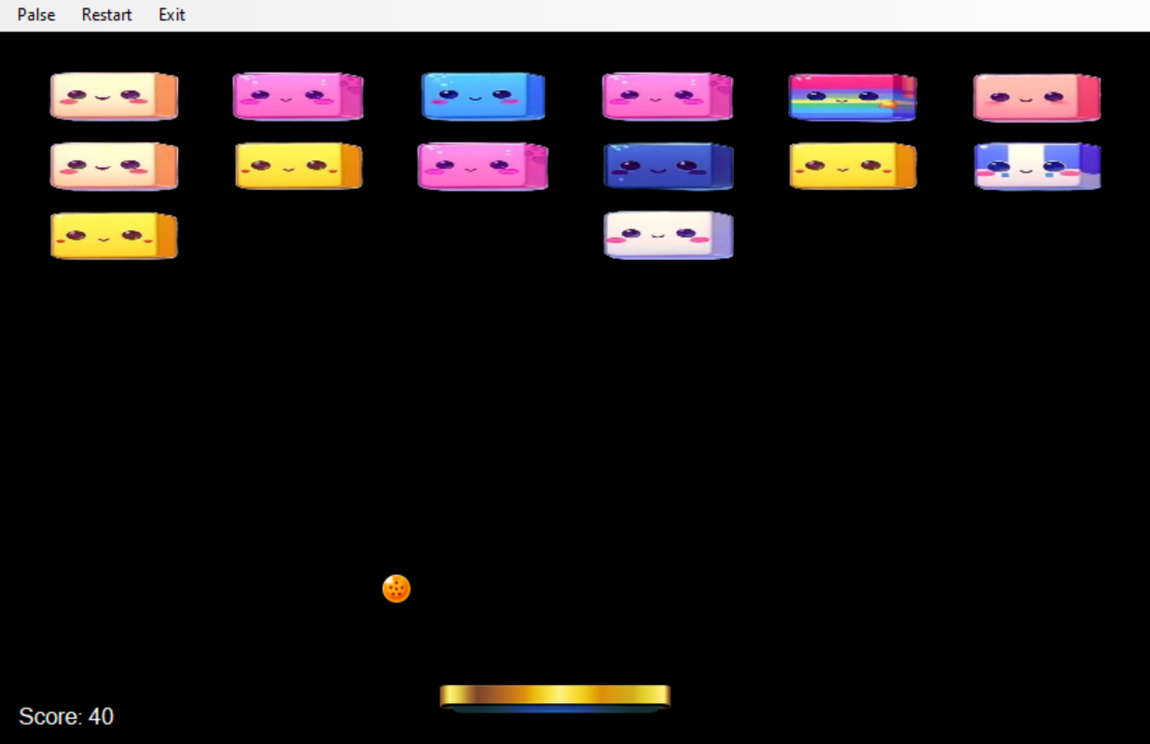

# Test Case 8

|  |  |  |  |
| --- | --- | --- | --- |
| **Requirement to test** | **Test Data Input** | **Expected Outcomes** | **Actual Outcomes** |
| The win message displayed when the user wins. | Control the ball to hit and clear all the bricks in Game Form | The win message is displayed in End Game Form | Same as expected outcomes |

# Test Case 9

|  |  |  |  |
| --- | --- | --- | --- |
| **Requirement to test** | **Test Data Input** | **Expected Outcomes** | **Actual Outcomes** |
| The lose message is displayed when the user loses. | Let the ball bounce outside of screen | “You Lose” message is displayed in End Game Form | Same as expected outcomes |

# Test Case 10

|  |  |  |  |
| --- | --- | --- | --- |
| **Requirement to test** | **Test Data Input** | **Expected Outcomes** | **Actual Outcomes** |
| User is getting an option to replay the game when the game is won or lost | Win or lose the game | The End game page is displayed with a Try Again button | Same as expected outcomes |

