VILNIAUS UNIVERSITETAS
MATEMATIKOS IR INFORMATIKOS FAKULTETAS
PROGRAMŲ SISTEMŲ KATEDRA

Programa
„Atbulinis išvedimas ruby kalba“

Darbą atliko: 3 Kurso 1 grupės studentas
Rytis Karpuška

Vilnius
2014

Turinys
Turinys 2
1. Darbo tikslas 3
2. Atbulinio išvedimo algoritmas 3
2.1 Detalus aprašymas 3
2.1.1 Įeitis 3
2.1.2 Išeitis 3
2.1.3 Algoritmo veikimas 3
2.2 Struktūrinė schema 4
2.3 Pseudokodas 5
2.4 Klasių diagrama 6
2.5 Ruby Kodas 6
2.6 Pavyzdžiai 12
2.6.1 Pavyzdys 1 12
2.6.2 Pavyzdys 2 13
2.6.3 Pavyzdys 3 15
2.6.4 Pavyzdys 4 16
2.6.5 Pavyzdys 5 17
2.6.6 Pavyzdys 6 18
2.6.7 Pavyzdys 7 19
2.6.8 Pavyzdys 8 20
2.6.9 Pavyzdys 9 21
2.6.10 Pavyzdys 10 22
2.6.11 Pavyzdys 11 24

1. Darbo tikslas
Šio darbo tikslas yra įgyvendinti ir aprašyti atbulinio išvedimo algoritmą.

2. Atbulinio išvedimo algoritmas
Atbulinio išvedimo algoritmas yra vienas iš dviejų pagrindinių protavimo algoritmų naudojamų išvedimo varikliuose.

2.1 Detalus aprašymas

2.1.1 Įeitis
Algoritmas turi tokią įeitį
- Taisyklės (produkcijos), išreikštos loginės implikacijos forma
- Faktai
- Tikslas

2.1.2 Išeitis
Algoritmas turi tokią išeitį:
- Vėliavėlę ar tikslas buvo sėkmingai pasiektas
- Kelias iki tikslo (išreikštas pritaikytomis taisyklėmis)

2.1.3 Algoritmo veikimas
Atbulinio išvedimo algorithmas pradeda darbą turėdamas sąrašą tikslų (pradinėse sąlygose jis yra tik vienas) ieško tokių taisyklių, kurių antecedentai būtų žinomi kaip tiesa (būtų tarp faktų). Jeigu antecedentas nėra žinomas kaip tiesa, jis pridedamas prie tikslų aibės ir pradedama nauja iteracija. Bendrai algorithmas susideda iš tokių žingsnių:
- Patikriname ar dabartinis tikslas yra tarp faktų, jeigu taip, grįžtame prie senesėns iteracijos
(Kode bus pažymėta MARK1)
- Patikriname ar dabartinis tikslas nebuvo jau bandomas išvesti, t.y. Tikriname ar nepatekome į ciklą
(kode bus pažymėta MARK2)
- Surandame taisyklę, kurios konsekventas yra mūsų tikslas
(kode bus pažymėta MARK3)
- Surastos taisyklės antecendai pridedami prie taisyklių sąrašo ir pradedama nauja iteracija.
(kode bus pažymėta MARK4)

2.2 Struktūrinė schema
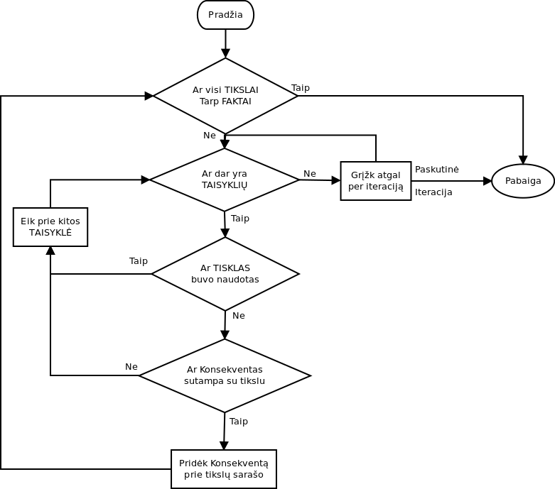

2.3 Pseudokodas
Pateikiamas rekusinis algoritmo variantas
LAIKINAS_KELIAS := SUKURTI NAUJĄ MASYVĄ
KELIAS := SUKURTI NAUJĄ MASYVĄ
PROCEDURE IŠSPRĘSK(TAISYKLĖS, FAKTAI, TIKSLAS)
IF TIKSLAS YRA TARP FAKTAI THEN <<MARK1
LAIKINAS_KELIAS.ISIMK(PASKUTINIS)
RETURN RASTA
ENDIF
IF TIKSLAS IN LAIKINAS_KELIAS <<MARK2
LAIKINAS_KELIAS.ISIMK(PASKUTINIS)
RETURN FALSE
ENDIF

FOREACH TAISYKLĖ IN TAISYKLĖS DO
IF NOT TAISYKLĖ.REZULTATAS = TIKSLAS THEN <<MARK3
CONTINUE
ENDIF
VISI_YRA := TRUE
FOREACH ANTECEDENTAS IN TAISYKLĖ DO
LAIKINAS_KELIAS.PRIDEK(TIKSLAS)
R := IŠSPRĘSK(TAISYKLĖS, FAKTAI, ANTECEDENTAS) <<MARK4
IF R = FALSE THEN
VISI_YRA := FALSE
LAIKINAS_KELIAS.ISIMK(PASKUTINIS)
KELIAS.ISVALYK
ENDIF

IF VISI_YRA = TRUE THEN
KELIAS.PRIDĖK(TAISYKLĖ)
ENDIF
ENDFOR

ENDFOR

RETURN FALSE
ENDPROC

2.4 Klasių diagrama
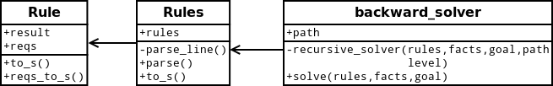

2.5 Ruby Kodas
backward_solver.rb
load 'chaining_rules.rb'

class Backward_solver
@resultText
@path
@tmpFacts
attr_accessor :resultText
attr_accessor :path
attr_accessor :tmpFacts

def initialize()
@resultText = Array.new
@path = Array.new
@tmpFacts = Array.new
end

def recursive_solver(rules, facts, goal, path, level)
@resultText << Array.new
@tmpFacts << Array.new

@resultText[-1] << level
@resultText[-1] << 'Goal ' + goal + ", "

if(facts.include? Goal) <<MARK1
@resultText[-1][-1] << "Goal is between facts"
path.delete_at(path.length - 1)
return true
end

if(path.include? Goal) <<MARK2
@resultText[-1][-1] << "Loop detected"
path.delete_at(path.length - 1)
return false
end

#search for rule with goal
rules.each_with_index do |rule, i|
if(rule.result != goal) <<MARK3
next
end

@resultText[-1][-1] << 'Using rule ' + rule.to_s + ', '
@resultText[-1][-1] << 'New goals ' + rule.reqs_to_s

#check for every requirement
allReqsFullfiled = true
rule.req.each do |req|
path << goal
result = recursive_solver(rules, facts, req, path, level + 1) <<MARK4
if(result == false)
@resultText << Array.new
@resultText[-1] << level
@resultText[-1] << 'Goal ' + goal + ", "
allReqsFullfiled = false
path.delete_at(path.length - 1)
@path.clear
break
end
end

#check if we reached goal
if(allReqsFullfiled)
@path << i;
return true
end
end

@resultText[-1][-1] << ' No suitable rule found for current goal'
path.delete_at(path.length - 1)
return false
end

def solve(rules, facts, goal)
#initialize
@resultText.clear
@tmpFacts.clear
@path.clear

path = Array.new

#solve recursively
result = recursive_solver(rules, facts, goal, path, 1)

return result

end
end

chaining_rules.rb
load 'chaining_rule.rb'

class ChainingRules
@rules
@errorLine
@errorString
attr_accessor :rules, :errorLine, :errorString

def initialize()
@rules = []
@errorLine = 0
@errorString = ""
end

def parse_line(line, index)
r = ChainingRule.new

words = line.split
if(words.size == 0)
return :ok
end

first_word = true
acceptable = false
words.each do |word|
if(word.start_with?("//"))
break
end

#check if we have comment without spaces
if(word.include?("//"))
commentStarted = true
word = word.split("//").first
end

if(word.length > 1)
@errorLine = index
@errorString = "Rule argument larger than 1 symbol"
return :parseError
end

if(first_word)
r.result = word
first_word = false
else
r.req << word
acceptable = true
end

if commentStarted
break
end
end

if(acceptable)
@rules << r

elsif(!acceptable && first_word == false)
@errorLine = index
@errorString = "Not enough data to form a rule"
return :parseError
end

return :ok
end

def parse(text)
text.lines.each_with_index do |line, index|
res = parse_line(line, index + 1)
if(res != :ok)
return res
end
end
return :ok
end

def to_s()
str = ""
rules.each do |rule|
str += rule.to_s() + "\n"
end
return str
end
end

chaining_rule.rb
class ChainingRule
@req
@result
@used
attr_accessor :req
attr_accessor :result
attr_accessor :used

def initialize()
@req = Array.new
@result = ""
@used = false
end

def to_s()
str = ""
@req.each_with_index do |req, index|
str += req
if(index < @req.size - 1)
str += ", "
end
end

str += " -> " + @result
return str
end

def reqs_to_s()
str = ""
@req.each do |req|
str += req + " "
end

return str
end
end

2.6 Pavyzdžiai

2.6.1 Pavyzdys 1
Semantinis grafas  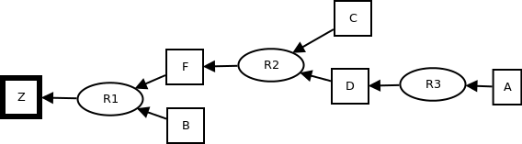 | Dalykinis grafas  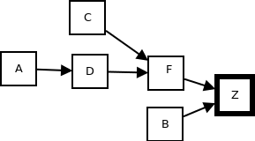
Įeitis

Z F B
F C D
D A

A B C

Z
Eiga

Algorithm Trace:
---->Goal Z, Using rule F, B -> Z, New goals F B
---->---->Goal F, Using rule C, D -> F, New goals C D
---->---->---->Goal C, Goal is between facts
---->---->---->Goal D, Using rule A -> D, New goals A
---->---->---->---->Goal A, Goal is between facts
---->---->Goal B, Goal is between facts

Išeitis

Goal reached successfully
Path: R3, R2, R1

2.6.2 Pavyzdys 2
Semantinis grafas  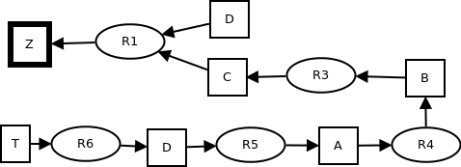 | Dalykinis grafas  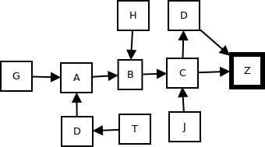
Įeitis

Z D C
D C
C B
B A
A D
D T
A G
B H
C J

T

Z
Eiga

Algorithm Trace:
---->Goal Z, Using rule D, C -> Z, New goals D C
---->---->Goal D, Using rule C -> D, New goals C
---->---->---->Goal C, Using rule B -> C, New goals B
---->---->---->---->Goal B, Using rule A -> B, New goals A
---->---->---->---->---->Goal A, Using rule D -> A, New goals D
---->---->---->---->---->---->Goal D, Loop detected
---->---->---->---->---->Goal A, Using rule G -> A, New goals G
---->---->---->---->---->---->Goal G, No suitable rule found for current goal
---->---->---->---->---->Goal A, No suitable rule found for current goal
---->---->---->---->Goal B, Using rule H -> B, New goals H
---->---->---->---->---->Goal H, No suitable rule found for current goal
---->---->---->---->Goal B, No suitable rule found for current goal
---->---->---->Goal C, Using rule J -> C, New goals J
---->---->---->---->Goal J, No suitable rule found for current goal
---->---->---->Goal C, No suitable rule found for current goal
---->---->Goal D, Using rule T -> D, New goals T
---->---->---->Goal T, Goal is between facts
---->---->Goal C, Using rule B -> C, New goals B
---->---->---->Goal B, Using rule A -> B, New goals A
---->---->---->---->Goal A, Using rule D -> A, New goals D
---->---->---->---->---->Goal D, Using rule C -> D, New goals C
---->---->---->---->---->---->Goal C, Loop detected
---->---->---->---->---->Goal D, Using rule T -> D, New goals T
---->---->---->---->---->---->Goal T, Goal is between facts

Išeitis

Goal reached successfully
Path: R6, R5, R4, R3, R1

2.6.3 Pavyzdys 3
Semantinis grafas  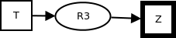 | Dalykinis grafas  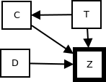
Įeitis

Z C D
C T
Z T

T

Z
Eiga

Algorithm Trace:
---->Goal Z, Using rule C, D -> Z, New goals C D
---->---->Goal C, Using rule T -> C, New goals T
---->---->---->Goal T, Goal is between facts
---->---->Goal D, No suitable rule found for current goal
---->Goal Z, Using rule T -> Z, New goals T
---->---->Goal T, Goal is between facts
Išeitis

Goal reached successfully
Path: R3

2.6.4 Pavyzdys 4
Semantinis grafas | Dalykinis grafas  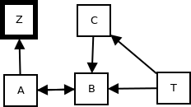
Įeitis

Z A
A B
B A C
B T
C T

T

Z
Eiga

Algorithm Trace:
---->Goal Z, Using rule A -> Z, New goals A
---->---->Goal A, Using rule B -> A, New goals B
---->---->---->Goal B, Using rule A, C -> B, New goals A C
---->---->---->---->Goal A, Loop detected
---->---->---->Goal B, Using rule T -> B, New goals T
---->---->---->---->Goal T, Goal is between facts
Išeitis

Goal reached successfully
Path: R4, R2, R1

2.6.5 Pavyzdys 5
Semantinis grafas  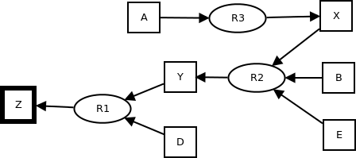 | Dalykinis grafas  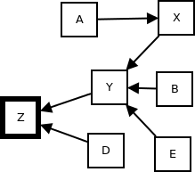
Įeitis

Z Y D
Y X B E
X A

A B C D E

Z
Eiga

Algorithm Trace:
---->Goal Z, Using rule Y, D -> Z, New goals Y D
---->---->Goal Y, Using rule X, B, E -> Y, New goals X B E
---->---->---->Goal X, Using rule A -> X, New goals A
---->---->---->---->Goal A, Goal is between facts
---->---->---->Goal B, Goal is between facts
---->---->---->Goal E, Goal is between facts
---->---->Goal D, Goal is between facts
Išeitis

Goal reached successfully
Path: R3, R2, R1

2.6.6 Pavyzdys 6
Semantinis grafas   | Dalykinis grafas  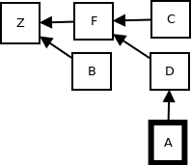
Įeitis

Z F B
F C D
D A

A

A
Eiga
Išeitis

Goal reached successfully

2.6.7 Pavyzdys 7
Semantinis grafas | Dalykinis grafas  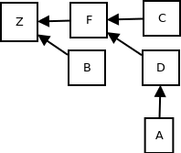
kĮeitis

Z F B
F C D
D A

A B C

W
Eiga

Išeitis

Goal Could not be reached

2.6.8 Pavyzdys 8
Semantinis grafas  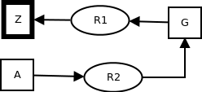 | Dalykinis grafas  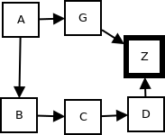
Įeitis

Z G
G A
B A
C B
D C
Z D

A

Z
Eiga

Algorithm Trace:
---->Goal Z, Using rule G -> Z, New goals G
---->---->Goal G, Using rule A -> G, New goals A
---->---->---->Goal A, Goal is between facts
Išeitis

Goal reached successfully
Path: R2, R1

2.6.9 Pavyzdys 9
Semantinis grafas  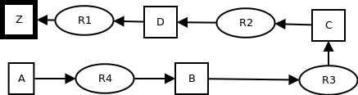 | Dalykinis grafas
Įeitis

Z D
D C
C B
B A
G A
Z G

A

Z
Eiga

Algorithm Trace:
---->Goal Z, Using rule D -> Z, New goals D
---->---->Goal D, Using rule C -> D, New goals C
---->---->---->Goal C, Using rule B -> C, New goals B
---->---->---->---->Goal B, Using rule A -> B, New goals A
---->---->---->---->---->Goal A, Goal is between facts
Išeitis

Goal reached successfully
Path: R4, R3, R2, R1

2.6.10 Pavyzdys 10
Semantinis grafas  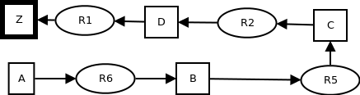 | Dalykinis grafas  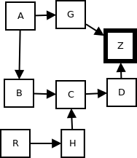
Įeitis

Z D
D C
C H
H R
C B
B A
G A
Z G

A

Z
Eiga

Algorithm Trace:
---->Goal Z, Using rule D -> Z, New goals D
---->---->Goal D, Using rule C -> D, New goals C
---->---->---->Goal C, Using rule H -> C, New goals H
---->---->---->---->Goal H, Using rule R -> H, New goals R
---->---->---->---->---->Goal R, No suitable rule found for current goal
---->---->---->---->Goal H, No suitable rule found for current goal
---->---->---->Goal C, Using rule B -> C, New goals B
---->---->---->---->Goal B, Using rule A -> B, New goals A
---->---->---->---->---->Goal A, Goal is between facts
Išeitis

Goal reached successfully
Path: R6, R5, R2, R1

2.6.11 Pavyzdys 11
Semantinis grafas  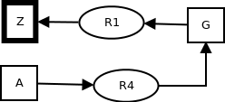 | Dalykinis grafas  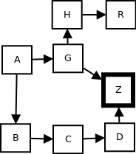
Įeitis

Z G
H G
G R
G A
B A
C B
D C
Z D

A

Z
Eiga

Algorithm Trace:
---->Goal Z, Using rule G -> Z, New goals G
---->---->Goal G, Using rule R -> G, New goals R
---->---->---->Goal R, No suitable rule found for current goal
---->---->Goal G, Using rule A -> G, New goals A
---->---->---->Goal A, Goal is between facts
Išeitis

Goal reached successfully
Path: R4, R1

