EU6 YTD Sales (CS) growth is at 45% and YTD Unit growth is at 32% the gap is 13%. We are growing CS more than Units.

Over the **last 12 weeks (WK 31-42) we’ve closed in on the CS - Unit gap** considerably across all markets. The CS - Unit gap from WK 1 – 30 was 20%. The **CS – Unit gap from WK 31 – 42 is -6%** meaning we have been growing Units over CS. This 12-week push has closed the gap from the 20% it was at the end of WK30 to the 13% it currently is at the end of WK 42!

For most of the year, we have been growing CS *above* Units, as is seen in the graph above where the grey CS Growth line is above the blue Unit Growth line in 28 of the 42 (67%) tracked weeks. There is a noticeable that occurs onward from WK 31 as the Unit Growth line matches and surpasses the CS Growth line. From WK 31, we’ve had Units grow above CS 9 out of 12 (75%) weeks.

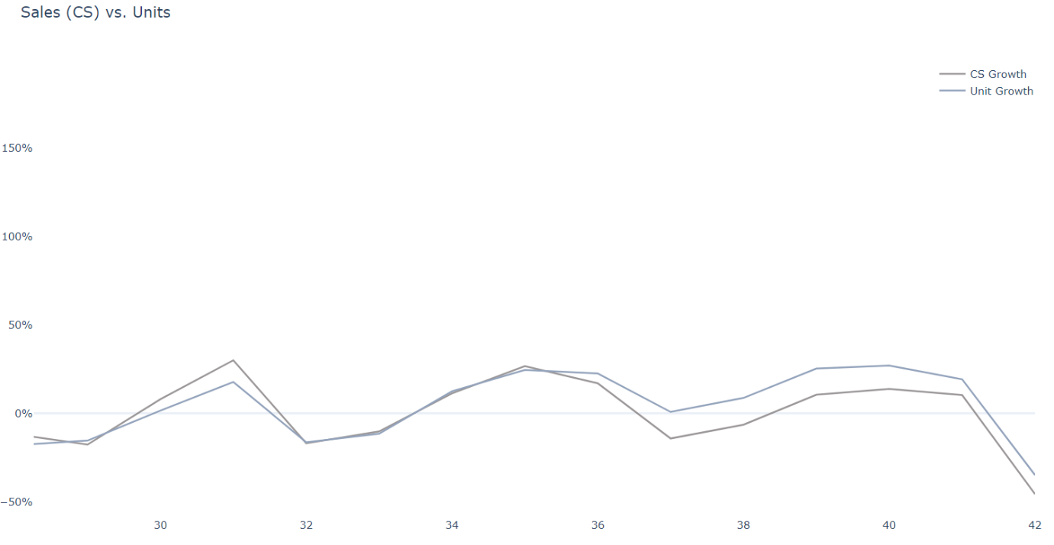

1

2

3

4

5

6

7

8

9

The longest Units *over* Value streak achieved from WK 1 – 30 was a 3 WK period in WK 11/12/13 (Easter). We currently have a 7 WK streak going.

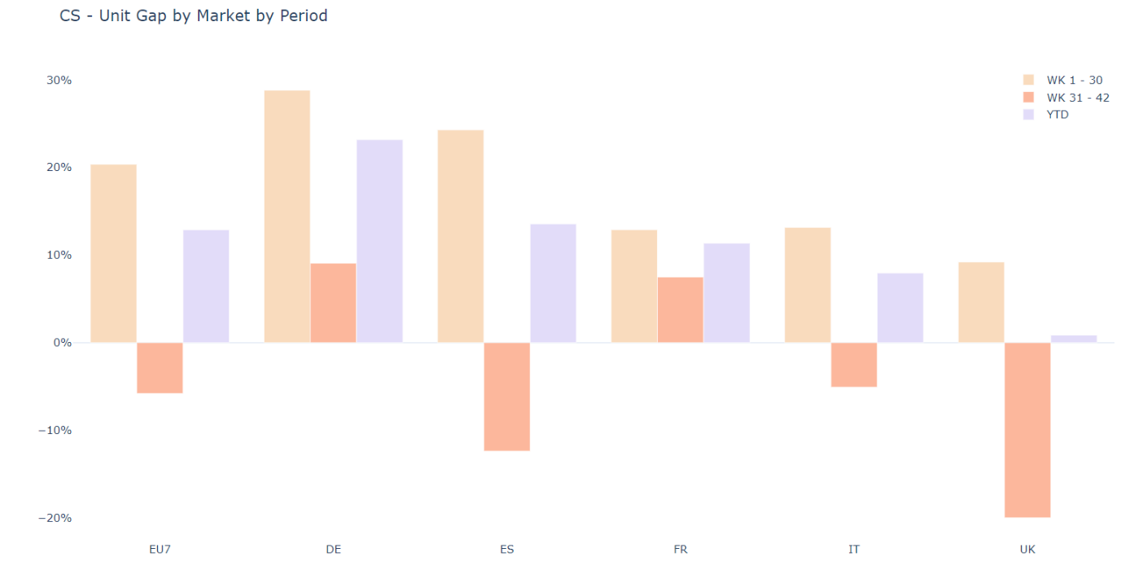

Units > Value

Value > Units

These past three months have helped close the gap across all countries as UK/ES/IT have been the clear drivers in Unit’s > Value growth. DE/FR have had substantial drop in their Value > Unit’s gap.

