Supplementary for *DCVtestkit*: a R package for linearity assessment and analysis of quality control dilution curves

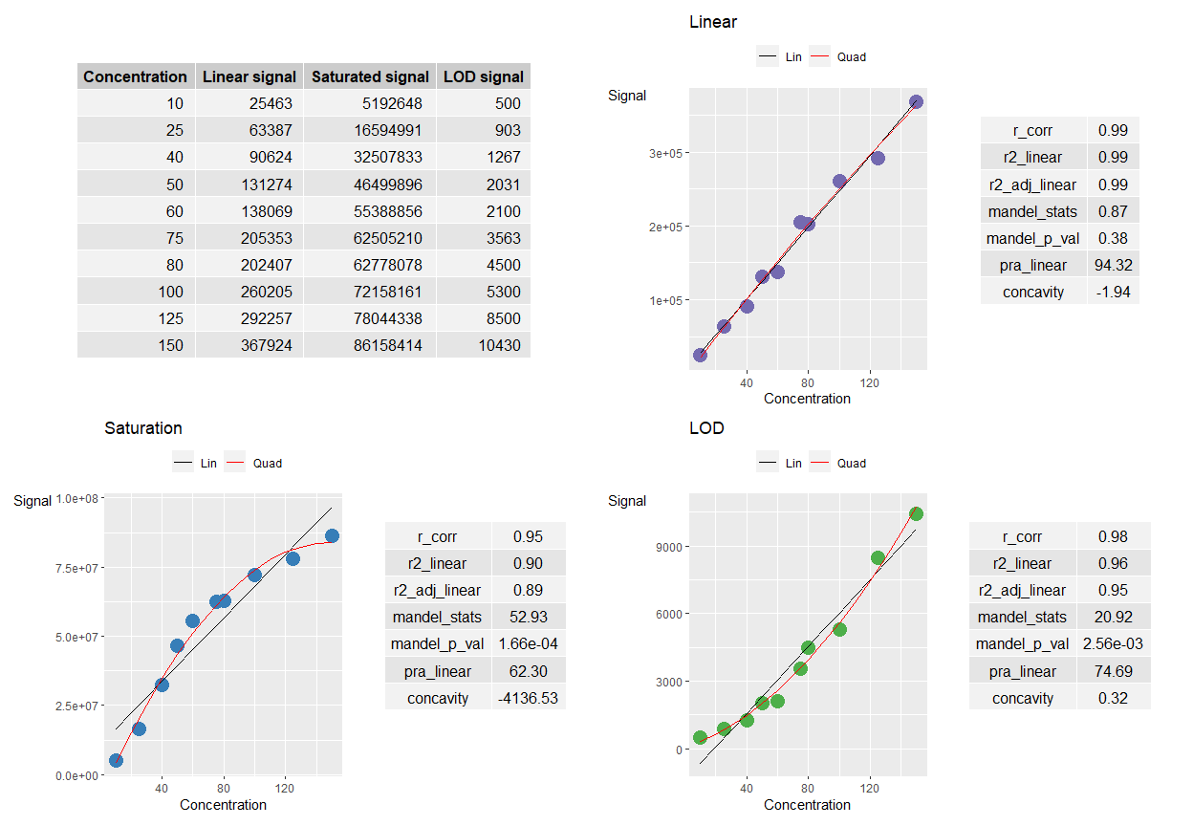

*Supplementary Figure 1*:

Plots and statistical results of three curves: Linear curve, Saturated curve and a curve with Limit Of Detection (LOD)

|  |
| --- |
|  |

*Supplementary Figure 2*:

Dilution Curve Grouping Workflows

|  |
| --- |
|  |

*Supplementary Figure 3*:

Simulation Results

|  |
| --- |
|  |

*Supplementary Figure 4*:

Viewing Several Interactive Dilution Curves