10.PROGRAM:HEART BEAT SENSOR

#define USE_ARDUINO_INTERRUPTS true

// Include necessary libraries

#include <PulseSensorPlayground.h>

// Constants

const int PULSE_SENSOR_PIN = 0;  // Analog PIN where the PulseSensor is connected

const int LED_PIN = 13;          // On-board LED PIN

const int THRESHOLD = 550;       // Threshold for detecting a heartbeat

// Create PulseSensorPlayground object

PulseSensorPlayground pulseSensor;

void setup()

{

  // Initialize Serial Monitor

  Serial.begin(9600);

  // Configure PulseSensor

  pulseSensor.analogInput(PULSE_SENSOR_PIN);

  pulseSensor.blinkOnPulse(LED_PIN);

  pulseSensor.setThreshold(THRESHOLD);

  // Check if PulseSensor is initialized

  if (pulseSensor.begin())

  {

    Serial.println("PulseSensor object created successfully!");

  }

}

void loop()

{

  // Get the current Beats Per Minute (BPM)

  int currentBPM = pulseSensor.getBeatsPerMinute();

  // Check if a heartbeat is detected

  if (pulseSensor.sawStartOfBeat())

  {

    Serial.println("♥ A HeartBeat Happened!");

    Serial.print("BPM: ");

    Serial.println(currentBPM);

  }

  // Add a small delay to reduce CPU usage

  delay(20);

}

#define USE_ARDUINO_INTERRUPTS true

// Include necessary libraries

#include <PulseSensorPlayground.h>

// Constants

const int PULSE_SENSOR_PIN = 0;  // Analog PIN where the PulseSensor is connected

const int LED_PIN = 13;          // On-board LED PIN

const int THRESHOLD = 550;       // Threshold for detecting a heartbeat

// Create PulseSensorPlayground object

PulseSensorPlayground pulseSensor;

void setup()

{

  // Initialize Serial Monitor

  Serial.begin(9600);

  // Configure PulseSensor

  pulseSensor.analogInput(PULSE_SENSOR_PIN);

  pulseSensor.blinkOnPulse(LED_PIN);

  pulseSensor.setThreshold(THRESHOLD);

  // Check if PulseSensor is initialized

  if (pulseSensor.begin())

  {

    Serial.println("PulseSensor object created successfully!");

  }

}

void loop()

{

  // Get the current Beats Per Minute (BPM)

  int currentBPM = pulseSensor.getBeatsPerMinute();

  // Check if a heartbeat is detected

  if (pulseSensor.sawStartOfBeat())

  {

    Serial.println("♥ A HeartBeat Happened!");

    Serial.print("BPM: ");

    Serial.println(currentBPM);

  }

  // Add a small delay to reduce CPU usage

  delay(20);

}

**IMAGE**

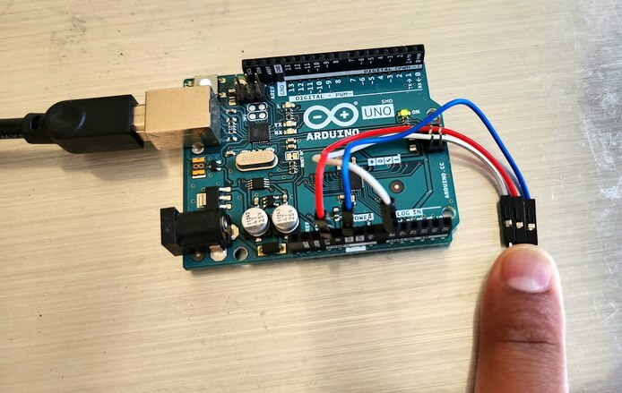

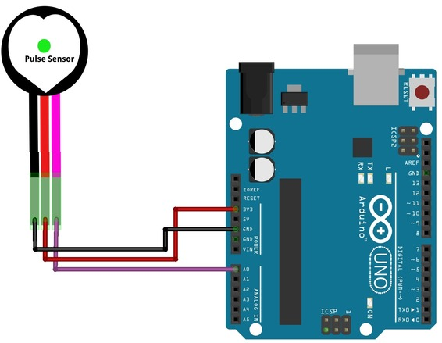

**OUTPUT:**

