Weekly reports are to be emailed to atbecker@uh.edu by 5:00pm on Tuesdays. The purpose of a weekly report is to: (1) give you text and images for your papers, thesis, and dissertation, (2) document progress, (3) identify if you are stuck or need resources.

Weekly report

1. **My *Goals* from last week**
   * To complete the function labelColor: It’s input is a binary part array and as an output it should give labelled part (partColored)
   * To complete checkpath function: It should implement following checks for the next location provided by the depth first search:
     1. The row or column from where the particle has to come should be empty until the goal location
     2. Check that if for instance the particle is coming from left then no particles of the mating color are in the row above or below
   * Change the depth first search algorithm so it gives the sequence of joining the particles for the following part:

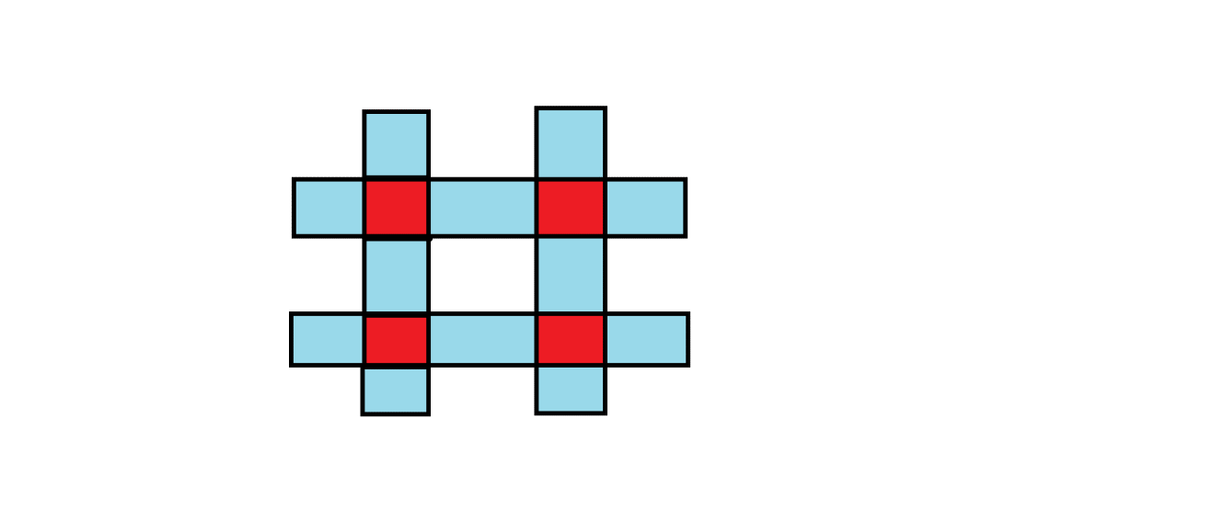

1. **My *Accomplishments* this week**
   1. I completed the ‘labelColor’ function and uploaded it to github
   2. I’m still working on the ‘checkpath’ function.
   3. Depth first search code now gives the sequence for the # part:



1. **My *Goals* for next week**
   1. Meeting with Dr. Becker on <30th September 2016 at 9:00 am>
   2. To understand next steps of the project
2. **What I need Dr. Becker to do:**
   1. ----