Weekly report

1. **My *Goals* from last week**
   * Objective 1: Improve the Gauss gun design by changing the leg bracings so that the sides of the gun bend in and out less. Keep trying to reduce voids when multi-stage guns are assembled. Print some on translucent acrylic to see how cool they’ll look
2. **My *Accomplishments* this week**
   1. Project 1: Gauss gun

* Changed the support pieces so that the long part of the leg braces lie horizontally, instead of vertically, so that the gun bends less. Changed the legs to work with this new configuration
* Added extra material to one end of the gun sides so that there’s less spacing when stages are connected

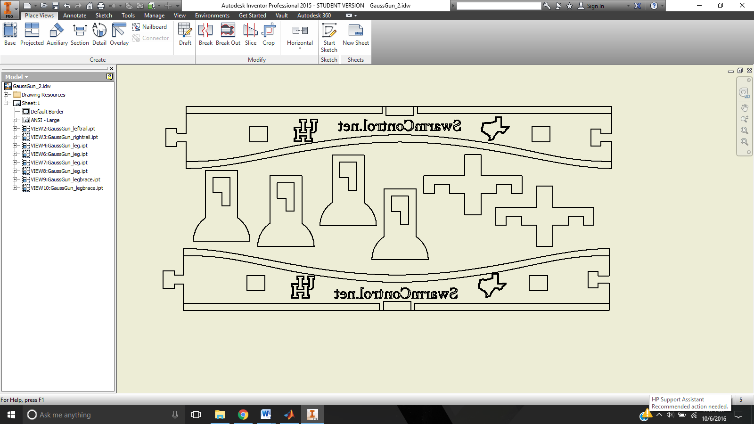

Figure 1. Newest Gauss gun design

1. **My *Goals* for next week**
   1. Project 1: Gauss gun

* Start production of the guns
* Make a script for the video

1. **What I need Dr. Becker to do:**
   1. Tell me what he thinks of the newest iteration
   2. Prepare a nice presentation for the Swarmathon interest meeting