Weekly reports are to be emailed to atbecker@uh.edu by 5:00pm on Tuesdays. The purpose of a weekly report is to: (1) give you text and images for your papers, thesis, and dissertation, (2) document progress, (3) identify if you are stuck or need resources.

Weekly report

1. **My *Goals* from last week**
   * Complete the following function for the Assembly project:

function [foundPath, sequence, dirs]=FindBuildPath(partXY)

% Given a polyomino part, searches for a valid build path described by

% order sequence and move direcions dirs.

% returns foundPath == true if a path is found, false else.

end

* + Read the paper on decomposition and layered manufacturing.
  + Run my code for a part in BS thesis and find the build sequence and directions for it

1. **My *Accomplishments* this week**
   1. I’ve uploaded the code for ‘FindBuildPath’ on github.
   2. I tried my code for the part:

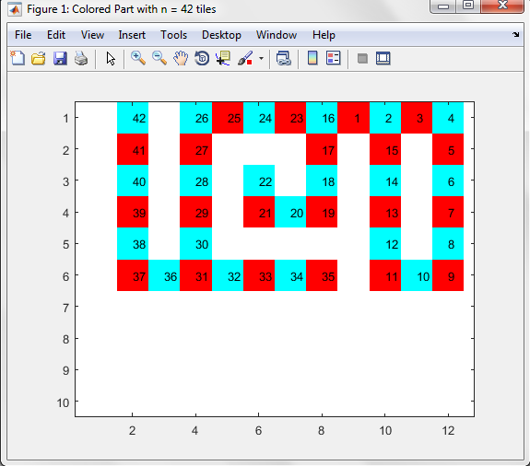

Previously my code was showing two figures: one for the sequence and the other for colored part.

I changed it to show the sequence and colored part in the same figure but it displays the inverted part; Could you please suggest me how may I fix this? Or two figures are alright?

1. **My *Goals* for next week**
   1. Meeting with Dr. Becker on <21st October 2016 at 9:00 am>
   2. Understand decomposition of parts which can’t be built from depth first.
   3. Complete codes for building factory layout and adding tiles to the part.
   4. I understand the final factory layout which would be made but I don’t fully get the concept of the stub code ‘factoryAddTile’. What would be the sequence of the functions: FindBuildPath, factoryAddTile and BuildFactory? Once I find the directions and sequence, factoryAddTile will give me the obstacle and part hopper locations which would then be used to build the factory. Is this right?
2. **What I need Dr. Becker to do:**
   1. ----