Weekly report

1. **My *Goals* for this week**

* **Obtain soil type data and drop test data for the darts**
* **Familiarize myself with the photon microcontroller**

1. …**My *Accomplishments* this week**
   1. Project 1: <Drop Tests Experiment >

* Deliverable 1: Collected data presented in a plot.
* We tested 10 dropped darts for two locations of wet soil/height.
* I generated a plot of the data that was collected, however, more data will need to be collected at different heights in order to get a curve for the relationship between the darts penetration depth and the height at which it is dropped at.

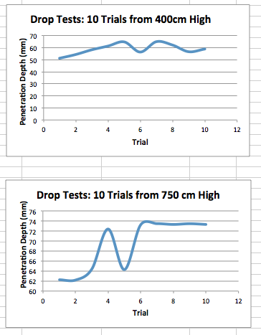

**Figure 1:** Plots of the data for the 10 trials of drop tests at two locations of wet soil. The first one is for a drop height of 400cm, and the second is for a drop height of 750cm.

1. **My *Goals* for next week**

* **Gather more drop test data to get the proper data**
* **Integration of the photon with the sensor and power source**
* **Start on housing part for the photon system** 
  1. Meeting with Dr. Becker on <Monday 23rd at 10:30am>