Weekly reports are to be emailed to atbecker@uh.edu by 5:00pm on Tuesdays. The purpose of a weekly report is to: (1) give you text and images for your papers, thesis, and dissertation, (2) document progress, (3) identify if you are stuck or need resources.

Weekly report

1. **My *Goals* from last week**
2. Coordinate in Git to develop basic feedback from video for real-time control.
3. Setup algorithm for collection of non-overlapping particles. Main objective would be on improving the pair selection and fitting a threshold for satisfied collection.
4. Going through collection of Literature survey folder and documenting short reviews on them- This will be a weekly process with updates in the literature review folder yet to be created.
5. Meeting with Dr. Becker and Li to discuss direction of work.
6. **My *Accomplishments* this week**
7. Object tracking performed on video file in Henry’s folder. Centroids can now be generated.!!!
8. Set up for realtime object tracking - Installed required matlab packages and code developed to pick up frames from video. Success- it works !!
9. Design idea for acrylic maze:
   * 1. a)Similar to tilt game, with draining set in different locations.
     2. b)3 layered : layer 1 -maze, layer 2- drain palet, layer 3- collection bin.
10. Useful literature survey relevant to the maxwell coil setup identified : <https://hal.archives-ouvertes.fr/hal-00714370/document> <https://hal.archives-ouvertes.fr/hal-01212140/document> although both are in same line of research as ours, main observations of relavence to us now is the talk about magnetic field strenght, particles and medium used. We can quickly see how there too, inference is made on iron oxide field weakness.
11. Identified Gaussmeter we can get :
12. [**http://www.trifield.com/content/dc-gaussmeter-model-gm2/**](http://www.trifield.com/content/dc-gaussmeter-model-gm2/) **- $675. + USB adapter $140 .**
13. Identified Low resistance petridish: <http://www.amazon.com/Glass-Petri-Tissue-Culture-Plate/dp/B00CPRTL5G/ref=sr_1_2?ie=UTF8&qid=1464109681&sr=8-2&keywords=glass+Petri+dish>
14. Setup parallel supply of 29.5 V, 3A setup in Coil 3,6 in x-axis direction and coil 2 in z direction. Generating a peak of 270 Gauss when 2 coils on. 135 Gauss when one turned on. 50 Gauss if z axis alone turned on.
15. 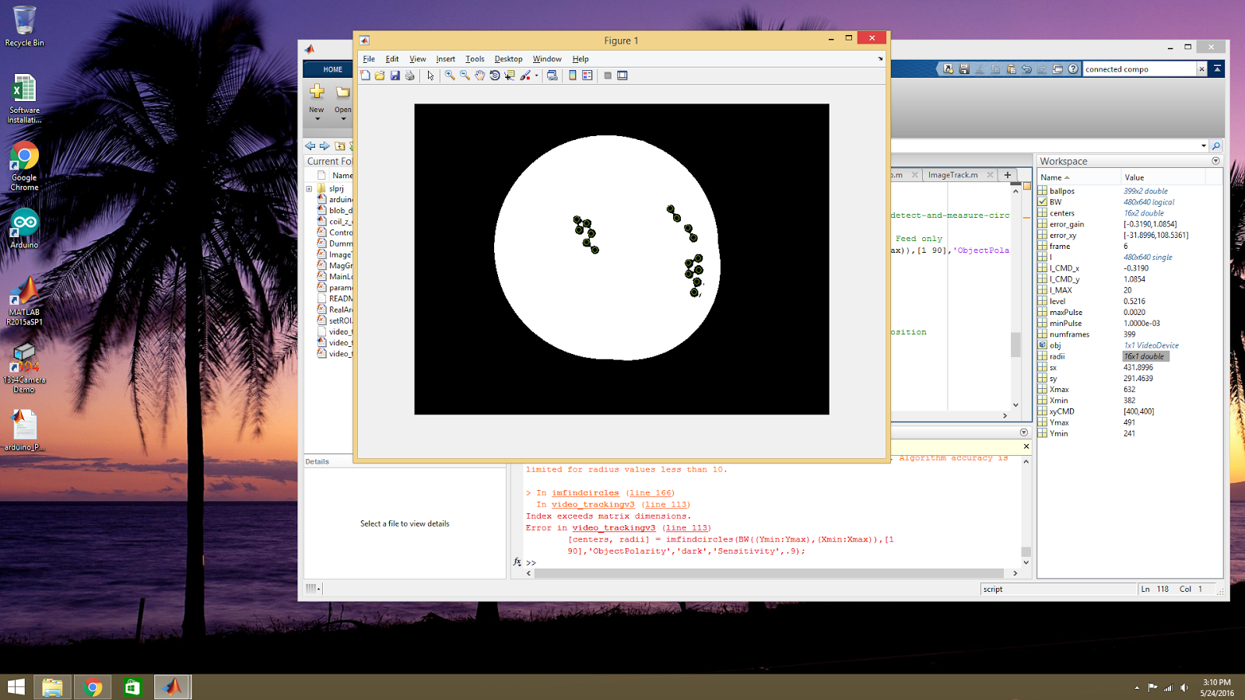

The existing code uses imfindcircles . We won’t need to do that. For this application fast processing and connected components with an emphasis on comparative processing to previous slide is required.

1. **My *Goals* for next week**
2. Need to combine and test for tracking using video cam, Comment code.
3. Test runtime and integrate with collection code.
4. **What I need Dr. Becker to do:**

Nothing for now.

Will let you know soon.