Weekly report

1. **My *Goals* from last week**
   * Gather more drop test data – **Delayed Until Dart Is Complete To Get All Data At Once**
   * Integration of the photon and power source
   * Start on housing part for the photon
2. **My *Accomplishments* this week**
   1. Project 1: Photon/Accelerometer system integration

* Established communication between the user and the Photon microcontroller over Wi-Fi to retrieve data from sensors. Put together one system with the power source and sensor for one dart to start designing a part to house the system.
* Started on the part for the housing of the system—research/design phase
  1. Project 2: Cardboard Grid For Magnetic Field Data From a Geophone Magnet
* Made a cardboard Euclidian grid so that Srikanth and I could measure the magnetic field of the geophone sensor at many points on a plane. The grid was 30cm by 15 cm large. We got a lot of data for the radial and axial components of the field but it turns out that we weren’t sure if the Gaussmeter was able to measure these values—and so I believe Srikanth will talk to you about this and the alternative soon.

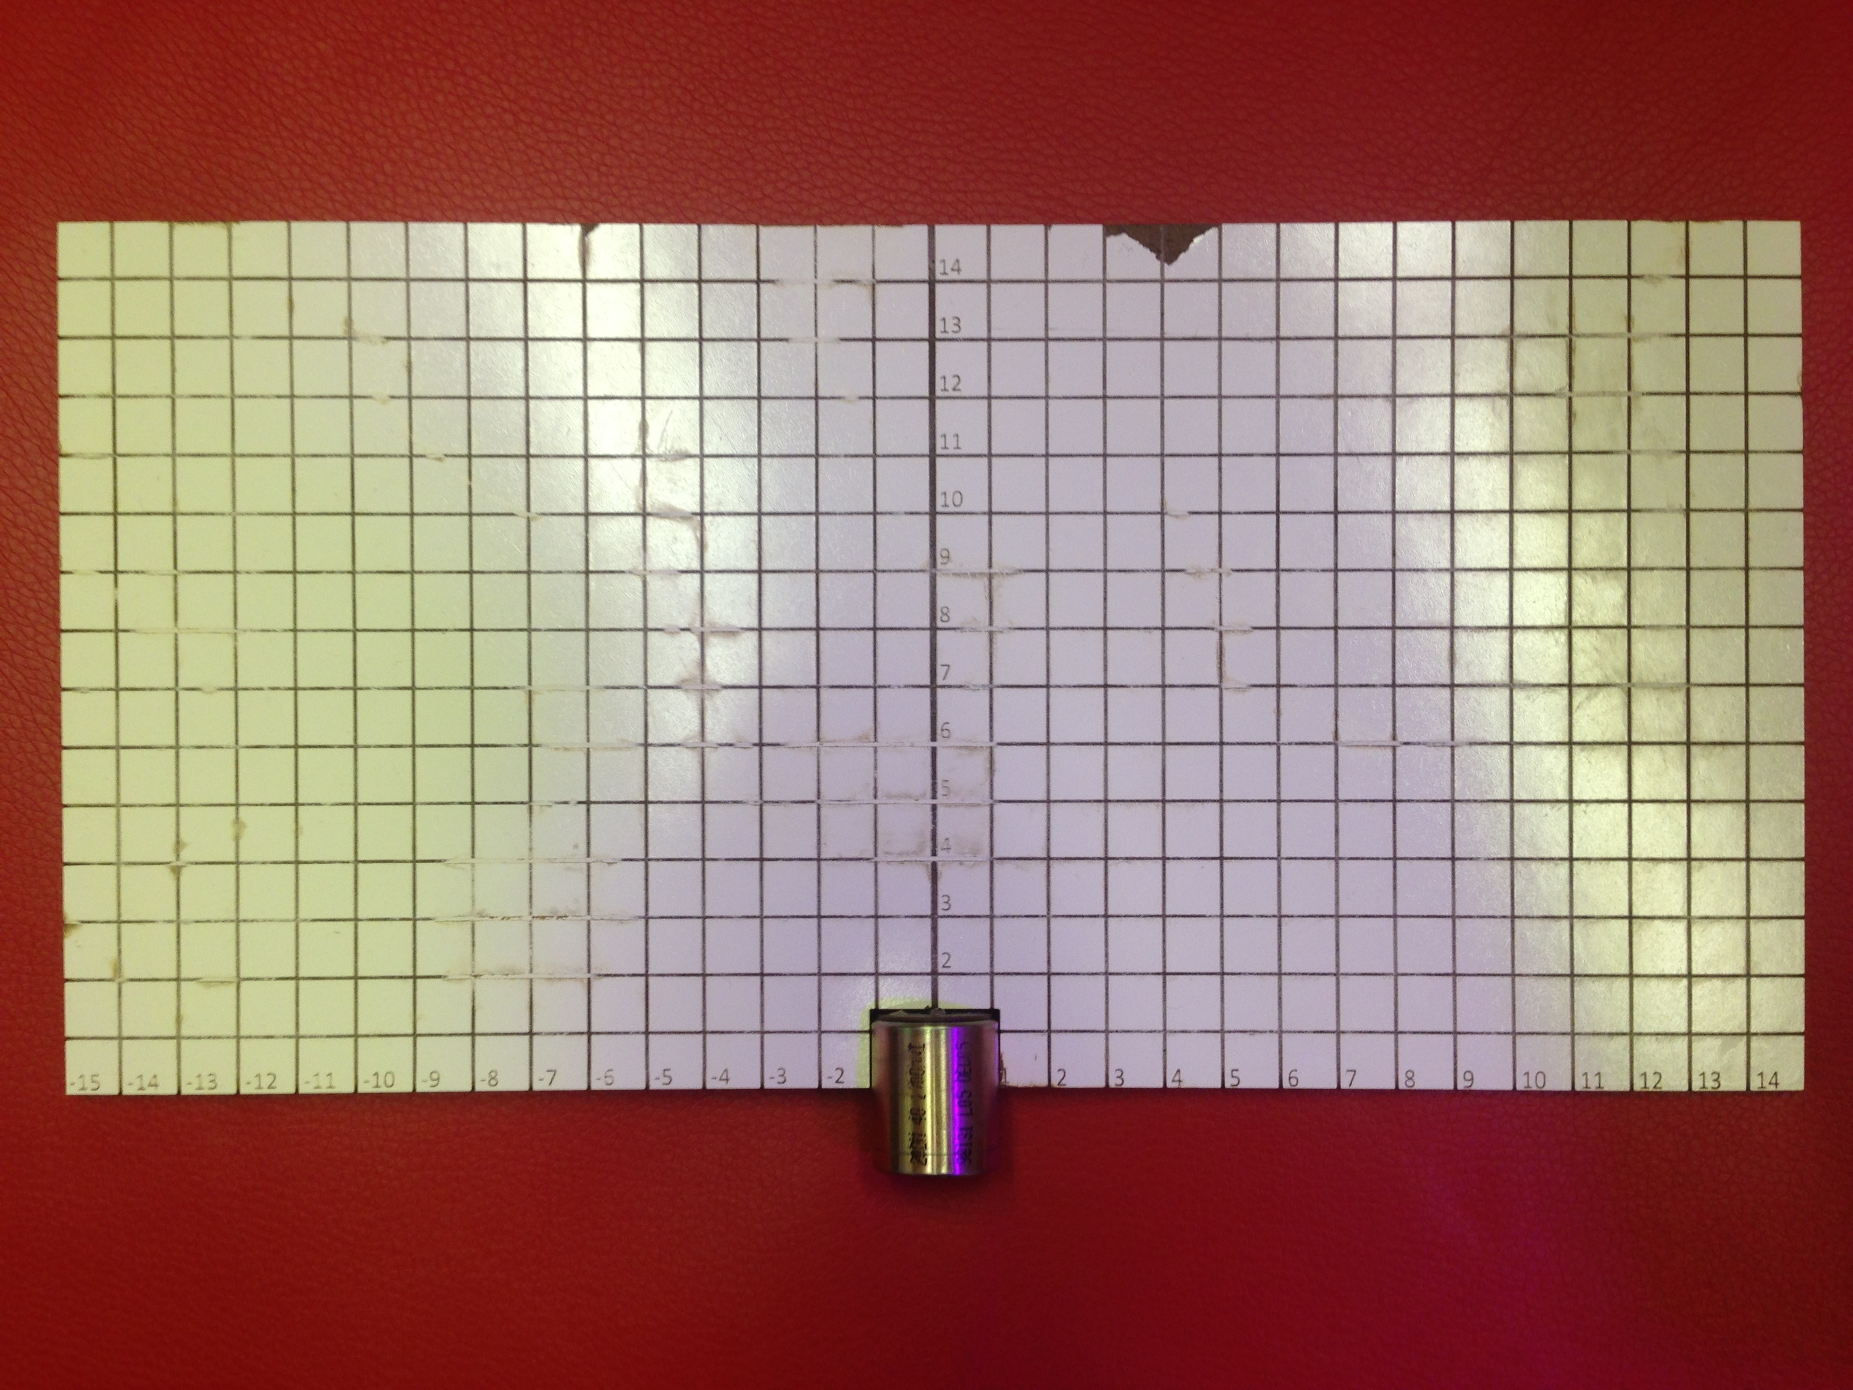

**Figure 1:** Small Grid made to measure the magnetic field of the geophone magnet (shown at the bottom center of grid) at specific points on a plane.

1. **My *Goals* for next week**

* Housing part for electronics in the dart—really want to focus on this
* Communication between multiple photon’s at once—have started
* Start learning how to use the cellular Electron
  1. Meeting with Dr. Becker on Monday May 30th 2016 at 10:00am