Weekly reports are to be emailed to atbecker@uh.edu by 5:00pm on Tuesdays. The purpose of a weekly report is to: (1) give you text and images for your papers, thesis, and dissertation, (2) document progress, (3) identify if you are stuck or need resources.

Weekly report

1. **My *Goals* from last week**
   * Learn how to work the Kilobots
   * Integrate myself into the lab
2. **My *Accomplishments* this week**
   1. Project 1: <Mean-Variance>

* deliverable 1. *Various errors in which not all kilobots were not seen. All pictures were generated into github*
* I calibrated the robots 3 times.
* I generated pictures from matlab with mable using the different lights to test how the lighting affects the thresholds
* We cleaned the table and secured the obstacles so they couldn’t be moved by the robot
* We have realized that the robots do get stuck already, on the corners. Should that be fixed? Will be brough up with Shiva.

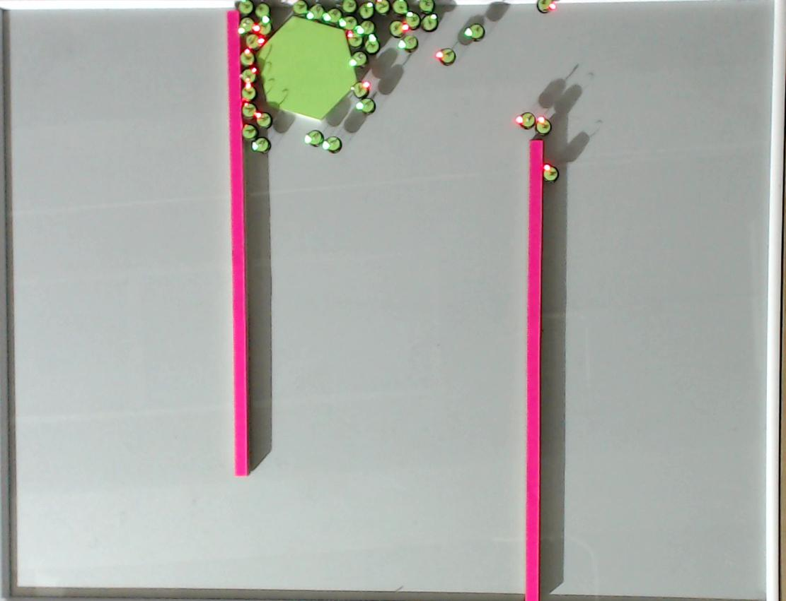

**Figure 1:** <example of error picture, see the rest in the github *>*

* 1. Project 1: <Variance Control Game>
* deliverable 1. *Test Code, currently unfinished for game. Currently 2 codes 1 player controlled system with time limit, no game mechanic yet and another math controlled code in order for me to play around and understand the system.*

1. **My *Goals* for next week**

* Finish the Variance Control Game
* Run all tests for Mean Variance Experiment
  + Getting 5 runs
  + Finding the perfect thresholds to see both
* Begin work on next experiment if there is extra time

1. **What I need Dr. Becker to do:**
   1. Inform me if I am doing something wrong, I am still new to the lab