Weekly report

1. **My *Goals* from last week**

* Housing part for electronics in the dart
* Communication between multiple photon’s at once
* Start learning how to use the cellular Electron

1. **My *Accomplishments* this week**
   1. Project 1: Smart Dart Electronics Housing

* Completely finished a first prototype of the housing for the electronics in the smart dart. You can see the assembled smart dart in Figure 1. It is made up of five parts, two of which were only necessary because of manufacturing problems and are attached to two other parts permanently so that the device is really just three parts. I didn’t get it 100% correct on the first try, but I will continue to work on this and I hope to have a functioning device by the end of the week.

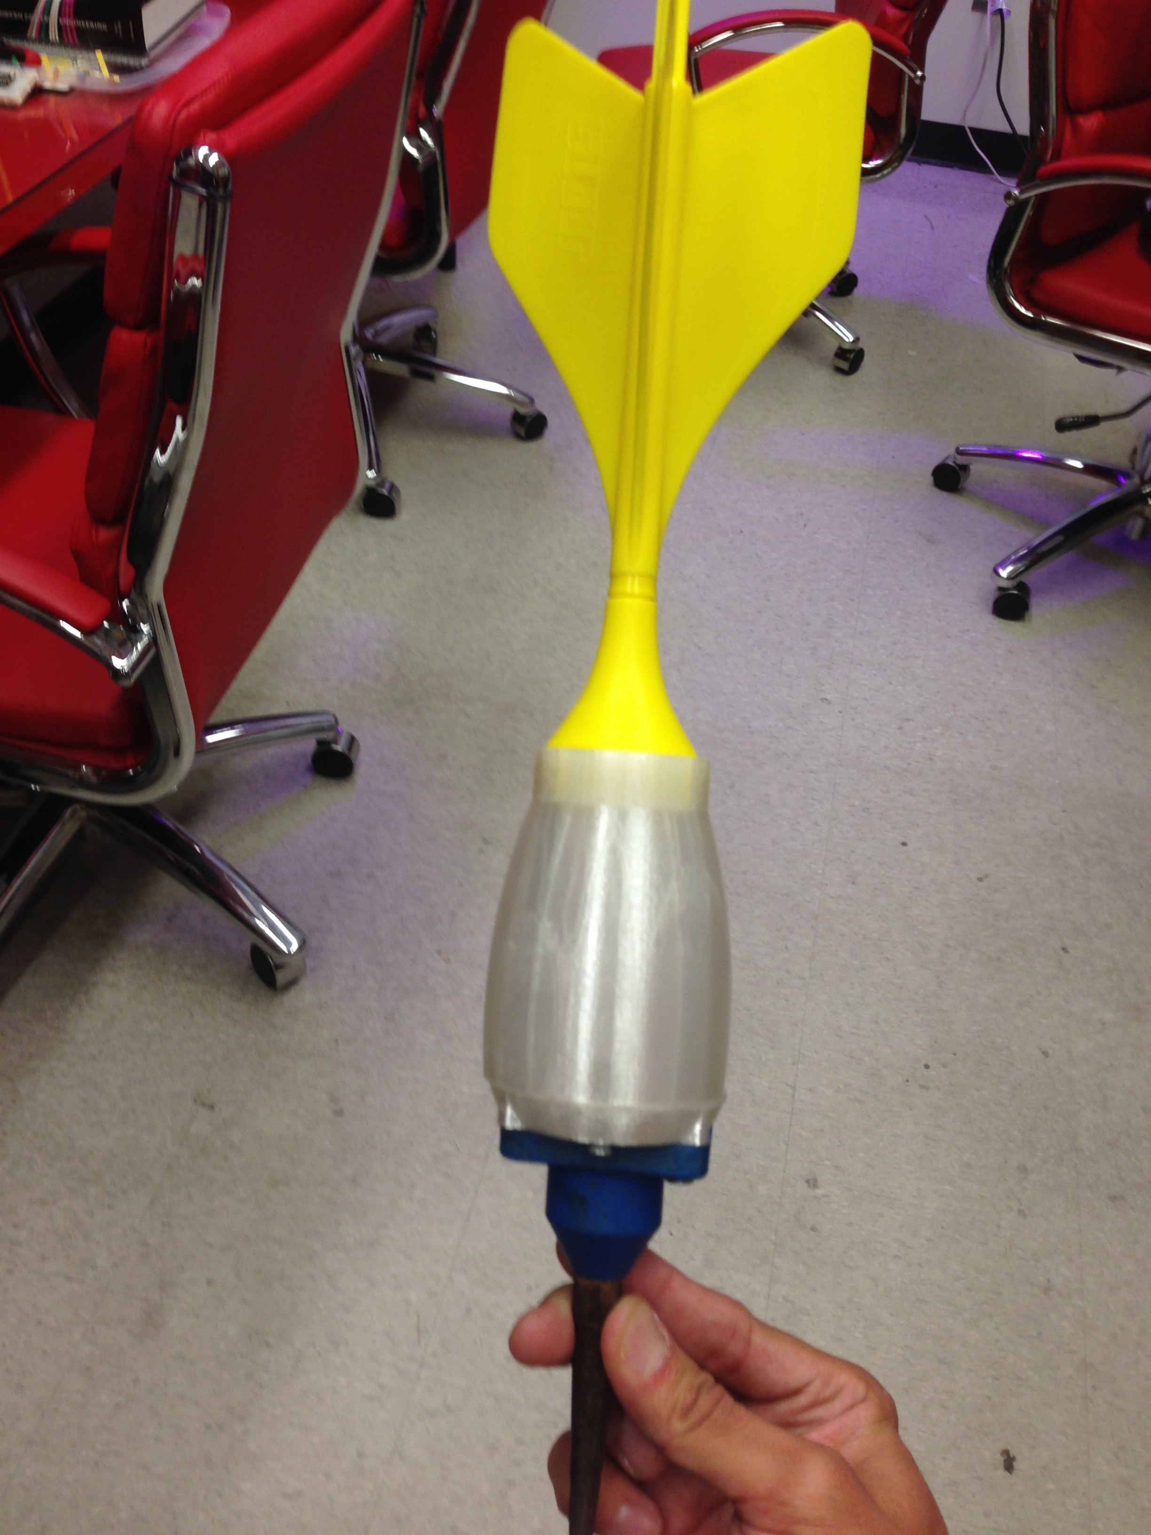

**Figure 1: Smart Dart Electronics Housing can be seen in between the dart and the and the**

**Geophone.**

* 1. Project 2: Communication with multiple Photons
* Has been achieved
* Also, the ability to measure angle with the accelerometer has been achieved

1. **My *Goals* for next week**

* Finish Housing for Electronics
* Cellular Electron still hasn’t arrived.
* Maybe start performing the drop tests with the new device?
* Begin research/design phase of dart dropping mechanism