Weekly report

1. **My *Goals* from last week**
   1. Finish the Variance Control Game
   2. Run all tests for Mean Variance Experiment
      1. Getting 5 runs
      2. Finding the perfect thresholds to see both
   3. Begin work on next experiment if there is extra time
2. **My *Accomplishments* this week**
   1. Project 1: <Mean-Variance>
      1. We changed the kilobots to run on a move to light code with no LEDs. This allows us to see almost all but two of the robots in the images
      2. Created titles to the images so we could tell what relays were on in the videos
      3. Created a Mean Control in order to try and compensate for the issue of all the lights coming on when the mean touches the object and the code getting into a perpetual loop. We attempted this in two ways
      4. Make the mean control feed in to Variance Control
      5. Make the mean use the light previously used
      6. Extended Delay Time
      7. Figured out what Scale did
      8. We have also designed and created a ledge with a 11mm overhand in order for the kilobots to not get stuck on the edges
         1. *Deliverable 1: Laser Cutter Code (see section 4)*
      9. We created a lighter hexagon by cutting out the material and a hexagon that tried to compensate for the problem we fixed above with the 3d printer edges.
         1. *Deliverable 2: 3D Model of lighter Hexagon and Hexagon with ledges (see section 4)*
         2. *Deliverable 3: Friction test graphs, the steeper the slope for more force required by gravity to move the hexagon*

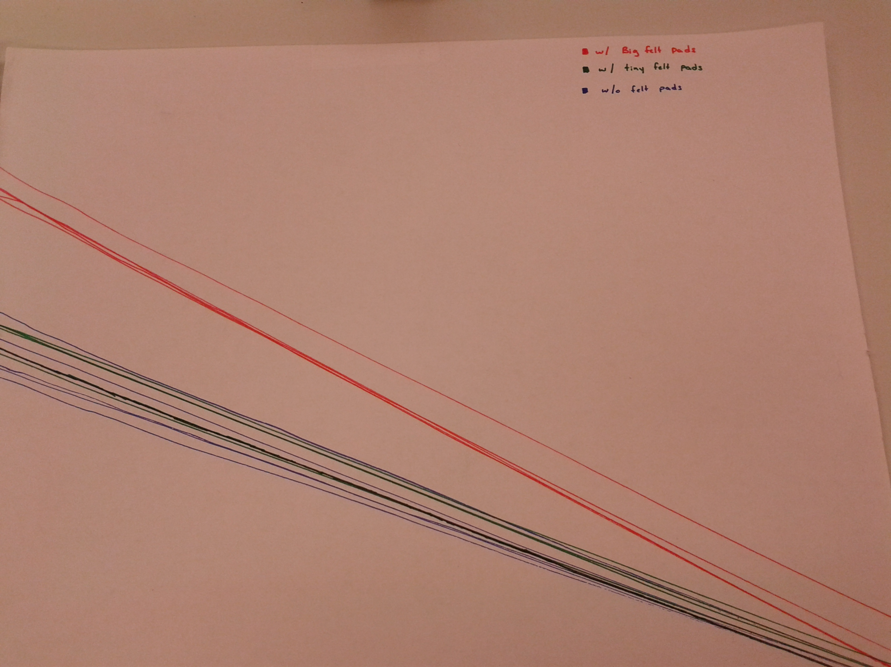

Figure - Friction Test for Old Hexagon

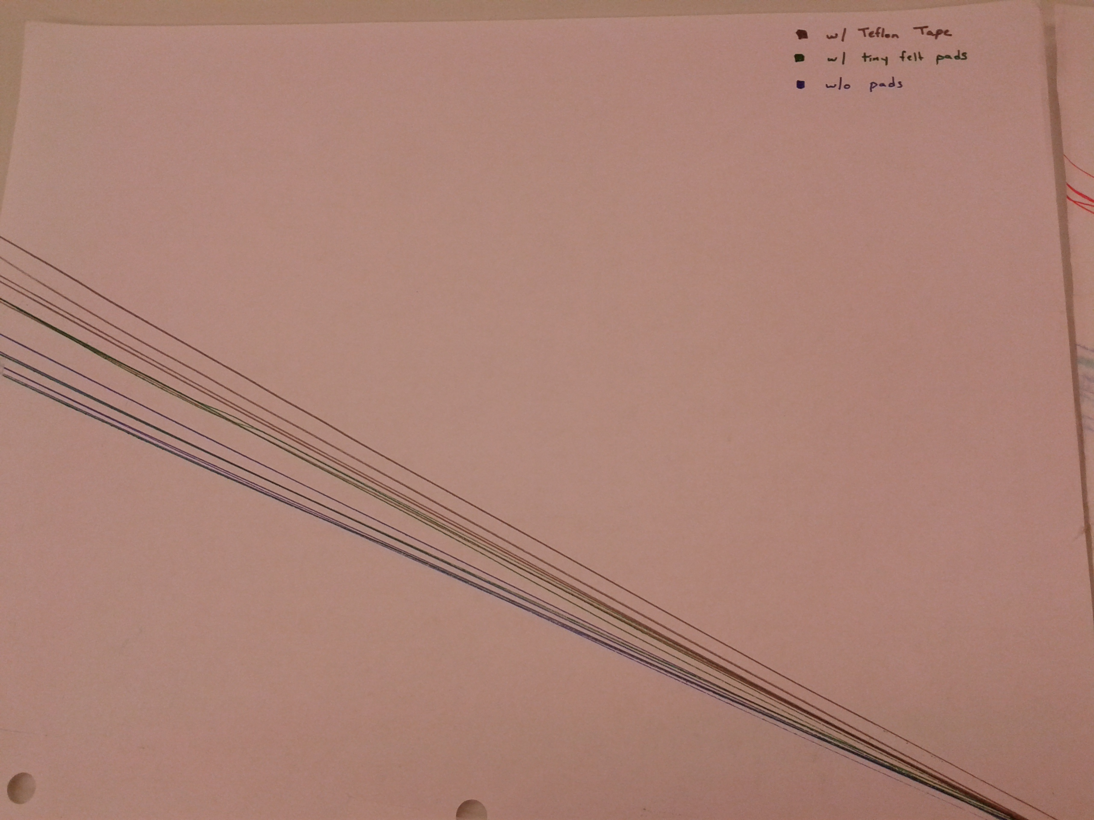

Figure - Friction Test for New Hexagon

* 1. Project 2: <Variance Control Game>
     1. deliverable 1. *Code is ready to play but no random elements yet. No terms of scoring, just tells user their percentage in variance. Need to randomize goals and get user input on colors and how long this game can keep their attention.*
  2. Project 2: <Mathmatica Demonstration>
     1. Found a consistent error in the code, e-mailed the details to Dr Becker
     2. Took thumbnail pictures
     3. Took pictures for snapshots



Figure - Mathematica Demonstration Snapshot, it looks better on Mathematica. Why is that?

1. **My *Goals* for next week**
2. Improve Variance Control Game based on feedback
3. Run successful tests for Mean Variance Experiment
4. Catch Shiva up on the data we have gathered thus far
5. **What I need Dr. Becker to do:**
   1. Give feedback on the game I have coded so far
   2. I’d also like access to the LaserCutter3DPrinter github so that I can post the Models and laser cutter plans