Weekly reports are to be emailed to atbecker@uh.edu by 5:00pm on Tuesdays. The purpose of a weekly report is to: (1) give you text and images for your papers, thesis, and dissertation, (2) document progress, (3) identify if you are stuck or need resources.

Weekly report

1. **My *Goals* from last week**

1) Combining codes for real time feedback control and test speed of algorithm.

2) Using Mathematics to find datasets for high density fluids

3) Placing particles and running collection algorithms on non-overlapping particles **My *Accomplishments* this week**

1) Code for real time tracking done.

2) ROI can be given as input:

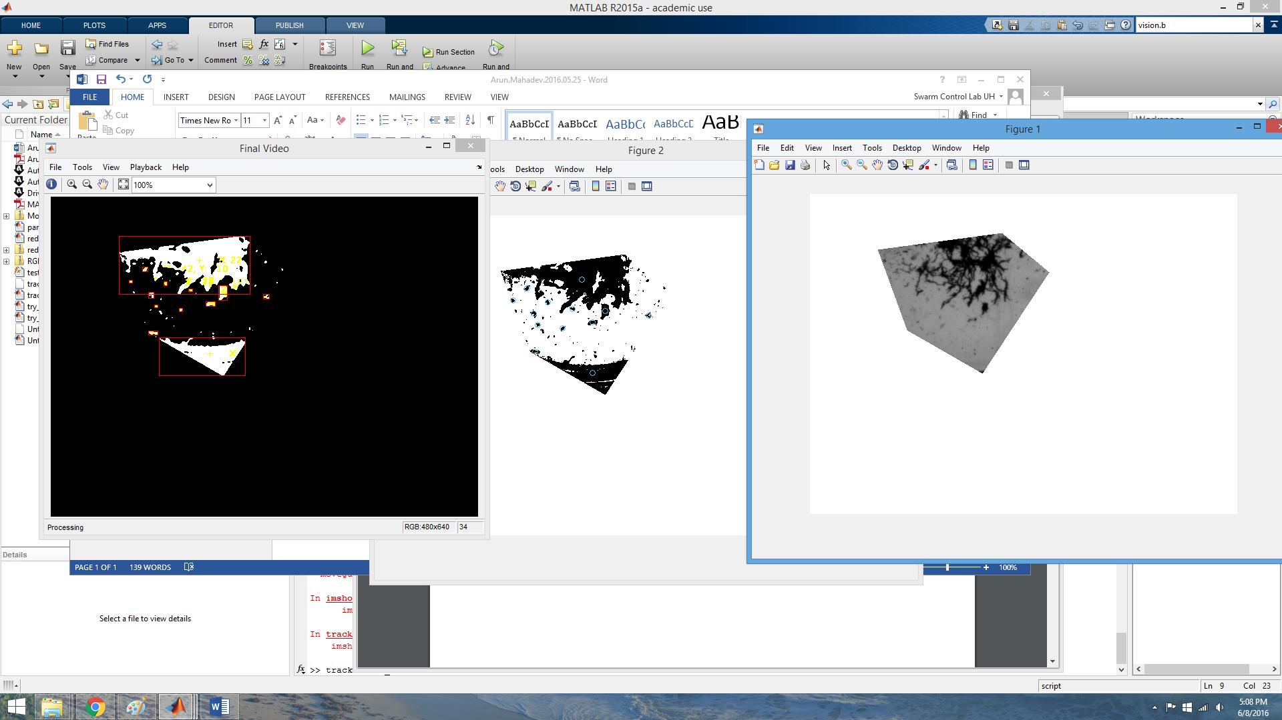

3) Amazing runtime: most time spent on me drawing a roi!!!!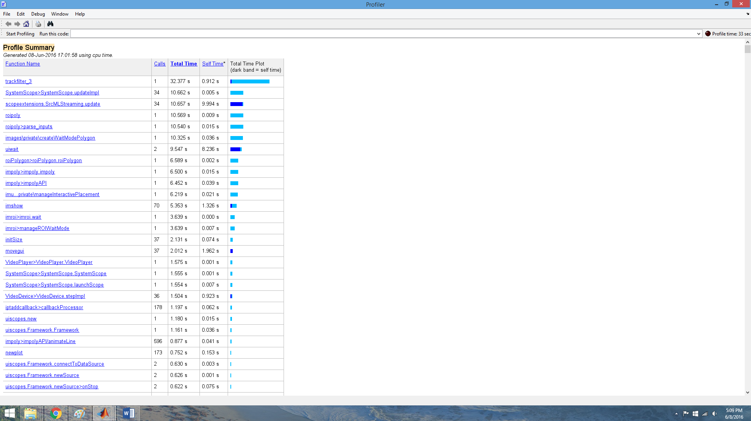

1. **My *Goals* for next week**
2. **Non-overlap code focus and implementation**
3. **What I need Dr. Becker to do:**
4. Stay tuned for updates for hardware orders