Weekly reports are to be emailed to atbecker@uh.edu by 5:00pm on Tuesdays. The purpose of a weekly report is to: (1) give you text and images for your papers, thesis, and dissertation, (2) document progress, (3) identify if you are stuck or need resources.

Weekly report

1. **My *Goals* from last week**

* Complete and test first design for Tilt Table Servo Mount.
* Test additional ideas for servo mount, if needed.
* Test ideas for magnetic mating sliders.
* Make video for a carry, summer or counter function.

1. **My *Accomplishments* this week**
   1. Project 1: <Tilt Table Servo Mount>

* DWG file of servo mount pieces. <https://github.com/aabecker/LaserCutter3DPrinter/blob/master/LaserCutter/Designs/Jarrett%20Lonsford/Tilt_Table_Stand.dwg>
* The stand is almost complete but since I was waiting on parts it did not get fully assembled or tested yet. The stand is sturdy and the servos fit well, I may use lead weights on it to counterbalance the weight of the servo if it causes any issues. I used the assembly concept that the ME arm used to fit the pieces of wood together. By using D shafts for axles and shaping the holes to fit them I have ensured that the axle will not slip. I am testing the stand today and if it proves successful then I will attach it to the tilt table.

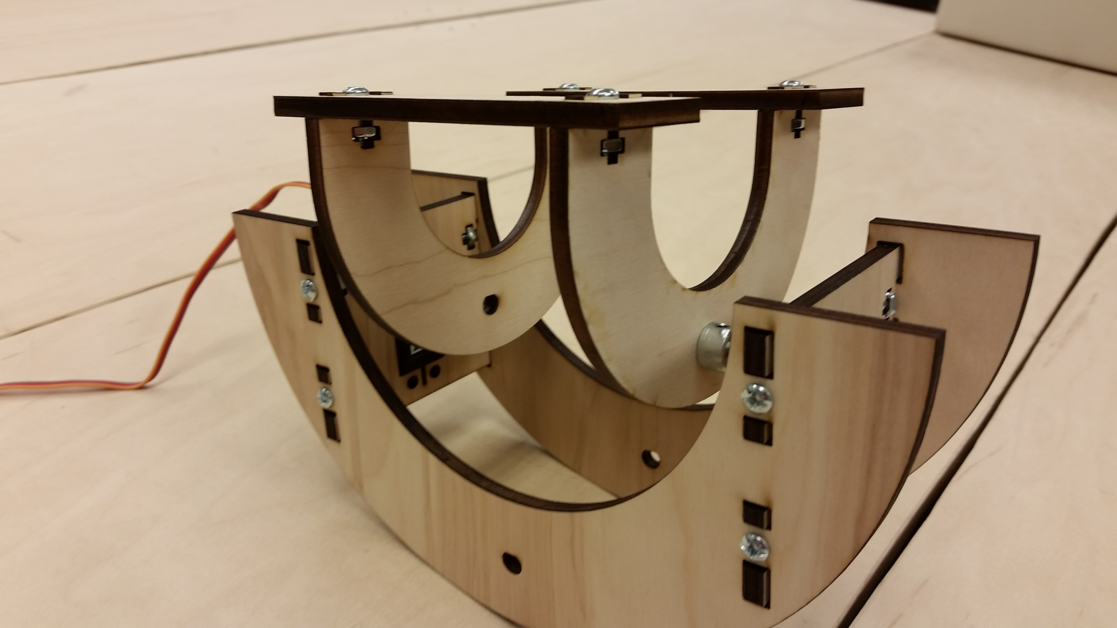

**Figure 1:** The nearly complete tilt table stand.

* 1. Project 2: <Magnetic Sliders>
     + DWG files for three different slider types. <https://github.com/aabecker/LaserCutter3DPrinter/blob/master/LaserCutter/Designs/Jarrett%20Lonsford/Magnetic_Slider_V1.dwg>

<https://github.com/aabecker/LaserCutter3DPrinter/blob/master/LaserCutter/Designs/Jarrett%20Lonsford/Magnetic_Slider_V2%26V3.dwg>

* + - The first slider version, which is a round slider with four magnets around its edge, has an issue where it connects to sliders of the same polarity in certain situations. To try and resolve this issue I made a round slider with eight magnets around its edge, but this slider creates a very large amount of repulsion and can cause sliders of the same polarity to rise out of the track. The third slider I made is a square slider with four magnets around its edge, while this slider prevents the previous two issues from occurring it does not slide as well as the round sliders, but could be improved with a good amount of sanding. Lastly, all of the sliders have an issue where the properly connected sliders can lift each other slightly out of the track due to their angled edge from being made with the laser cutter. To resolve this last issue I am considering using the 3D printer to make new mating slider prototypes.

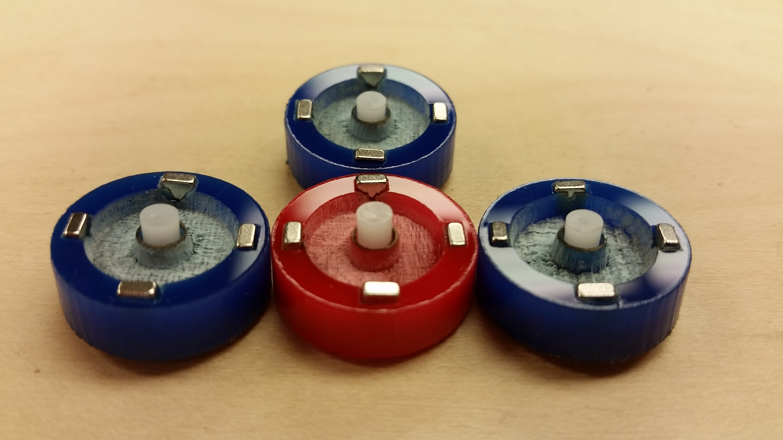

**Figure 2:** Four version one magnetic sliders working correctly.

1. **My *Goals* for next week**

* Complete and test Tilt Table Servo Mount.
* Test additional ideas for servo mount, if needed.
* Test more ideas for magnetic sliders that resolve issues with original designs.
* Make video for a carry, summer or counter function.

1. **What I need Dr. Becker to do:**

Time Sheet: (Zoom in to read) Notes for week 4: My summer class began on Tuesday.

