Weekly reports are to be emailed to atbecker@uh.edu by 5:00pm on Tuesdays. The purpose of a weekly report is to: (1) give you text and images for your papers, thesis, and dissertation, (2) document progress, (3) identify if you are stuck or need resources.

Weekly report

1. **My *Goals* from last week**

* Complete and test Tilt Table Servo Mount.
* Test additional ideas for servo mount, if needed.
* Test more ideas for magnetic sliders that resolve issues with original designs.
* Make video for a carry, summer or counter function.

1. **My *Accomplishments* this week**
   1. Project 1: <Tilt Table Servo Mount>

* DWG file of servo mount pieces (Updated from last week) and acrylic piece that holds shaft hubs onto the servo heads.

<https://github.com/aabecker/LaserCutter3DPrinter/blob/master/LaserCutter/Designs/Jarrett%20Lonsford/Tilt_Table_Stand.dwg>

<https://github.com/aabecker/LaserCutter3DPrinter/blob/master/LaserCutter/Designs/Jarrett%20Lonsford/Servo_Shaft_Connector.dwg>

* The stand is complete and after initial testing with no table or weight being supported, I quickly realized that the table needed a more stable base as the rotation of the lower half circle would cause the entire mechanism to tip over. I added a large flat base to the bottom which is about the size of the tilt table and can be seen in the picture below.

I also had to redesign the small wooden piece that held the shaft hubs to the servo heads as they were quickly stripped out by the teeth of the servo. After a large amount of searching online for servo head dimensions I found that no producers list these exact specifications and so I measured the size of the 25 teeth to the best of my ability and made an acrylic piece that would fit onto the servo teeth. These pieces worked well initially but has since failed for the plastic geared servo as its dimensions aren’t the exact same as the metal gear servo that I based everything on.

I also encountered problems with not having enough current to accurately control the servos, which will hopefully be resolved with the addition of a servo shield for the Arduino and an extra 5 volt power supply.

Although I had trouble controlling the exact angle, I was still able to stress test the mechanism for a while and even had a fairly successful run controlling the tilt table that was only held on by duct tape.

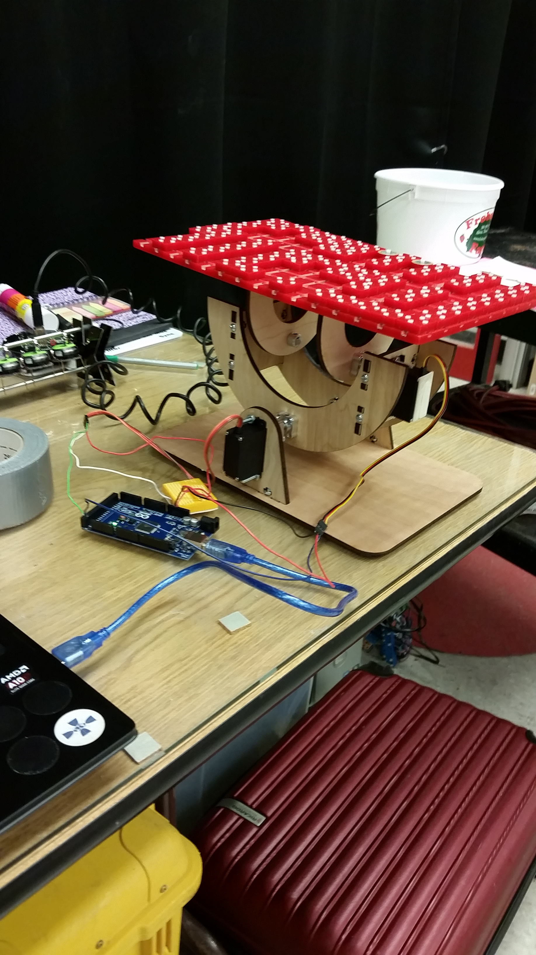

**Figure 1:** Tilt table stand controlling the Tilt Table via Arduino and MatLab.

* 1. Project 2: <Magnetic Sliders>
     + DWG files for three different magnetic slider types. <https://github.com/aabecker/LaserCutter3DPrinter/blob/master/LaserCutter/Designs/Jarrett%20Lonsford/Magnetic_Slider_V1.dwg>

<https://github.com/aabecker/LaserCutter3DPrinter/blob/master/LaserCutter/Designs/Jarrett%20Lonsford/Magnetic_Slider_V2%26V3.dwg>

* + - While trying to solve the issues of my first magnetic slider design I found new issues with both my second and third designs. Version 2, which is a square slider with four magnets embedded, has the unique issue that it can get stuck trying to go through a narrow passage as the sliders can easily rotate when sliding. The only possible solution I have for this issue is to design the parts bin tilt table without any narrow passes.

Slider version 3, which is a circular slider with eight magnets, repels other sliders of the same polarity too much. This prevents the same polarity sliders from sliding in tracks next to each other, which means the parts bin probably won’t function correctly. A possible solution for this is to use weaker magnets, which could prevent opposite pole sliders from staying well attached. Another possible solution is setting every other magnet closer to the center of the slider to reduce the repulsion force while still preventing sliders with the same polarity from sticking together. This will be magnetic slider version 4 and I am currently working on that drawing.

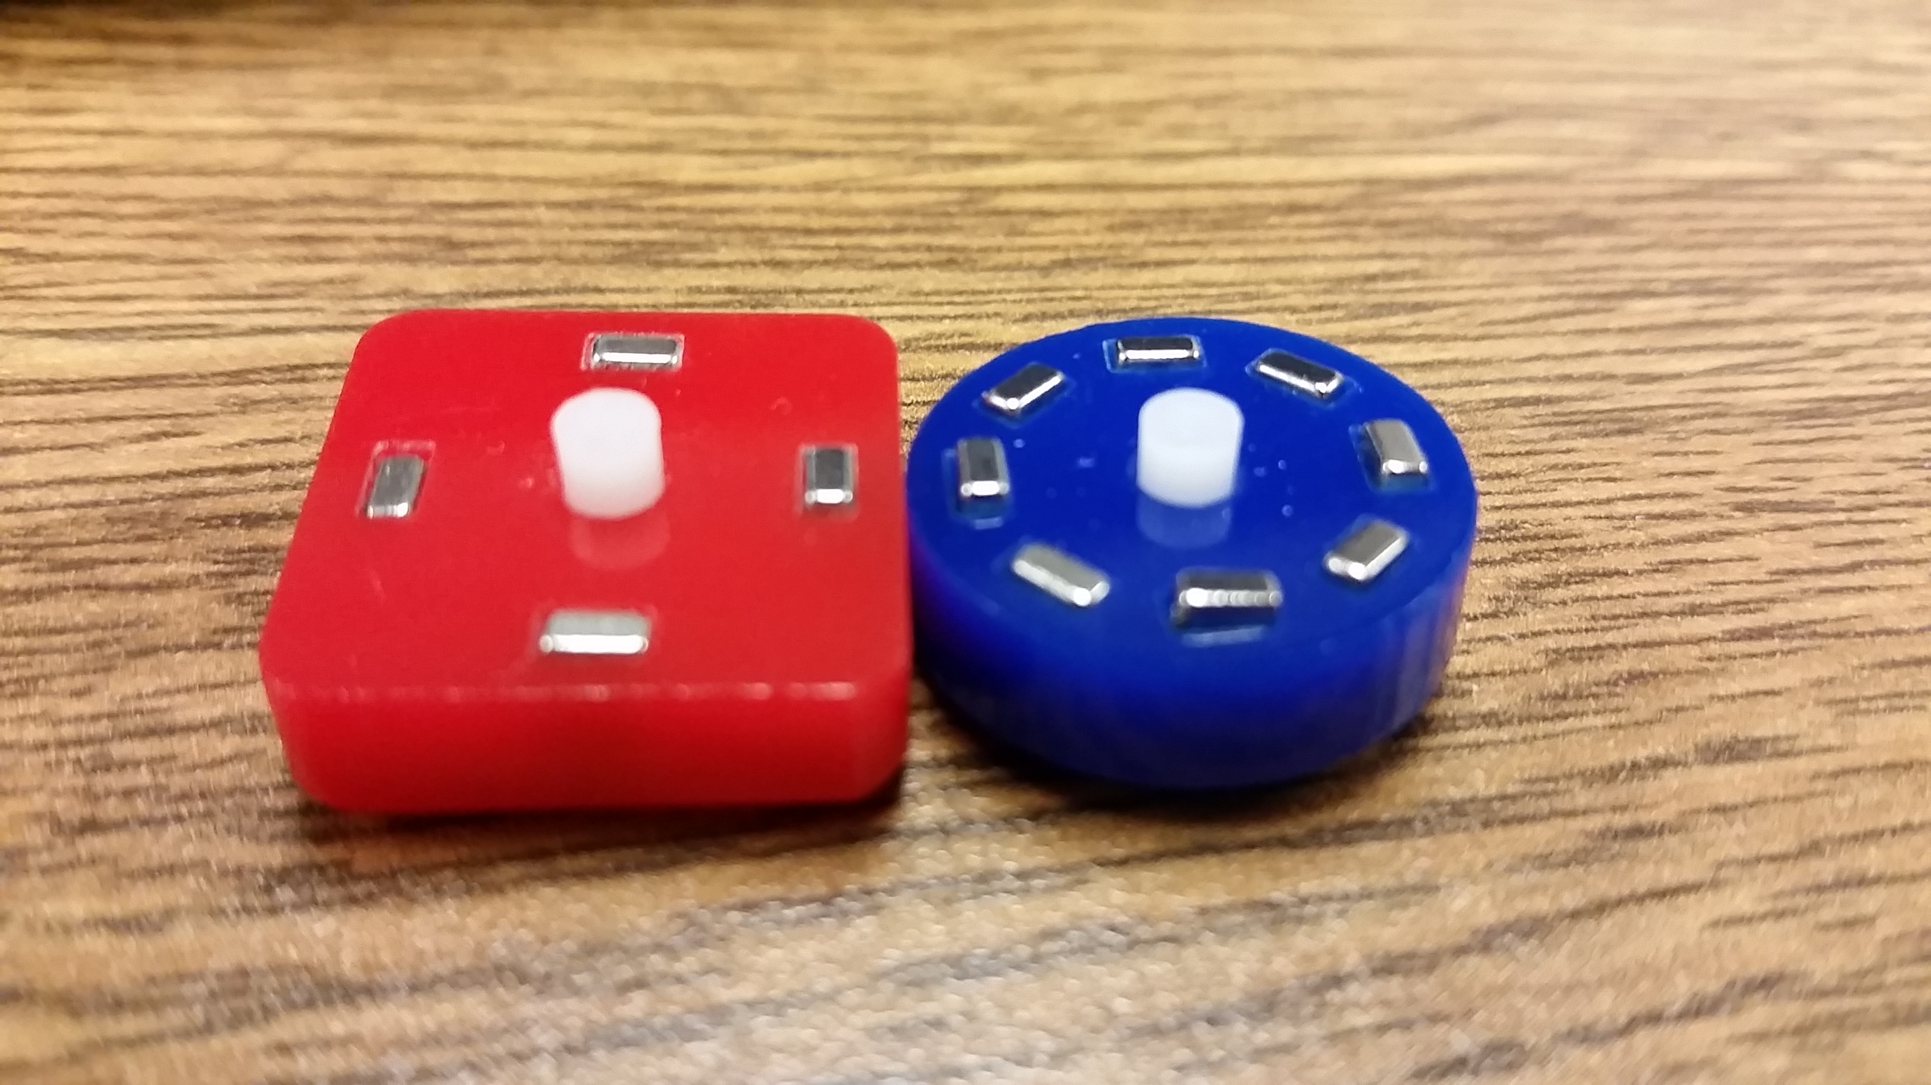

**Figure 2:** Version 2 and version 3 magnetic mating sliders.

* 1. Project 3 <Video for Carry Function>
     + I made a low quality video of the AND/OR logic gate being completed by my MATLAB code and the tilt mechanism and I was preparing to make a better video of the Carry function. But in order to do so I need to replace the plastic gear servo with a metal gear servo and add the arduino servo shield. I created the carry function on my tilt table and made sure it works by hand and will make the servo controlled video once my parts come in.

1. **My *Goals* for next week**

* Enjoy RSS.
* Find time to do school work in Michigan.
* Learn a lot of new robotics things.
* Not have a bad airplane experience. (This is only my second time flying.)

1. **What I need Dr. Becker to do:**
   1. Help me not have a bad airplane experience.

Time Sheet: (Zoom in to read)

