Weekly report

1. **My *Goals* from last week**

* Obtain drop test results
* Perform a manual drop with the hexapod hexacopter system
* Submit a PPTX document for the new poster.

1. **My *Accomplishments* this week**

* Perform a manual drop with the hexapod hexacopter system. A video was taken and edited and sent to Dr. Rob. It showed the pickup, drop and the hexapod moving and planting its sensors.
* Submitted a pdf document for the poster presentation during the RSS conference.
* Done with the electronics for the Jart mechanism and accelerometer works.
* Done with the task of assembling and making a document for the CASE reviews.
* Attached a GPS module and made new sets a legs for the hexapod which are stronger.

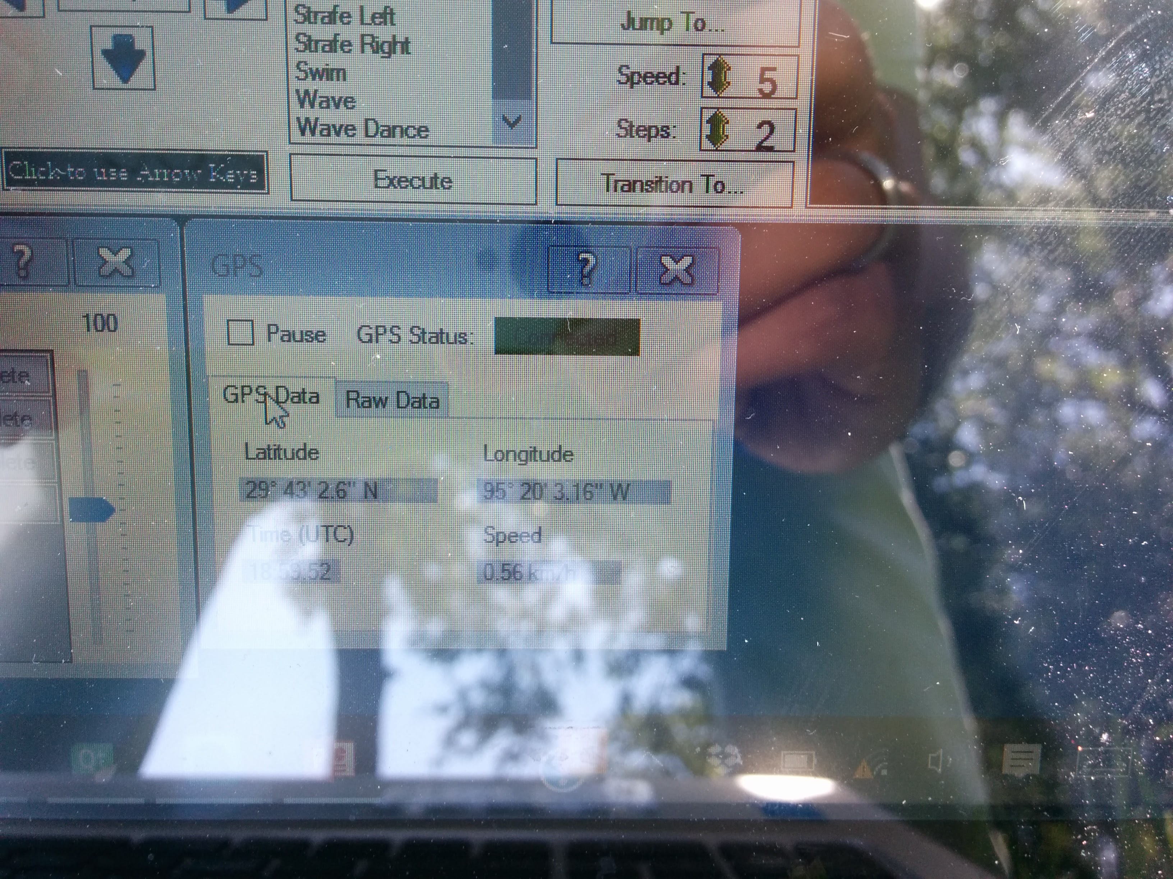

1. **My *Goals* for next week**

* Write a script for hexapod to move to specific GPS locations and perform sensing.
* Work on adding more sensors to the hexapod and thereby making it more robust. We can purchase the 4 in1 accelerometer, gyro, compass and temperature sensor. The piezo electric and other components to make the legs without the sensors as sources.
* Planning to use the hexapod for solving the retrieval problem. Making the hexacopter retrieve makes sense since we could use the same concept for both the Jarts/ hexapod retrieval but since the hexapod is already an intelligent robot, it has a camera on it. We can place this upwards use vision to hook itself up. We can use multiple sensors and use a combined output to solve this problem. We can tackle the problem from both sides to make it easily solvable.
  1. Meeting with Dr. Becker on Friday 11 A.M. (If needed this can be changed)

1. **What I need Dr. Becker to do:**

Discuss and come out with a plan for rest of the summer for me. Which direction should I work in, among the list of suggestions, we need to analyze which are the most important for the RA-L conference. Discuss a short term and long term goal.