Weekly report

1. **My *Goals* from last week**
   * Run the drop test experiment
   * Make a functioning prototype of the Smart Dart deployment mechanism
   * Review Srikanth’s paper for CASE
2. **My *Accomplishments* this week**
   1. Project 1: Smart Dart Drop Test Experiment

* A drop test experiment was performed on the Smart Dart for four different soil types to determine the relationship between the Smart Dart’s penetration depth, and the height at which it was dropped at.
* The experiment also provided data to show the relationship between the angle of error from the vertical gravitational axis of the planted Smart Dart and the height at which the Smart Dart was dropped at for four different soil types. Examples of the plots that were received for this data can be seen in Figure 1. Srikanth will send you all of them, I just didn’t want to crowd the page.

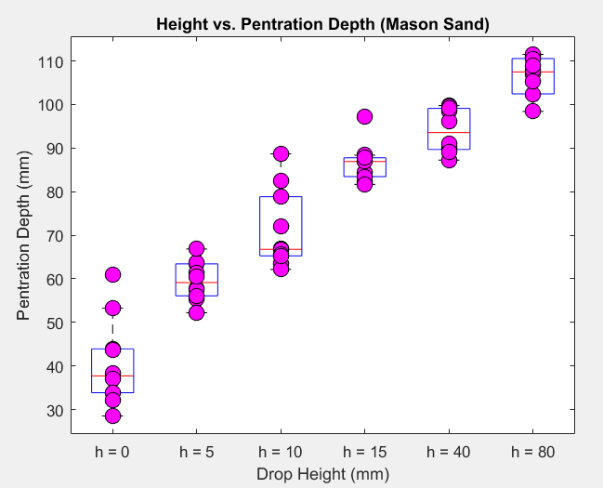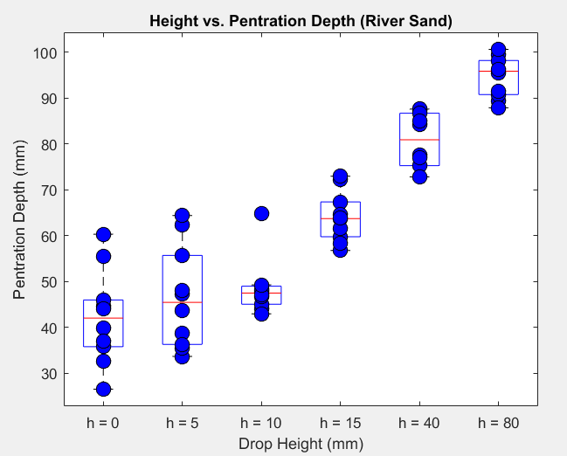

**Figure 1:** *Examples of the plots that were obtained for the drop test experiment on the Smart Dart. The plot on the left shows the plot for mason sand, while the plot on the right shows the same data, but for river sand.*

* 1. Project 2: Functioning Smart Dart deployment mechanism prototype
* Manufactured a working prototype of the SD deployment mechanism
* The mechanism is not yet alive, but this is what I am currently working on
* I have learned a lot of new CAD techniques and abilities to further assist me on creating and modeling gear assemblies.
  1. Project 3: Review Srikanth’s CASE paper
* Corrected basic grammar mistakes without focusing too much on structural correction

1. **My *Goals* for next week**

* Furthur development of the deployment mechanism for the Smart Dart
  + Needs motion
  + Also, needs thought on how to actually attach and work with the hex-copter

1. **What I need Dr. Becker to do:**
   1. I may need a new servo. However, before buying one, I am want to complete a gearing prototype with the existing servo from the senior design box to determine exactly which servo we’d need if we need one at all.