Weekly reports are to be emailed to atbecker@uh.edu by 5:00pm on Tuesdays. The purpose of a weekly report is to: (1) give you text and images for your papers, thesis, and dissertation, (2) document progress, (3) identify if you are stuck or need resources.

Weekly report

1. **My *Goals* from last week**

* Make more version 4 magnetic sliders.
* Make more stop blocks.
* Begin assembling a parts bin layout.
* Test the servo stand with the large tilt table.
* Decide which passive sliders are best.

1. **My *Accomplishments* this week**
   1. Project 1: <1’x 2’ Parts Bin Tilt Table>

* No new files.
* After cutting and assembling 150 stop blocks and making eight more magnetic sliders I ran out of magnets. I also had enough pieces to assemble a parts bin on the large tilt table though and this took a little longer than expected. Due to the limitations of the magnetic sliders once they are connected together, I had to redesign the parts bin layout to make it functional with the sliders. I made a layout that makes the same combined part as the parts bin in the MatLab code, it just uses a more roundabout slide pattern as seen below in Figure 1 and Figure 2. The parts bin works fairly well as long as the pieces aren’t moved too quickly or abruptly. There are some issues caused by the flexibility of the board which I hope to resolve this upcoming week. I also tried to see if the large tilt table would work with the servo stand that was built for the smaller table, unfortunately this table is just too bulky for the servos to handle.

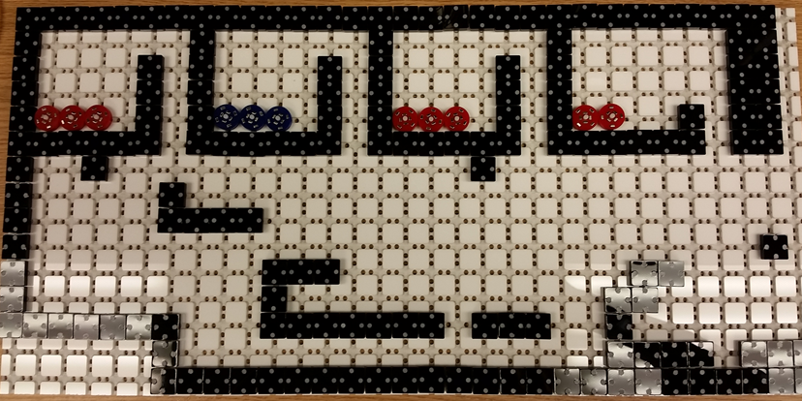

**Figure 1:** One foot by two foot tilt table, with initial layout for the parts bin.

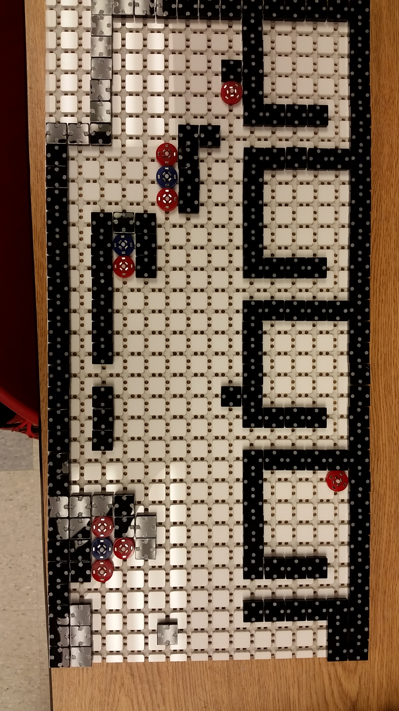

**Figure 2:** Parts bin layout after several rotations with one fully assembled part.

* 1. Project 2: <Best Passive Sliders>
     + After testing the 3D printed sliders more I’ve decided that they are too light and too inconsistent to be worth using. Since they only saved me a small amount of time they are simply not worth making or using.

1. **My *Goals* for next week**

* Make even more version 4 magnetic sliders once more magnets come in.
* Make the large tilt table sturdier and less flexible.
* Work with Arun to make one of the tables useful for his demonstrations.

1. **What I need Dr. Becker to do:**

Time Sheet: (Zoom in to read)

