Weekly report

1. **My *Goals* from last week**

* Getting Pixhawk to work and perform waypoint control.
* Getting the Cellular Photon to work and control a servo using the microcontroller setup.

1. **My *Accomplishments* this week**

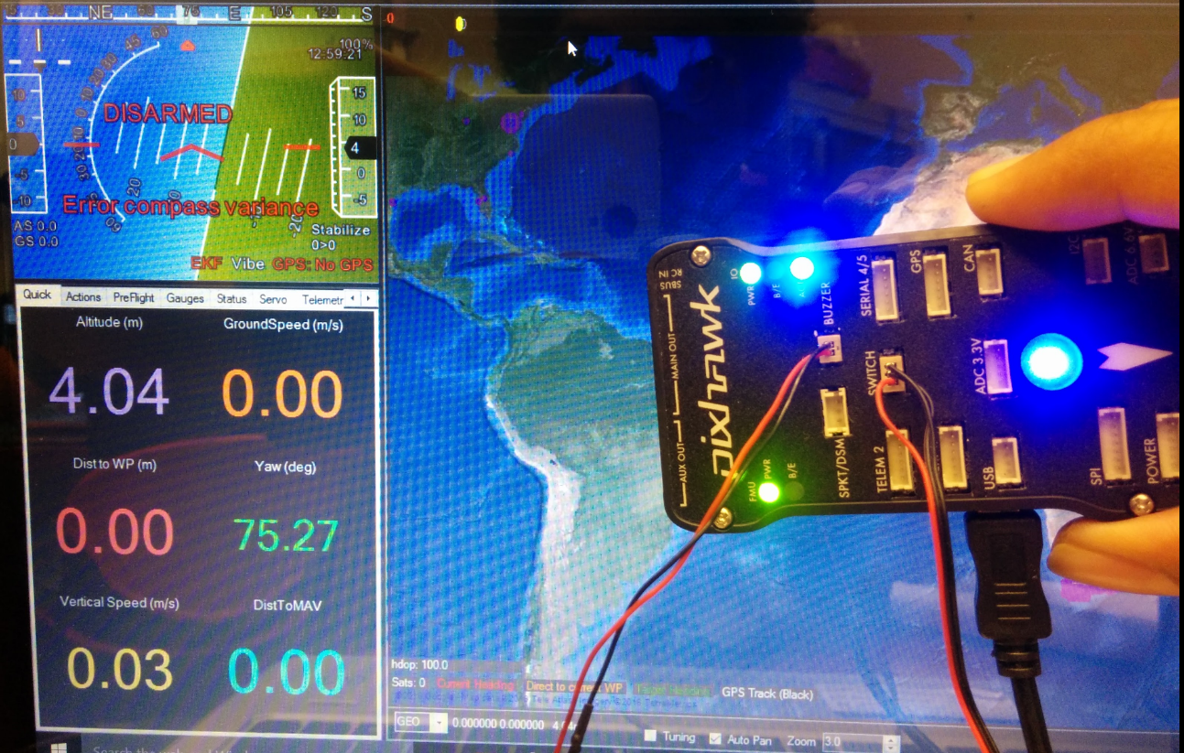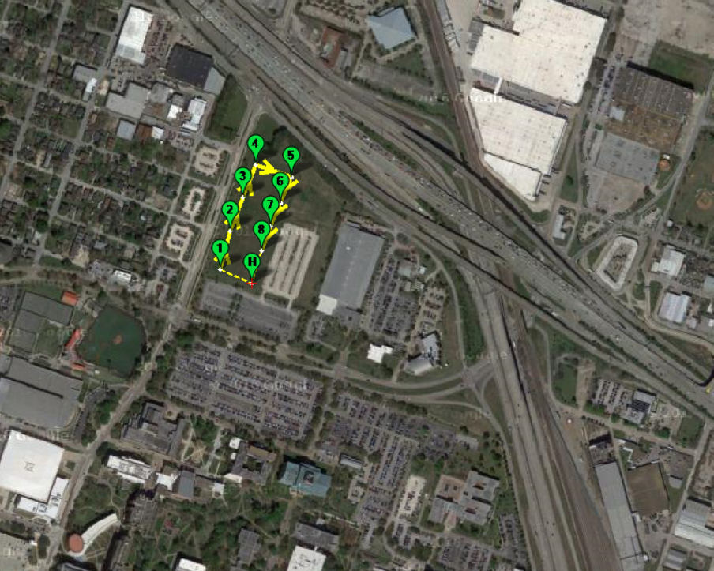

* I have got the Pixhawk running. It is able to detect altitude and roll, pitch and yaw angles. I’m able to plan a GPS waypoint survey. Each waypoint can perform different functions, we can tailor this to our needs. I have some python code that could be modified too.
* Submitted CASE conference paper.

1. **My *Goals* for next week**

* Getting the cellular photon to work.
* Making progress with the python code, if possible plug the flight controller on to the hexacopter and see how it works out. But An was telling there are some components required to control the hexcopter using Pixhawk.
* I can further perform wireless radio communication with the computer and the Pixhawk.
* Start documenting the experiments performed.
  1. Meeting with Dr. Becker on Friday 11 A.M. (If needed this can be changed)

1. **What I need Dr. Becker to do:**