Weekly report

1. **My *Goals* from last week**
   1. Understand Chris’s changes to the variance game
   2. Finish the block pushing experiment
   3. Figure out how to get robots stuck for the friction experiment
   4. Restart the Pure torque experiment with the new 3D printed object
   5. Start the orientation control code when Mable is done with her part
2. **My *Accomplishments* this week**
   1. Project 1: <Block Pushing Kilo-bots Project>
      1. Implemented the flow around the object in simulation
         1. Created 3 sets of arrows: attractive, repulsive and combined
         2. Shiva decided to use the previous goal mode when behind the object so code was changed to reflect this change
      2. Implemented the flow around code in Matlab
      3. Combined the flow around code with the Region code simulation
         1. This code has run into issues. We are currently tackling with the code now in order to get these to work. The problems are as follows:
            1. When it is switching from forced based goal determination to the previous goal system it tends to get stuck
            2. The mean gets stuck on the goal
            3. The regions get to a point at which we
      4. *<Deliverable 1,2, &3> FlowAround, RegionBasedBlockPushing_Complete, and ObjectManipulation_Regions_FlowAround can be found in the Github*

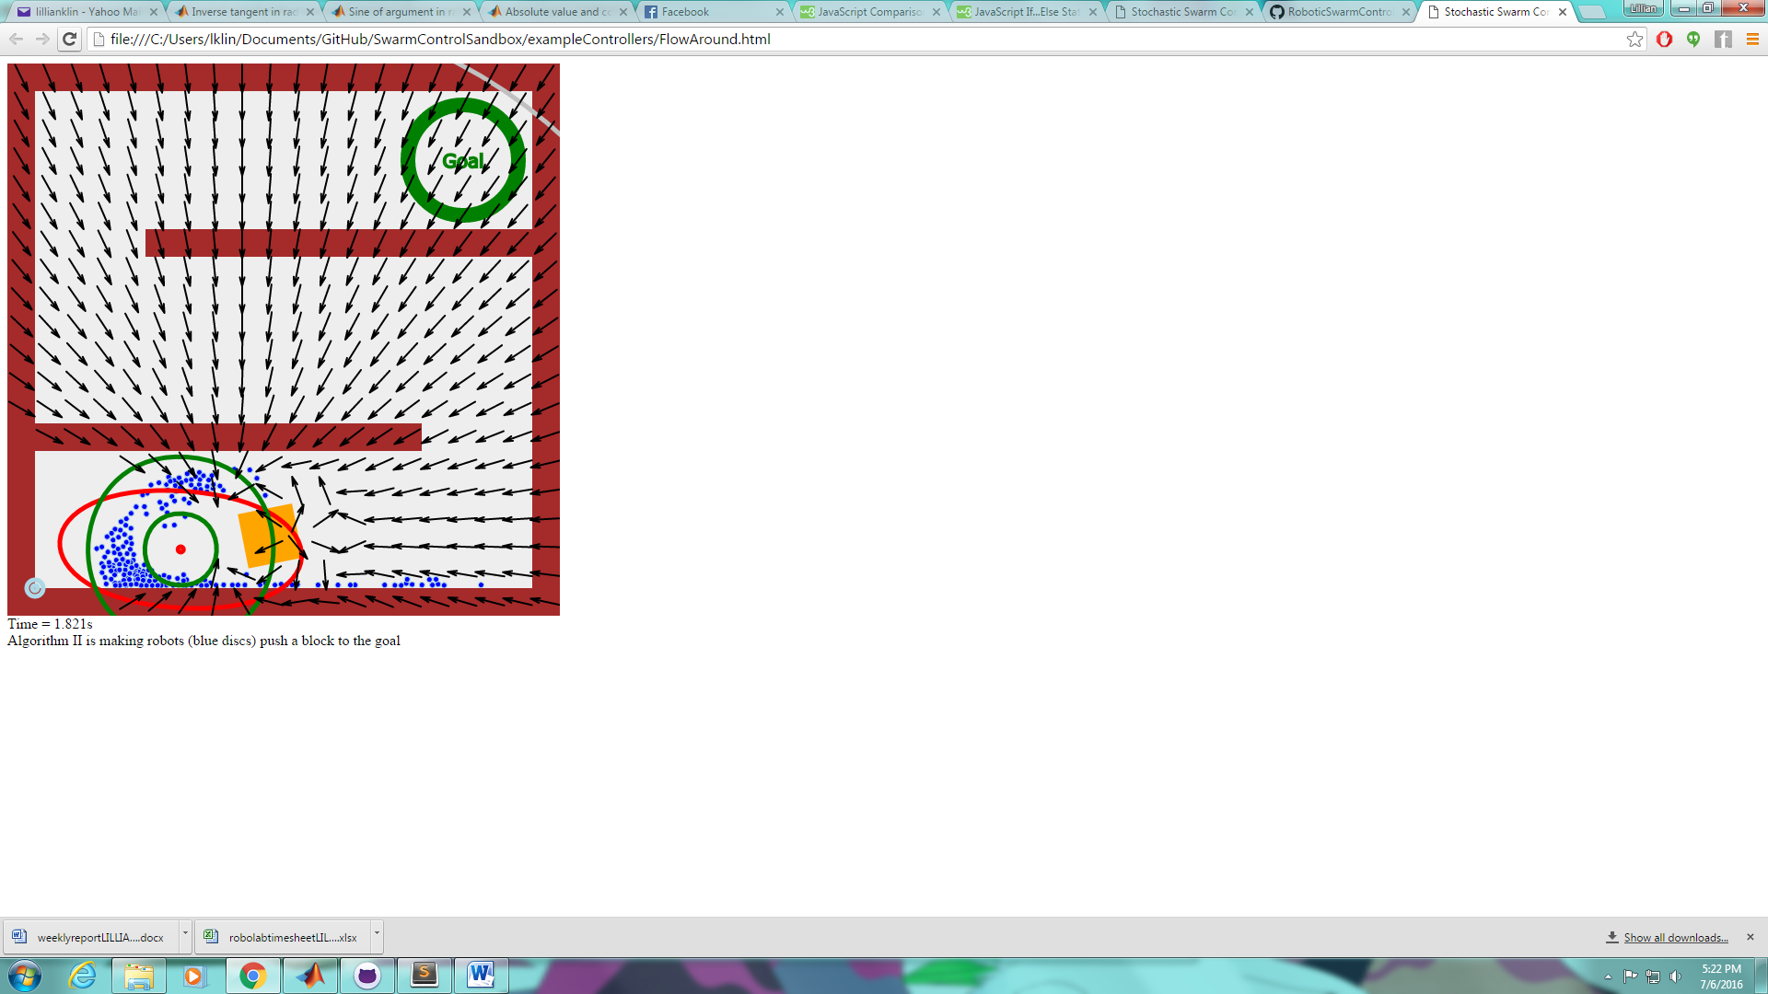

Figure 1- Force Arrows on FlowAround Code

* 1. Project 2: <Pure Torque Control Experiment>
     1. Mahek did not finish printing the torque object so I started printing a one
        1. Object was scrapped as Shiva said it was too heavy, object has gone through 3 renditions this week
           1. 5 mm width one
           2. 3 mm width one
           3. 3 mm width one with the bottom cut to only have feet
        2. 3D printer has been running into an issue consistently where the material has not been feeding through the tube because it gets stuck in the feeding motors until the motors grind the plastic into a stuck position.

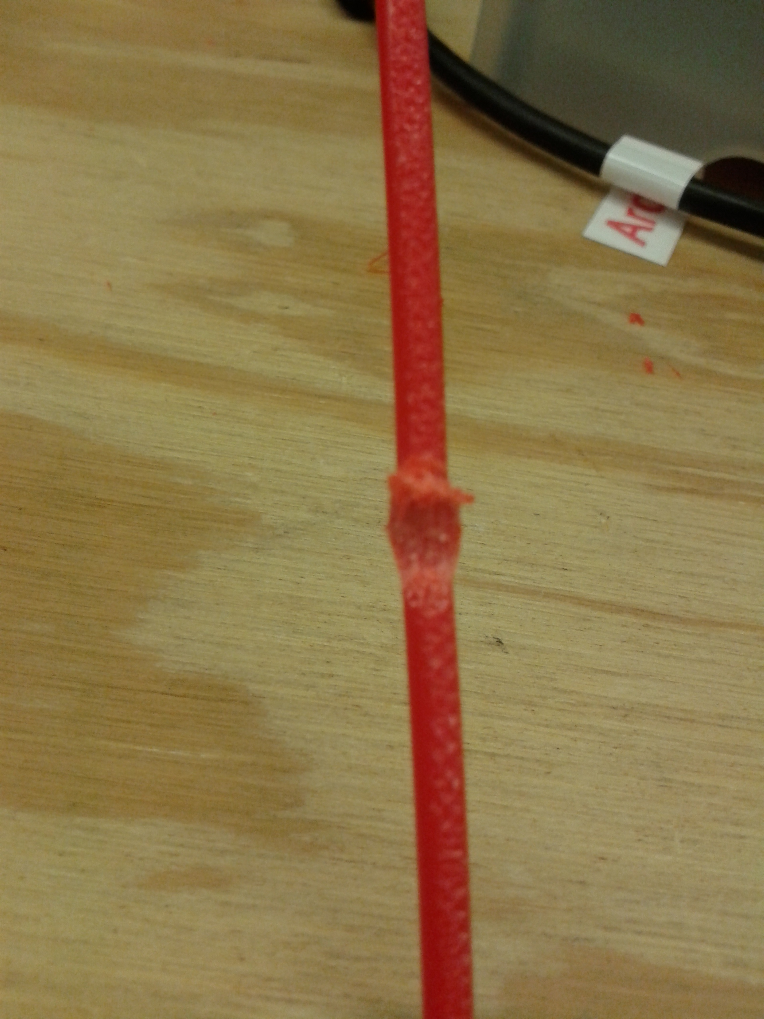

Figure 2 - Plastic ground by the stepper motor

* 1. Project ?: <Other>
     1. Obtained a new Computer
        1. I broke my last computer so I finally bought a new one on 7/6/2016

1. **My *Goals* for next week**
   1. I did not call Chris
   2. Begin the block pushing experiment with new code