Weekly reports are to be emailed to atbecker@uh.edu by 5:00pm on Tuesdays. The purpose of a weekly report is to: (1) give you text and images for your papers, thesis, and dissertation, (2) document progress, (3) identify if you are stuck or need resources.

Weekly report

1. **My *Goals* from last week**

*Project 1* <Kilobots Matlab>

*Project 2* <Object Manipulation Simulation>

* Automate multiple simulation scenarios with simple true/false activations. I need to vary the # of robots, the noise, and add different shapes.
* Add a control for when the # of robots in the region is zero. If that happens, we’ll pick the adjacent region with the most robots and navigate them to the object. Having the # of robots equal zero is a problem causes our mean and cov calculations to be undefined.

*Project 5* <Object Orientation Matlab>

*Project 4* <Object Orientation Simulation>

*Project 4* <Mean Game>

* None

*Project 5*<Miscellaneous>

* I need to pick my research topic
* Look over Chris’s game instructions

**My *Accomplishments* this week**

*Project 1* <Kilobots Matlab>

* **We completed 4 successful experiments!!!**

*Project 2* <Object Manipulation Simulation>

* Automate multiple simulation scenarios with simple true/false activations. I need to vary the # of robots, the noise, and add different shapes. -done! I added simple booleans to turn on/off different simulation scenarios
* Add a control for when the # of robots in the region is zero. If that happens, we’ll pick the adjacent region with the most robots and navigate them to the object. Having the # of robots equal zero is a problem causes our mean and cov calculations to be undefined. -done and improved, see below
* I added a lot to the simulation code. I:
  + Solved the problem of having zero robots in the region. When there is less than 10% of the robots in the region, go to variance control.
  + Improved variance control by selecting a more effective corner, which depends on which region has the object and which region has the most robots.
  + Merged the regions code with the flow around code. Currently I am fine tuning the parameters.
  + Added local storage to store results so we can run the simulations overnight. Each simulation has a different input value for # of robots.

*Project 5* <Object Orientation Matlab>

*Project 4* <Object Orientation Simulation>

*Project 4* <Mean Game>

* None

*Project 5*<Miscellaneous>

* I need to pick my research topic -still brainstorming
* Look over Chris’s game instructions -scheduled a google hangout with him
* Started to write the paragraphs for the main/transfer region strategy. Here are the images so far.
* Tested our friction idea with the magnets and metal shavings and it does! Will run tests tomorrow.

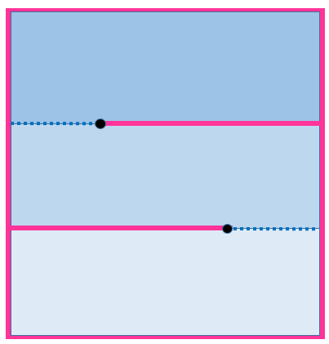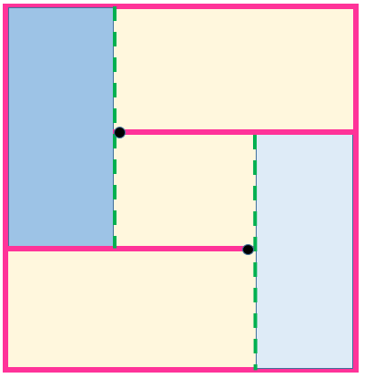

Figure Main Regions Transfer Regions

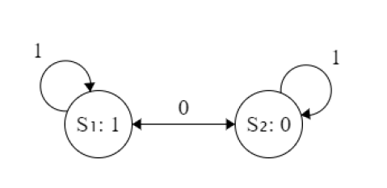

Figure State Machine

1. **My *Goals* for next week**

*Project 1* <Kilobots Matlab>

*Project 2* <Object Manipulation Simulation>

* Having a working simulation
* Run the tests
* Plot the results
* Write the paragraphs explaining the main/transfer regions.
* Write the algorithms for the paper

*Project 5* <Object Orientation Matlab>

*Project 4* <Object Orientation Simulation>

*Project 4* <Mean Game>

* None

*Project 5*<Miscellaneous>

* I need to pick my research topic by the end of July. So far I am interested in applying machine learning to the swarm robots. Perhaps through reinforcement learning or deep learning, the algorithm will successfully manipulate the object with the swarm. I’m playing with the idea right now. I need to find a more specific hypothesis/application.
* Look over Chris’s game instructions

1. **What I need Dr. Becker to do:**

* Have a great vacation!
* Purchase magnets, ask Shiva!
* Continue giving feedback on anything and everything