Weekly report

1. **My *Goals* from last week**

* Smart Dart Deployer

**My *Accomplishments* this week**

* 1. Project 1: Smart Dart Deployer
* Giant prototype completely finished, and tested. Some problems with spacing and gear deflection were found, and fixed. These problems were due to the large scale, however, and shouldn’t reoccur in the next design. The mechanism can be seen in Fig. 1.
* This mechanism was designed around a motor that turned out not to work, and so the video I took was of the mechanism working with me turning the gear on the motor. This video will be in the email. The servomotor was tested out by 3 of us and we all think it broke somehow.
* New, smaller servomoter has been purchased and should arrive by 8:00pm tonight.
* Next design has begun, around the new servomoter with way smaller gears.

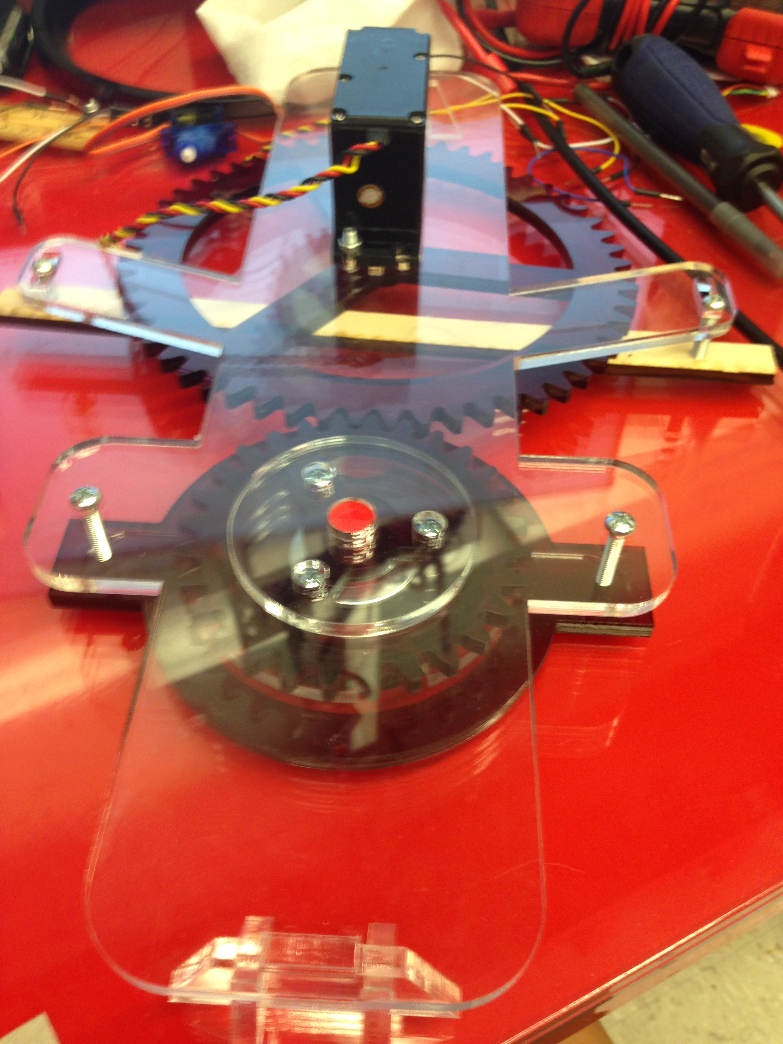

Fig 1: Demonstrational prototype of the smart dart deployer.

1. **My *Goals* for next week**

* New design will be all around smaller, with smaller gears and a smaller housing that I hope to design with an so that it will work with the hex copter

1. **What I need Dr. Becker to do:**
   1. Please imagine the mechanism in the video to be powered by a working servo, and to be a lot more compact in the future.