Weekly report

1. **My *Goals* from last week**

* Getting the cellular photon to work.
* Making progress with the python code for GPS waypoint control with the pixhawk.
* Perform wireless radio communication with the computer and the Pixhawk.
* Start documenting the experiments performed.

1. **My *Accomplishments* this week**

* I have got the electron to work. I have coded in html to control the servo to drop the jart at a particular location. We have ordered a new servo and we are waiting on it. But I was able to use this 9g servo to test my code. I made two templates one is a slider and the other is a button config.

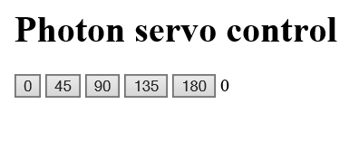 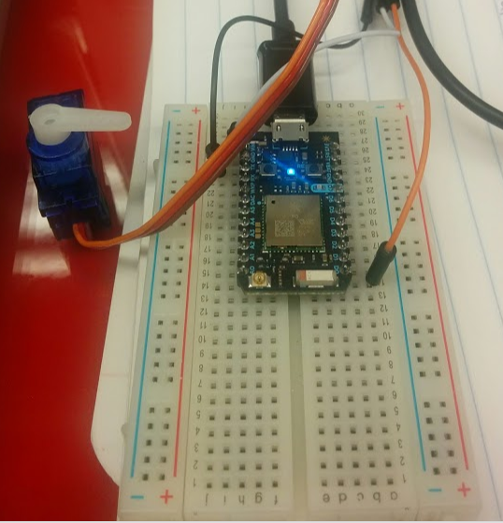

* I have a basic code which would work for GPS waypoint control. I’m waiting for the GPS to make further progress. An started on the pixhawk, we are planning to put together a small quadcopter to test GPS waypoint control and then extrapolate the idea to the hexacopter.
* I have made a basic tex file and started writing about the experiments we are currently doing.

1. **My *Goals* for next week**

* I would want to solve a linear programming problem. The objective function would be to minimize aX1 + bX2 where
* a = $200 (Smart Dart)
* b = $800 (hexapod)
* X1 = No. of Smart Darts needed
* X2 = No. of Hexapods needed

***How do I obtain other constraints? How do I bring in the Hexacopter flight time, cost into the constraints.***

* + - I would want to do some coding on MATLAB. If there is any possibility for this.
    - Make progress with the quadcopter pixhawk control.
    - Produce a basic outline for the conference paper.
  1. Meeting with Dr. Becker on Friday 11 A.M.

1. **What I need Dr. Becker to do:**