Weekly report

1. **My *Goals* from last week**
   1. I did not call Chris
   2. Begin the block pushing experiment with new code
2. **My *Accomplishments* this week**
   1. Project 1: <Block Pushing Kilo-bots Project>
      1. Implemented the flow around code into matlab successfully
      2. Updated the codes so that they are compatible with PC
      3. Changed the simulation to be more similar to be kilobots
      4. Success! We have gone all the way to the end 5 times!
      5. *<Deliverables 1,2,&3> Below are requested Pictures*

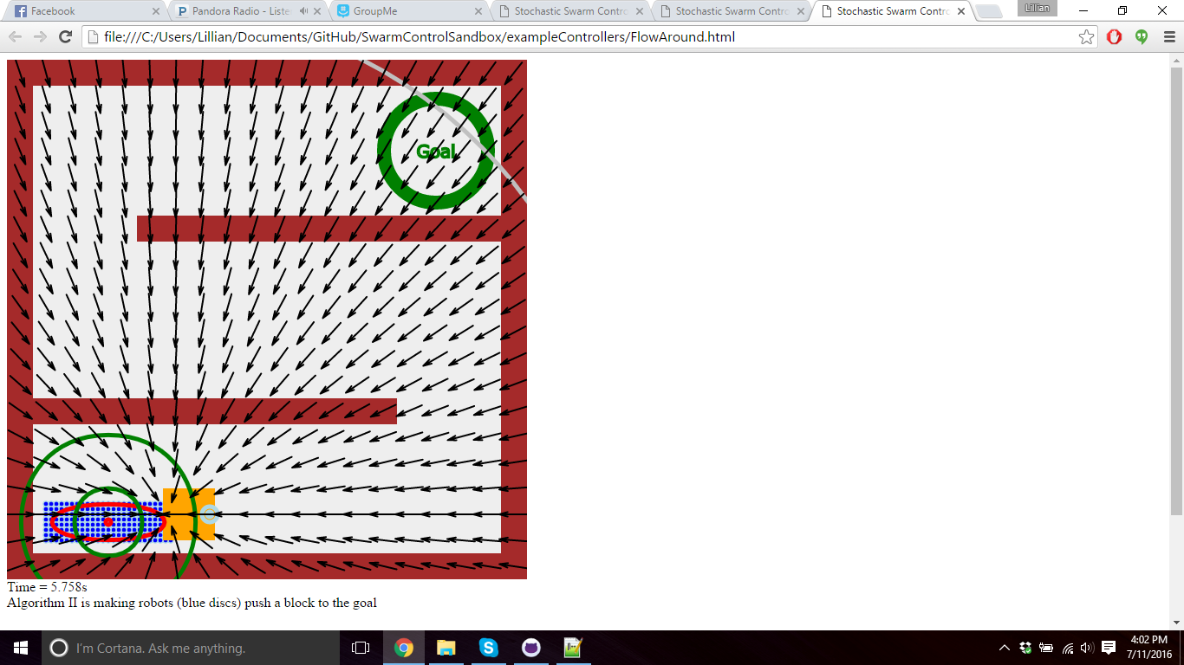

Figure 1- Attractive Forces

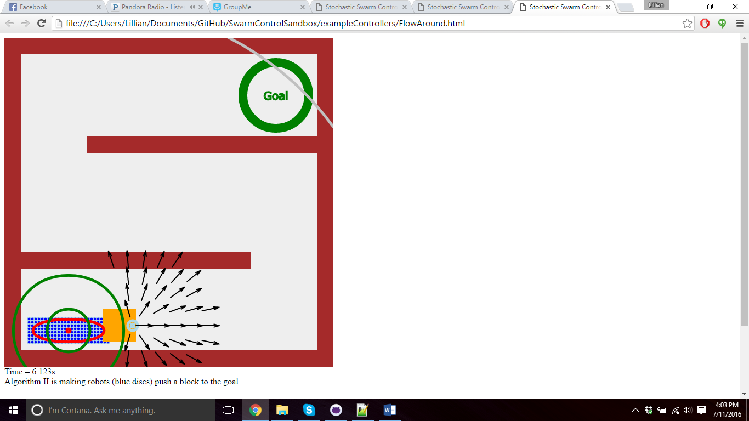

Figure 2 - Repulsive Forces

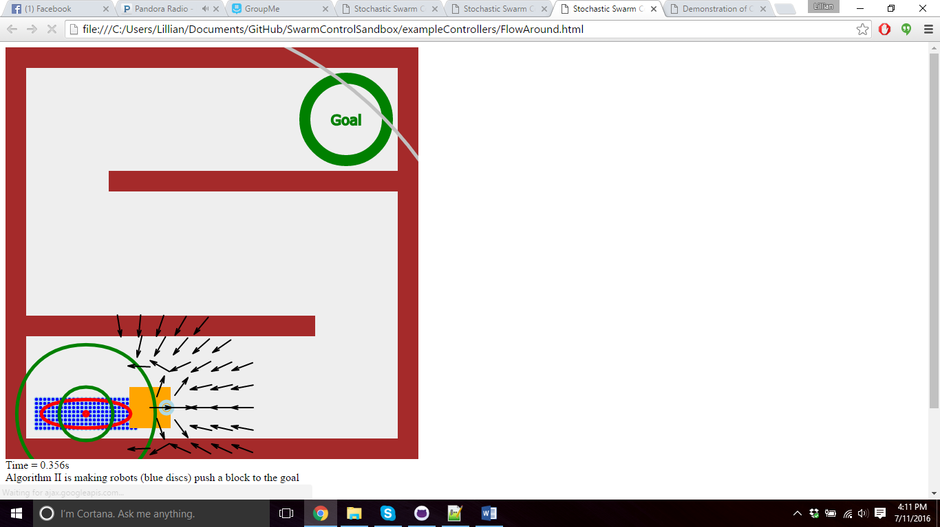

Figure 3 - Repulsive and Attractive Forces Combined

* 1. Project 2: <Pure Torque Experiment>
     1. Multiple Pure Torque Control expiraments successfully run
     2. *<Deliverable 4> New object w/ loop made (The 3D printer is working now? It seems like it intermittently has fits)*

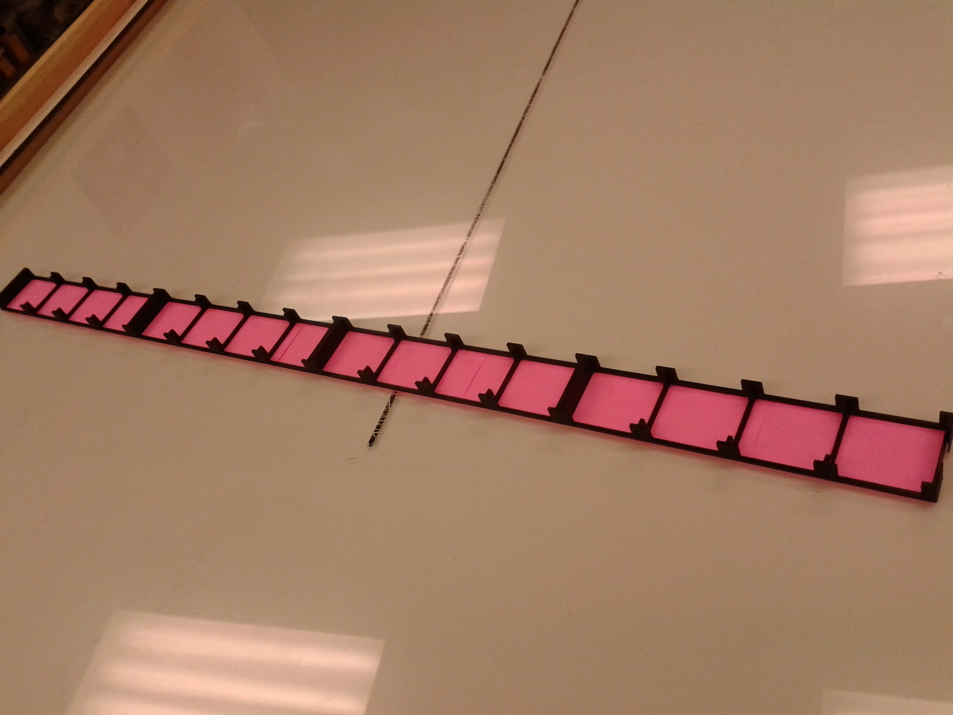

Figure 4 - New Torque Object (upside down)

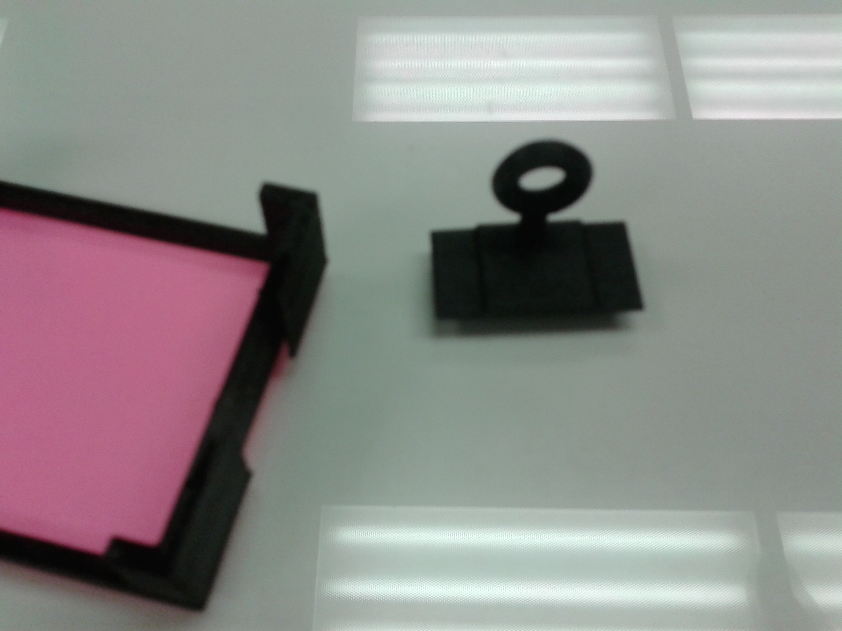

Figure 5 - Loop insert to Torque Object for Pure Torque Control

* 1. Project 3: <Orientation Control>
     1. Code started.
        1. Recognizes portion of goal angle and torque object is closer to the top
        2. Recognizes which side it should be pushing from depending on the mean position’s relative side to the object.
        3. *<Deliverable 5> Code as it stands can be found at SwarmControlSandbox\papers\Kilobots Code\OrientationControl*

1. **My *Goals* for next week**
   1. Finish Torque Control Experiments
   2. Finish Orientation Control Code to start experiments