Weekly reports are to be emailed to atbecker@uh.edu by 5:00pm on Tuesdays. The purpose of a weekly report is to: (1) give you text and images for your papers, thesis, and dissertation, (2) document progress, (3) identify if you are stuck or need resources.

Weekly report

1. **My *Goals* from last week**

* Make even more version 4 magnetic sliders, magnets just came in yesterday!
* Work with Arun on both of our demonstrations.

1. **My *Accomplishments* this week**
   1. Project 1: <More Magnetic Sliders!>

* No new files.
* After a lot of supergluing and many hours of sanding there are now a total of 38 magnetic sliders, 27 red and 11 blue. More can be made if needed, my fingers were just worn out.

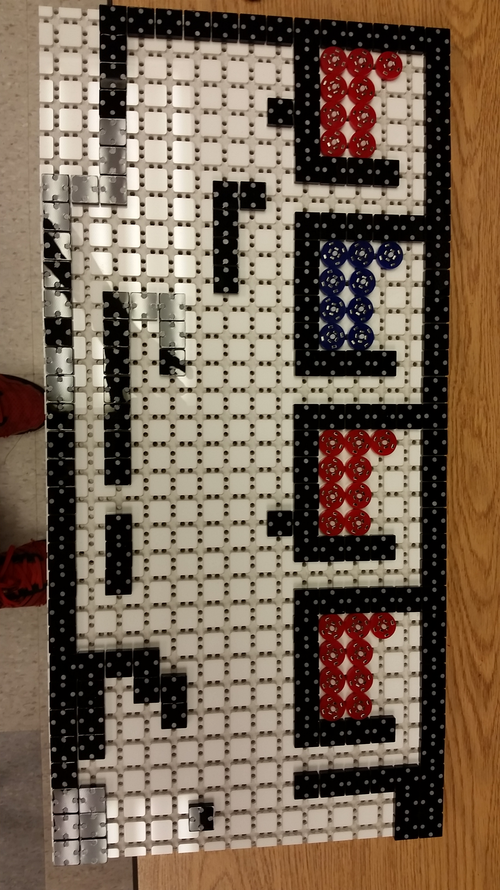

**Figure 1:** Tilt table with enough sliders to build 9 T-shaped parts.

* 1. Project 2: <Arun’s Discrete Motion Demo >
     + DWG file for a board to hold cylindrical magnets in place.

<https://github.com/aabecker/LaserCutter3DPrinter/blob/master/LaserCutter/Designs/Jarrett%20Lonsford/magnet%20board.dwg>

* + - In order to create discrete motion to model Arun’s algorithm we are going to be using my magnetic sliders on an 8x8 area of the tilt table and move a board filled with magnets against the bottom of the table. This will allow all the sliders to move uniformly at discrete intervals according to Arun’s algorithm. We made the magnetic board today and tomorrow we will begin on a couple of additional modifications to the existing tilt table layout so that the demo runs as smooth as possible. These modifications will be a clear piece of acrylic over the top of the workspace to keep the sliders from jumping out or on top of each other due to the magnetic forces. There will also be new stop blocks made so that when a slider is against a wall it cannot move parallel to the wall but only away from the wall.

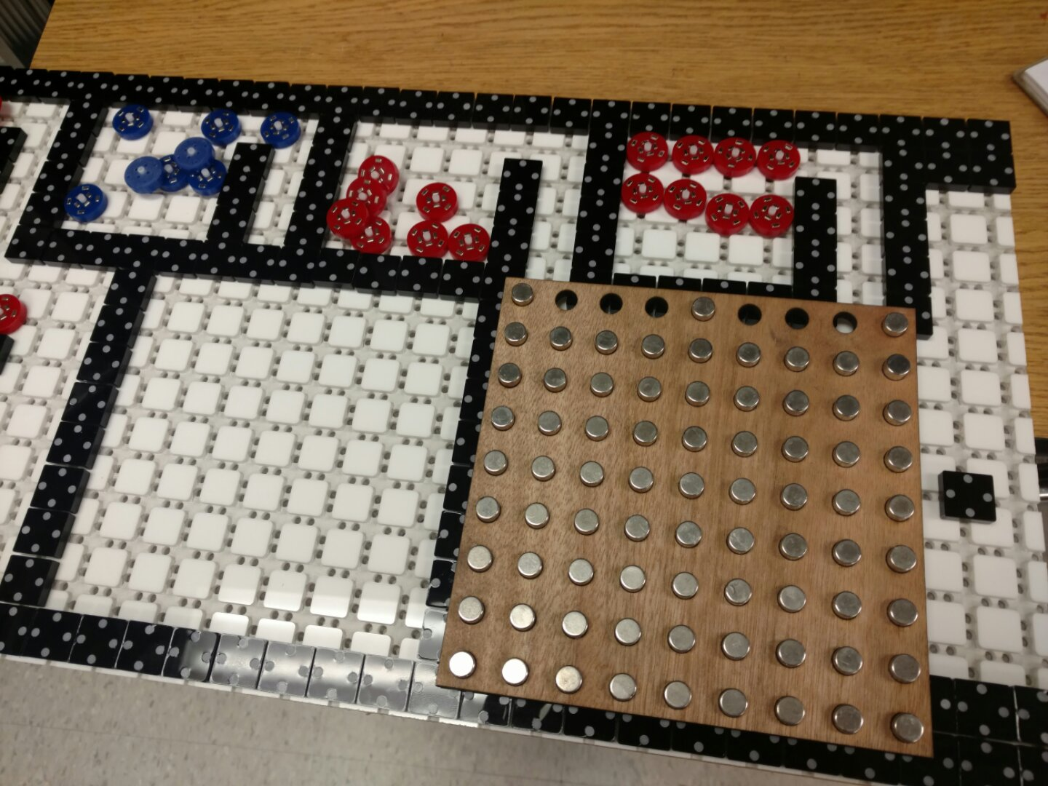

**Figure 2:** 8x8 workspace and magnet holding board that will be used for the discrete movement demo.

1. **My *Goals* for next week**

* Complete the modifications for the discrete motion demo and make a video for it.
* Make videos for the parts bin and some of the logic gates.

1. **What I need Dr. Becker to do:**
   1. Do we have a rubber mallet? If not could we purchase one please?

Time Sheet: (Zoom in to read)

