Weekly report

1. **My *Goals* from last week**

* New design will be all around smaller, with smaller gears and a smaller housing that I hope to design with an so that it will work with the hex copter

1. **My *Accomplishments* this week**
   1. Project 1: Smart Dart Deployer
   * Version two of the Smart Dart deployment mechanism has been designed, and manufactured. This version is a lot more compact, as it was designed to fit under the hex copter. This version was designed around a new, smaller servomotor. Lots of testing for slot fitting, screw holes, and servo-teeth fitting was performed in order to design more robustly. This mechanism can be seen in Fig.1.
   * The mechanism has been tested, and works great. The servo works this time.
   * Learned a lot about servomotors. I found lots of open source CAD files of the more popular servomotors (for the purpose of designing around them), and then chose one that I thought would take up the least space, have a low weight, and yet be powerful enough to push four darts through the mechanism. Then I ordered four of these for the price of two.
   * Met with Dr. Rob and his gang and discussed the future of the project.

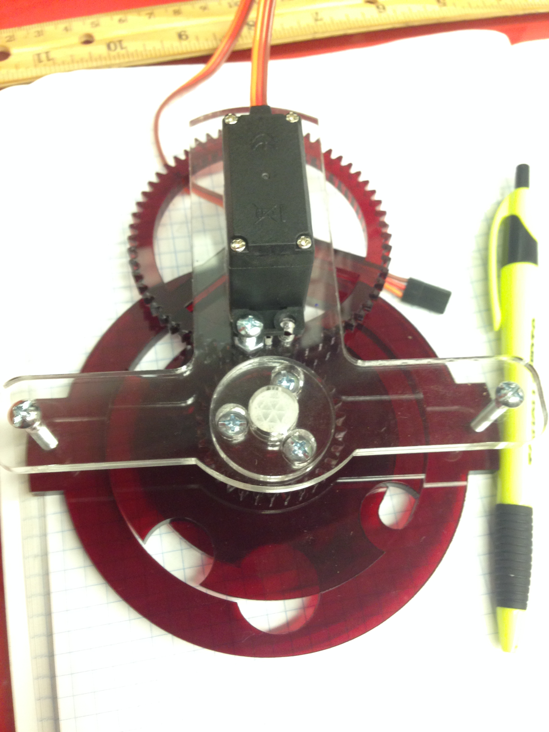

**Figure 1:** Smaller, more compact version of the Smart Dart deployment mechanism. It has been tested, and is performing just how it was designed to.

**My *Goals* for next week**

* Further design the Smart Dart Deployment mechanism to be attached to the hex-copter.