Weekly report

1. **My *Goals* from last week**

* Further design the Smart Dart deployment mechanism to be attached to the hexacopter

1. **My *Accomplishments* this week**
2. Project 1: Smart Dart Deployment Mechanism
   * The Smart Dart deployment mechanism was successfully attached to the hexacopter, capable of holding at least one real dart, and three dummy-darts so far. I was designing an attachment part that would be made of acrylic, but to get results faster, I figured out a way to just Velcro on the deployment mechanism. The mechanism attached to the hexacopter can be seen in Figure 1.
   * I made rudimentary a landing/takeoff base for the hexacopter that serves as a support for the hexacopter to take off from while the darts are loaded into the mechanism—it basically just has a giant hole in it. This was needed because the hexacopter cannot sit on the ground with long darts attached underneath it. The dart-loaded hexacopter on the landing/takeoff base can be seen in Figure 2.
   * The team performed an awesome flying drop test experiment on the current setup in Figure 2. Basically, everything worked out pretty well, but getting the dart to penetrate vertically was a bit difficult. We think this has to do with the added swing given to it by the rotating deployment mechanism when it rotates the dart out of the slot. *This could be a reason to implement the other dropping mechanism design—the one that is a direct release actuated by a cam, rather than the current one that works by swinging the dart out of the slot.*

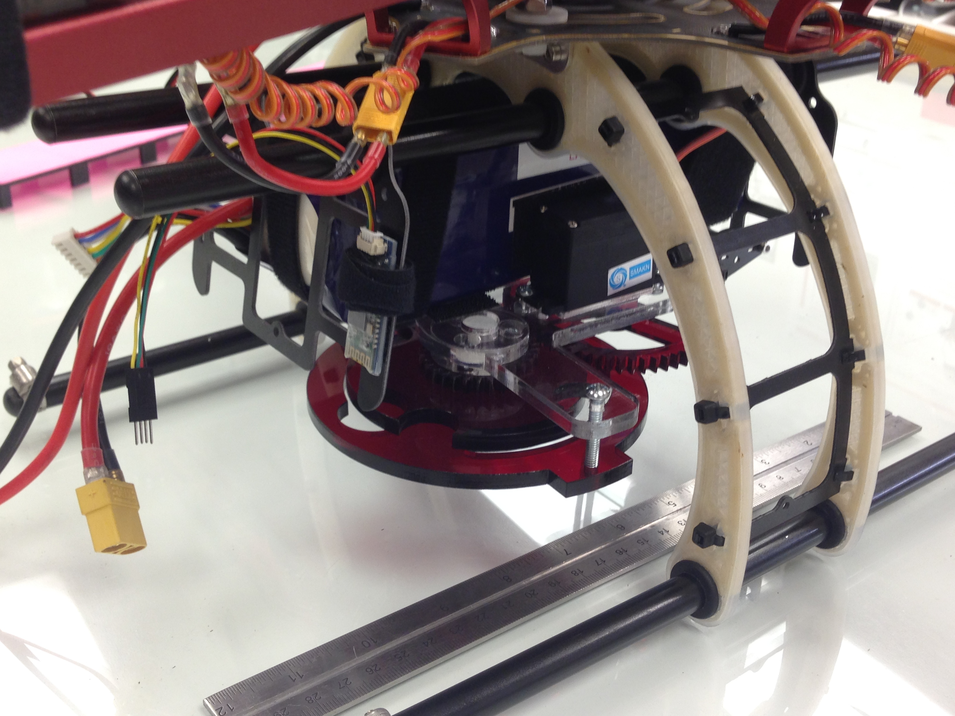 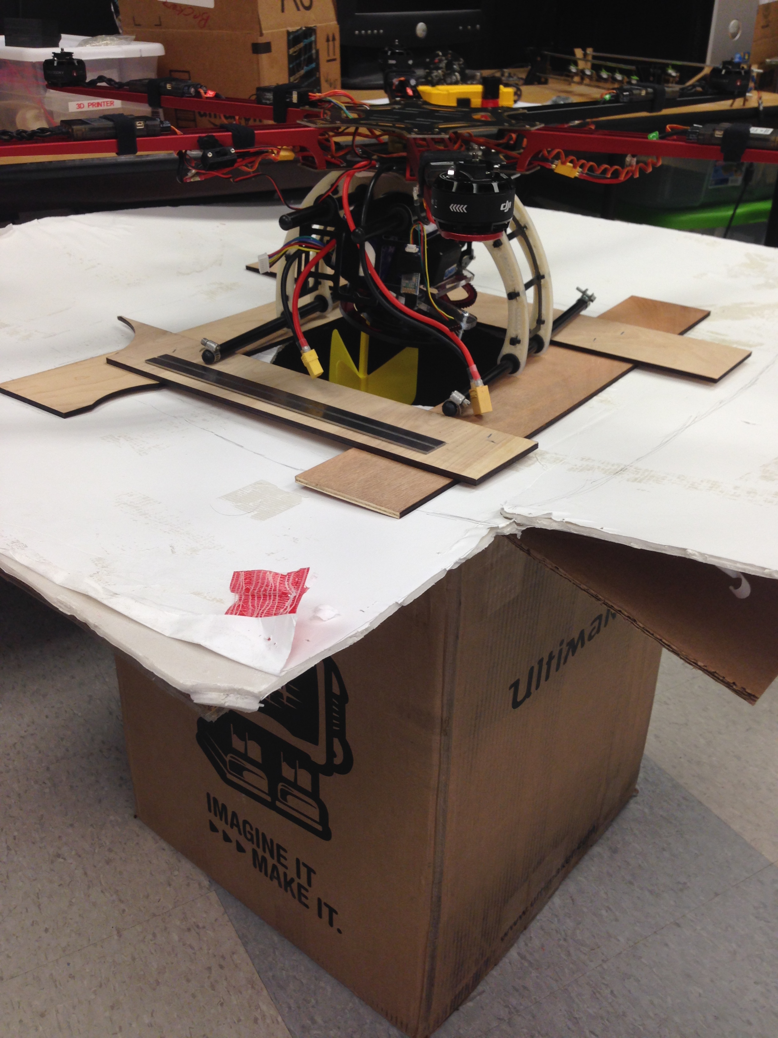

**Figure 1 (Left Image):** Deployment mechanism “Velcro’d” onto the hexacopter**.**

**Figure 2 (Right Image):** Dart-loaded hexacopter resting on custom landing/takeoff

base, made entirely of recycled materials.

**My *Goals* for next week**

* Working on the 6 deliverables that were recently requested.
* Figuring out the bent fin vs. straight fin situation.