Weekly report

**My *Goals* from last week**

* Working on the 6 deliverables that were recently requested.
* Figuring out the bent fin vs. straight fin situation.

**My *Accomplishments* this week**

Project 1: Smart Dart / Dart Deployment

* Straight fin vs. Bent fin experiment was performed. Although the Photons were giving us so much trouble, a couple of bent-finned Smart Darts were manufactured. With the help of Dr. Becker, a drop test experiment was performed to try and determine which Dart landed the most vertical in the soil. Unfortunately, there wasn’t as much of a difference as we expected.
* The Smart Dart was updated to include positive and negative holes to feed the geophone sensor outputs through to read data from. This new dart with the signal wire sticking out can be seen in Figure 1.

Project 2: Arun’s Algorithm Experiment

* Although I do not fully understand Arun’s experiment, he needed some extra function on his marbles moving under the influence of magnetic force. Basically, they were behaving a bit chaotic to what he wanted (they were behaving naturally) and so I made a little part to keep his marbles in and now they’re a bit more stable and keep a good distance from each other. These can be seen in Figure 2.

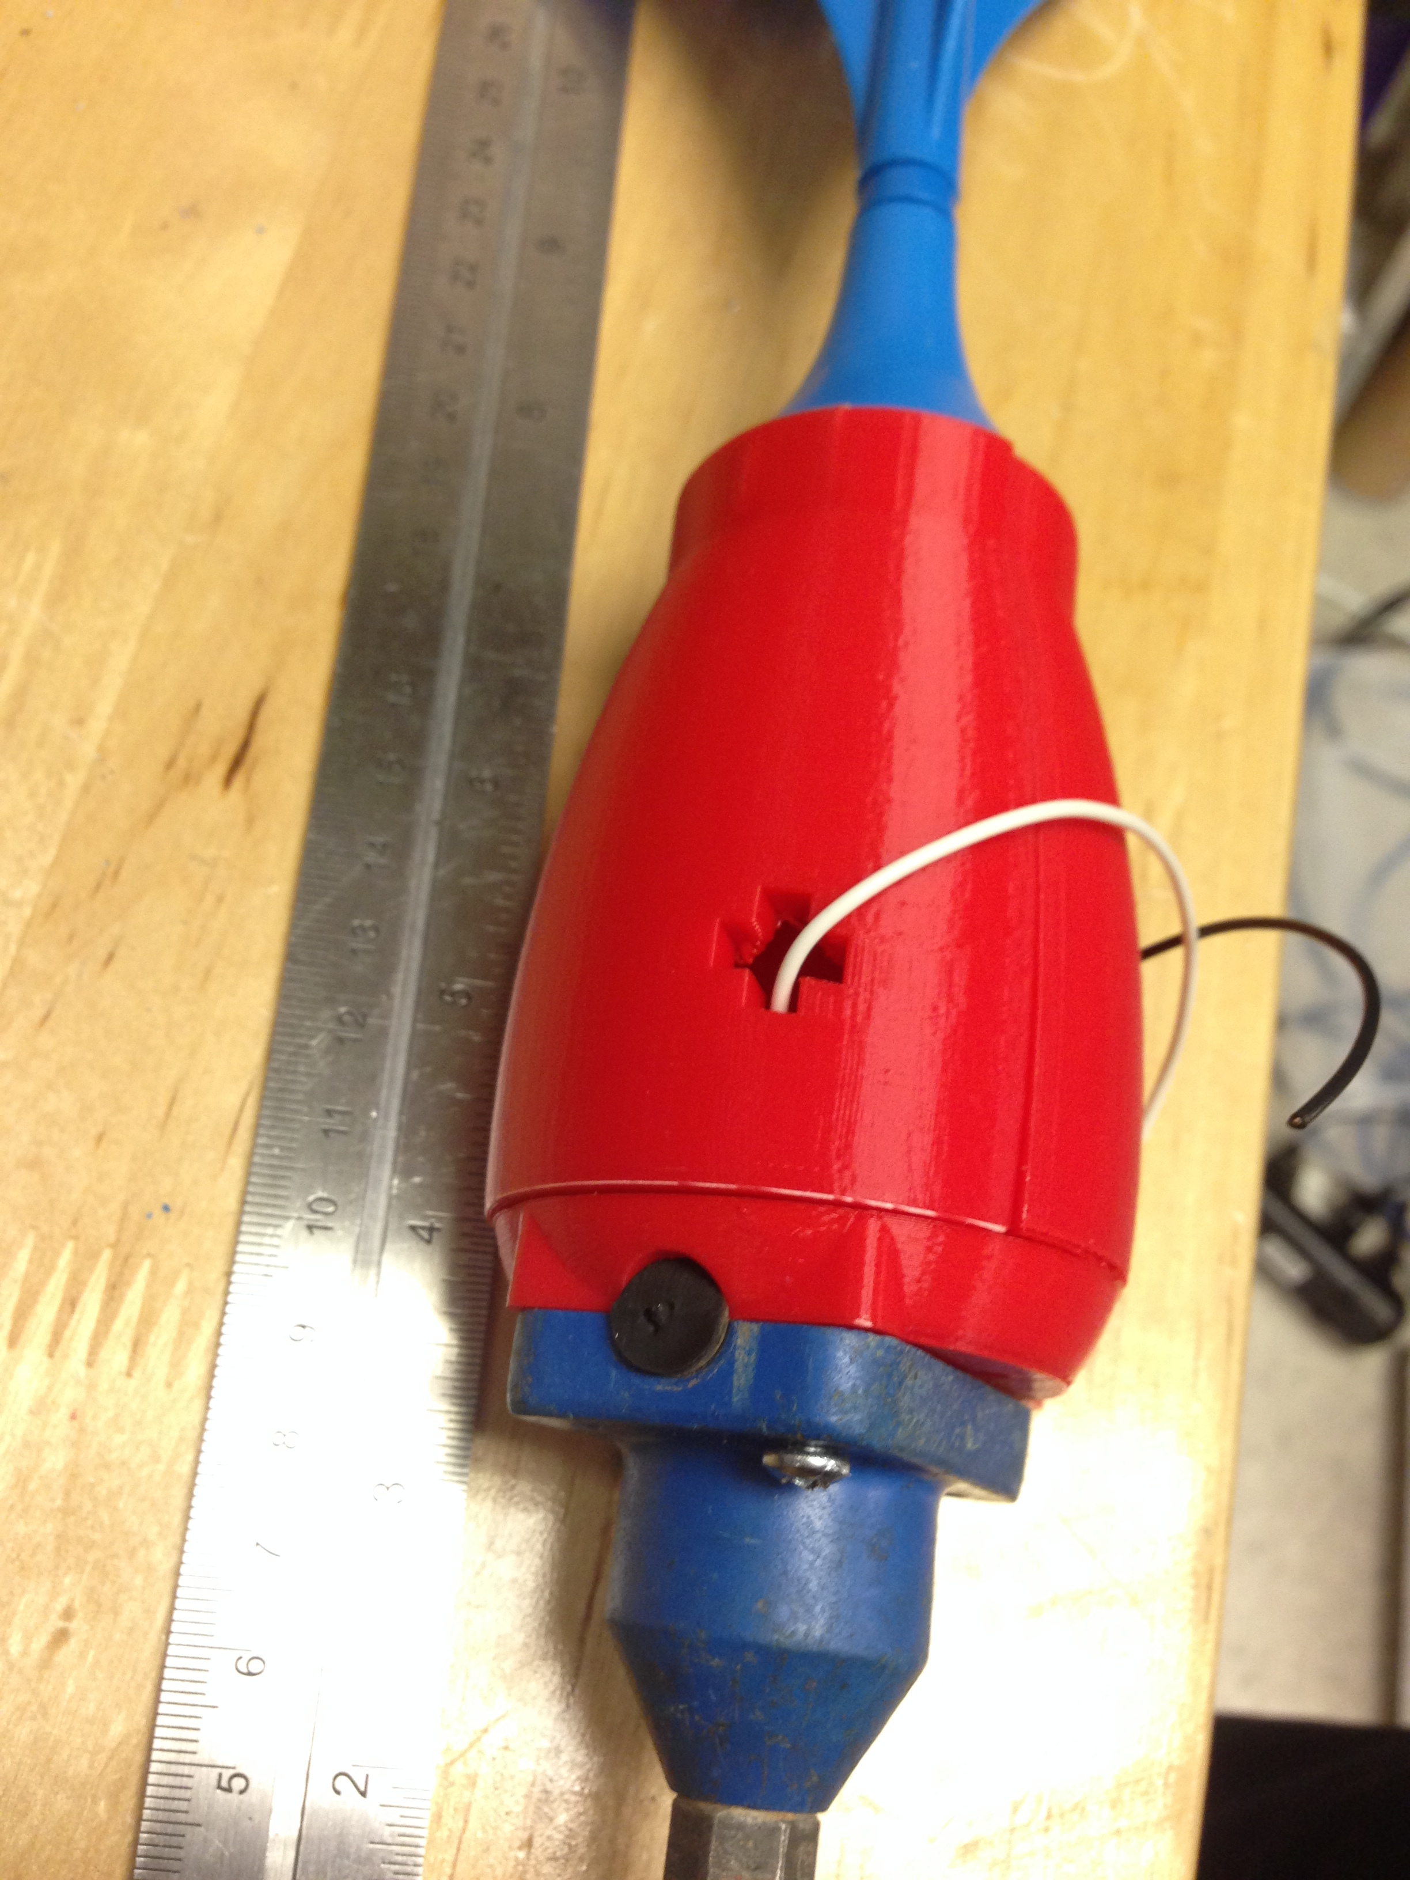 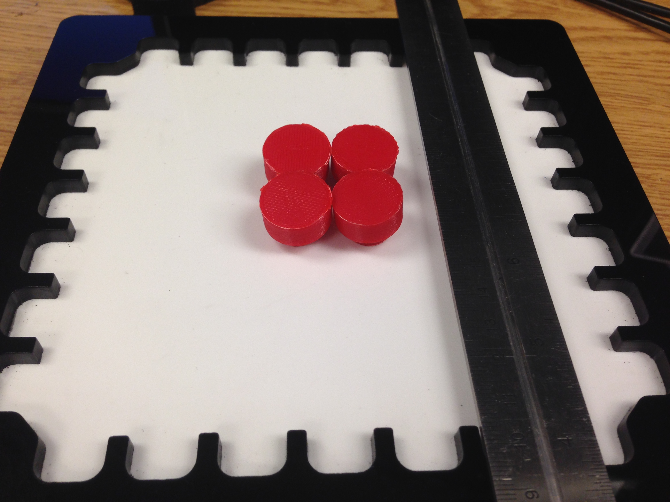

**Figure 1.** Updated Smart Dart with **Figure 2.** Arun’s Experiment setup with

shaped holes cut for the geophone new parts surrounding his metal marbles

wires to feed through. to provide more stability during motion.

**My *Goals* for next week**

* Get a loop hooked up to the Smart Dart for retrieval
* Manufacture enough of these darts to start seismic testing experiments