Weekly reports are to be emailed to atbecker@uh.edu by 5:00pm on Tuesdays. The purpose of a weekly report is to: (1) give you text and images for your papers, thesis, and dissertation, (2) document progress, (3) identify if you are stuck or need resources.

Weekly report

1. **My *Goals* from last week**

* Complete the video for the carry function.
* Make video for the simple counter.
* Determine what my most interesting design is and make a parts list and instructions for it.

1. **My *Accomplishments* this week**
   1. Project 1: <Tilt Table Videos>

* Link to MP4 files on Github.

<https://github.com/aabecker/particleComputation/tree/master/Videos>

* I completed all the videos for all 16 different experiments done in the papers, including the caterpillar or worm matrix permutation. Each video was cropped to limit the amount of background in the video, each has had all audio removed and each was trimmed to keep only the desired parts. Only a few videos were sped up and those that are have a small bit of text displaying the speed increase. Each video was edited with Wondershare Filmora and saved as an MP4.

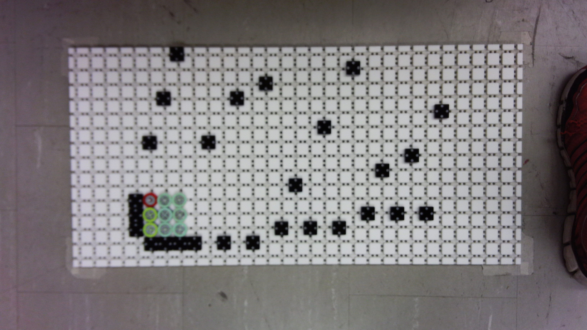

**Figure 1:** Worm Matrix Permutation set up on the large Tilt Table.

* 1. Project 2: Upload Designs to Thingiverse
* I have uploaded each of my final designs to the Robot Swarm Control Lab Thingiverse account and included a brief summary and a longer description of all the necessary parts and tools needed for assembly of each thing and the purpose of each file. I also added nicer pictures of all the parts laid out together.

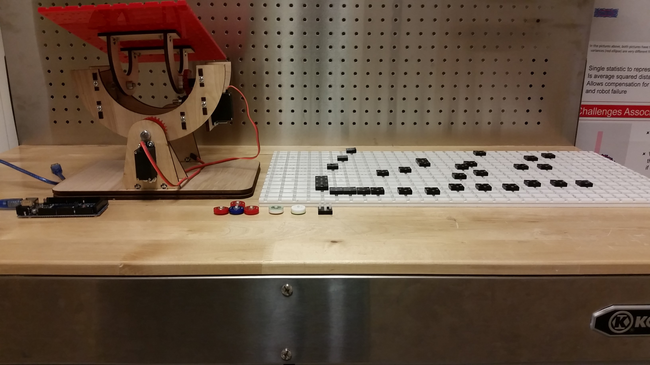

**Figure 2:** Picture of both Tilt Tables, sliders and stop blocks laid out.

1. **My *Goals* for next week**

* Complete any other small things Dr. Becker needs from me.

1. **What I need Dr. Becker to do:**

Time Sheet: (Zoom in to read)

