Weekly reports are to be emailed to atbecker@uh.edu by 5:00pm on Tuesdays. The purpose of a weekly report is to: (1) give you text and images for your papers, thesis, and dissertation, (2) document progress, (3) identify if you are stuck or need resources.

Weekly report

1. **My *Goals* from last week**
   * Build new SMT platform with open build materials for 1m and 4m
   * Record 1m pulse train experiment video
   * Take photos of new platform
   * Start writing draft of paper
   * Complete TA work
2. **My *Accomplishments* this week**

* Scored work sheet1 and 2, communicated with student who had confuse or submit wrong file by mistakes.
* Complete 1m experiment platform and take photos for setup

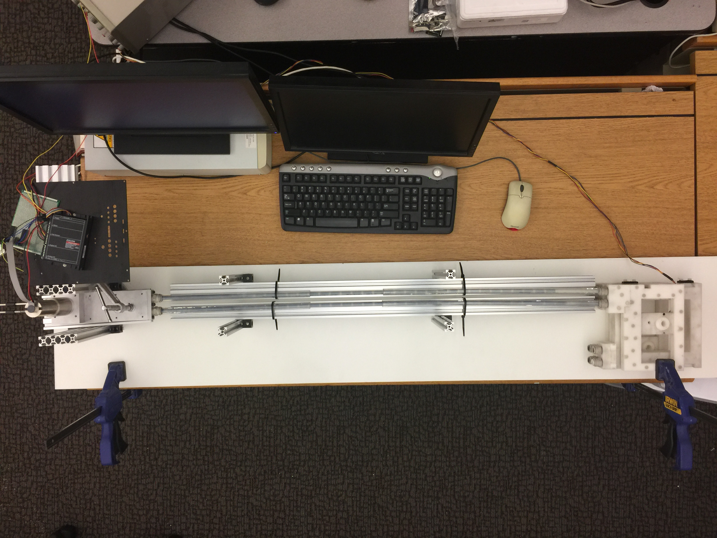

* Record 1m pulse train video
* Complete 4m set up frame, we can not finish because the nylon tubing doesn’t fit with acrylic conduits, we are waiting for lubricant and new conduits.
* Complete abstract and experiment setup(plan)

1. **My *Goals* for next week**

* Continue writing draft
* Complete 4m mimic MRI environment experiment
* Complete TA work

1. **What I need Dr. Becker to do:**
   1. Please send me the course homework and worksheet answer