Weekly reports are to be emailed to atbecker@uh.edu by 5:00pm on Tuesdays. The purpose of a weekly report is to: (1) give you text and images for your papers, thesis, and dissertation, (2) document progress, (3) identify if you are stuck or need resources.

Weekly report

1. **My *Goals* from last week**

* Meet with Sheryl
* Get better acquainted with Gauss Guns

1. **My *Accomplishments* this week**
   1. Project 1: Met with Sheryl / Began working on ideas for paper

* I met with Sheryl to discuss her paper and began forming ideas for what I can add to make the physical model more relevant.
  1. Project 2: Getting acquainted with Gauss Guns
     + I took a few of Javier’s Gauss gun sets and experimented with them to see how changing the number of balls on one end of the magnet affected the velocity of the launched ball as well as how the number of stages affected the velocity of the ball. What I found was that some of the Gauss gun sets are difficult to assemble and that three balls starting on one side of the magnet gives the best launch velocity. I also found that after around three or four stages the velocity does not increase by a noticeable amount.

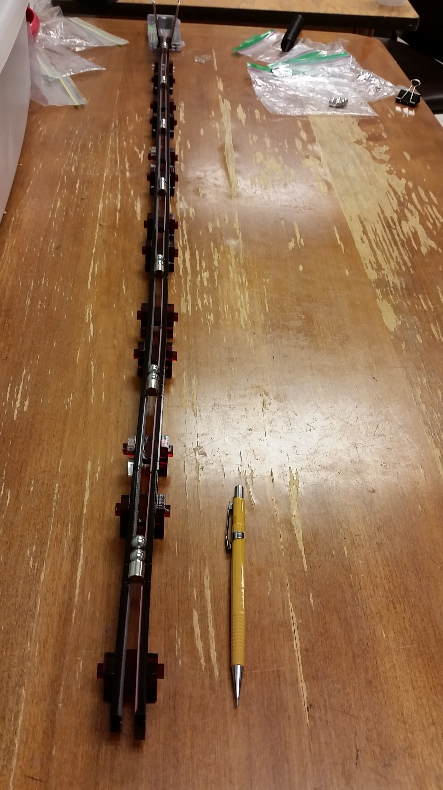

**Figure 1:** Operational Seven Stage Gauss Gun

1. **My *Goals* for next week**

* Complete first draft of contribution to Sheryl’s particle assembly paper.
* Complete several tests to determine the magnetic, gravitational and frictional forces involved in the physical particle assembly demo.
* Begin working on second draft of particle assembly contribution.

1. **What I need Dr. Becker to do:**
   1. Email me the underwater robot NSF funding application so that our capstone team has a complete image of the full scope of the project and so we can share this with our professor.