Weekly report

1. **My *Goals* from last week**
   * Objective 1: Test the tilting frame with salt
   * Objective 2: Make a scalloped surface for the tilting frame and test using the lead balls
2. **My *Accomplishments* this week**
   1. Objective 1: The salt was not heavy enough to make the bar rotate. Figure 1 shows the frame with the salt
   2. Objective 2: The bar with a scalloped surface is better to hold the lead balls. Had to play a bit with the spacing so that the balls would actually stack up. Unfortunately, the bar didn’t rotate when the magnets were removed. Figure 2 shows the frame with the balls

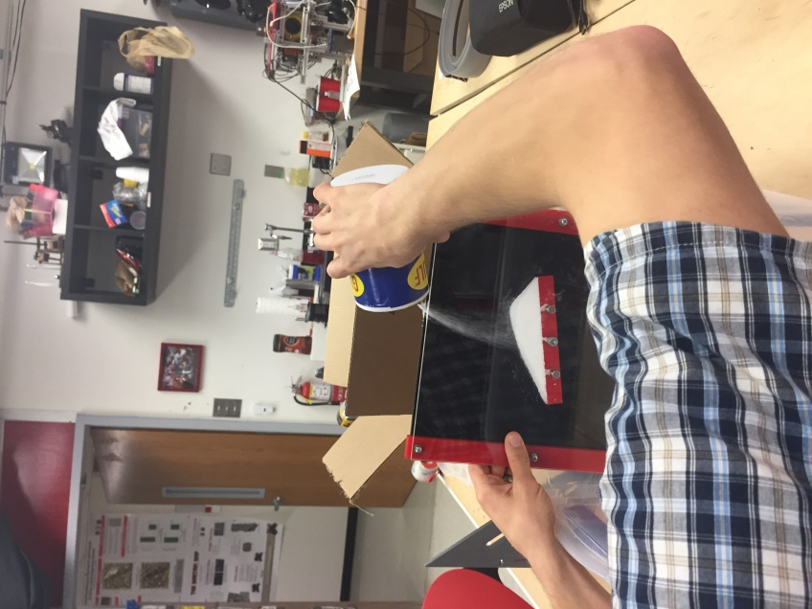 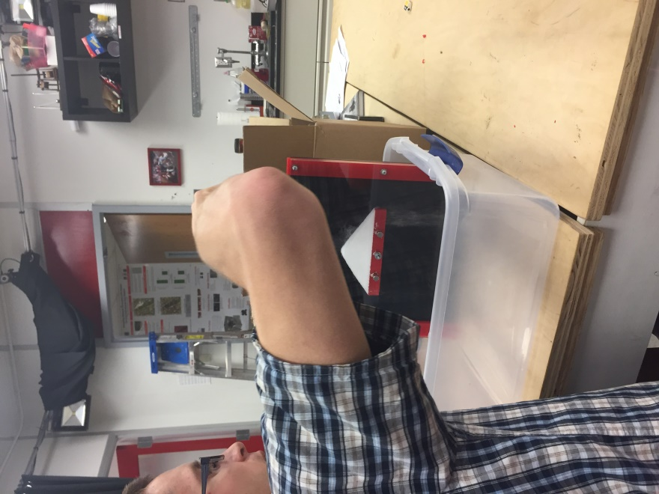

**Figure 1.** Testing the tilting frame with salt ft. Dr. Becker.

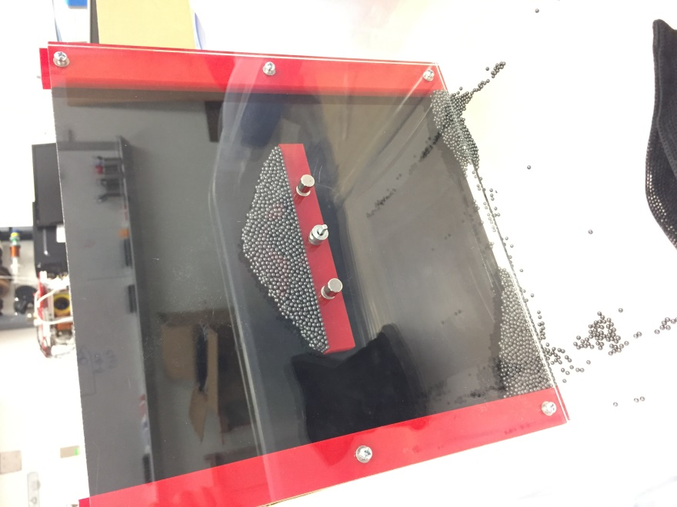

**Figure 2.** Tilting frame with lead balls.

1. **My *Goals* for next week**
   * Tilting frame

* Try out using bearings to help the bar rotate easier. Maybe test the frame with other particles, like heavy sand

1. **What I need Dr. Becker to do:**
   * Update me on the demonstrations the lab plans to do for Mars Rover