Weekly report

1. **My *Goals* from last week**
   1. Read through IROS 2017 draft - change image 1 and add algorithm in latex
   2. Implement coverage and produce plot of moves vs number of robots after doing multiple runs.
   3. Make robots circular shaped.
   4. Find equation for ci , this allows us to use the probability formula to find the maximum gap for 1 D coverage/ mapping as in (1)
2. **My *Accomplishments* this week**
   1. Code for coverage implemented.

The algorithm has been uploaded in the git repository: [**MagneticController**](https://github.com/aabecker/MagneticController)/[MassiveUniformControl](https://github.com/aabecker/MagneticController/tree/master/MassiveUniformControl)/[AggregateCodeArun](https://github.com/aabecker/MagneticController/tree/master/MassiveUniformControl/AggregateCodeArun)/**bluedijkstra_coverage.m**

Here is a link to the video showing the coverage at work:

<https://drive.google.com/open?id=0BxdfmdmLImhFaFBHWGl6ZV9JeXc>

* 1. For the robots to appear as discs, a function drawcirc() was made. The code has been commented accordingly.
  2. The equation for ci has been analytically derived using the description in 1.

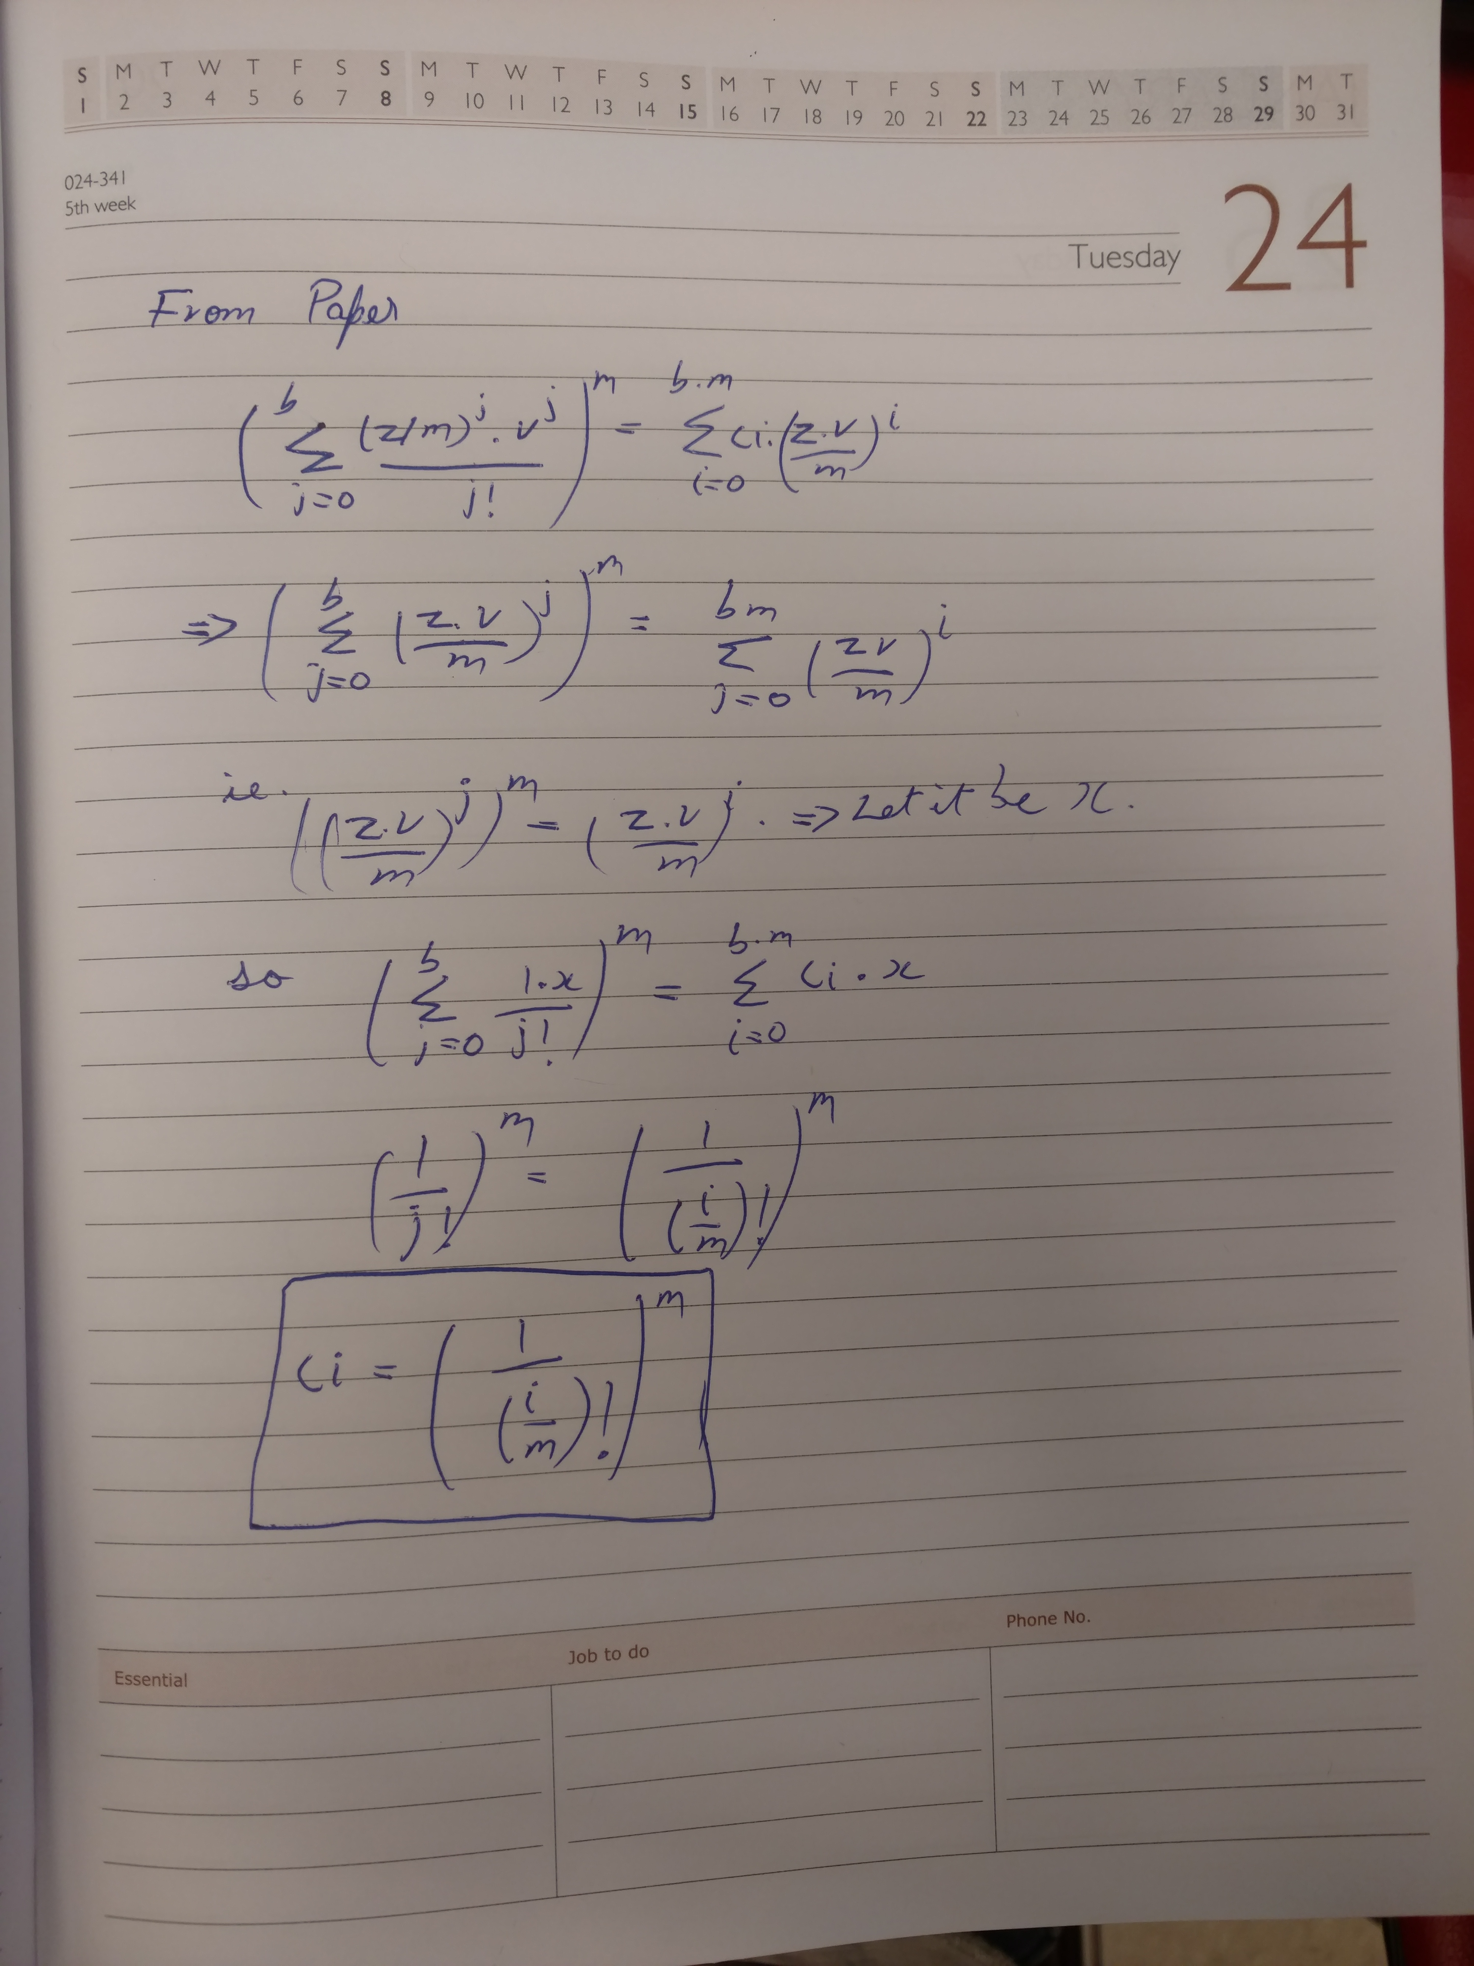

I am yet to implement this in the Mathematica demonstration.

* 1. The Maxwell computer registration form has been submitted. In the meantime, I am running the plot for 100 iterations of n=200:400:5400. The data is also being saved for future reference.
  2. Fig.1 in paper has been updated. The robots are now discs.

1. **My *Goals* for next week**
   1. Write the algorithm in latex.
   2. Write inferences for plot and update paper.
   3. Give update on related work.
   4. Mail Dominik and determine what algorithms are suitable for this paper.
   5. Make 2D laser print for mazes and start recording for manual implementation.
2. **Needed from Dr Becker**
   1. Need meeting to decide sections of paper, proofs for heuristics and analysis.
   2. Need LOR ASAP. Application closing date is Feb 1st. Also, any update on the employment authorization from the university?

Gonnet, Gaston H. "Expected length of the longest probe sequence in hash code searching." *Journal of the ACM (JACM)* 28.2 (1981): 289-304.