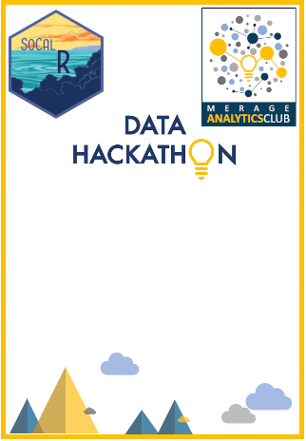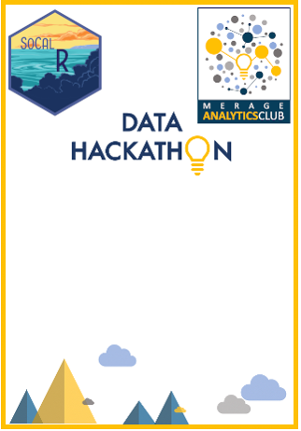

**Participant**

**Participant**

**Participant**

**Participant**

**Participant**

**Participant**

**Participant**

**Participant**

**2022-04**

**2022-04**

**2022-04**

**2022-04**

**2022-04**

**2022-04**

**2022-04**

**2022-04**

**<NAME>**

**<NAME>**

**<NAME>**

**<NAME>**

**<NAME>**

**<NAME>**

**<NAME>**

**<NAME>**



**Participant**

**Participant**

**Participant**

**Participant**

**Participant**

**Participant**

**Participant**

**Participant**

**2022-04**

**2022-04**

**2022-04**

**2022-04**

**2022-04**

**2022-04**

**2022-04**

**2022-04**

**<NAME>**

**<NAME>**

**<NAME>**

**<NAME>**

**<NAME>**

**<NAME>**

**<NAME>**

**<NAME>**



**Participant**

**Participant**

**Participant**

**Participant**

**Participant**

**Participant**

**Participant**

**Participant**

**2022-04**

**2022-04**

**2022-04**

**2022-04**

**2022-04**

**2022-04**

**2022-04**

**2022-04**

**<NAME>**

**<NAME>**

**<NAME>**

**<NAME>**

**<NAME>**

**<NAME>**

**<NAME>**

**<NAME>**



**Participant**

**Participant**

**Participant**

**Participant**

**Participant**

**Participant**

**Participant**

**Participant**

**2022-04**

**2022-04**

**2022-04**

**2022-04**

**2022-04**

**2022-04**

**2022-04**

**2022-04**

**<NAME>**

**<NAME>**

**<NAME>**

**<NAME>**

**<NAME>**

**<NAME>**

**<NAME>**

**<NAME>**



**Participant**

**Participant**

**Participant**

**Participant**

**Participant**

**Participant**

**Participant**

**Participant**

**2022-04**

**2022-04**

**2022-04**

**2022-04**

**2022-04**

**2022-04**

**2022-04**

**2022-04**

**<NAME>**

**<NAME>**

**<NAME>**

**<NAME>**

**<NAME>**

**<NAME>**

**<NAME>**

**<NAME>**



**Participant**

**Participant**

**Participant**

**Participant**

**Participant**

**Participant**

**Participant**

**Participant**

**2022-04**

**2022-04**

**2022-04**

**2022-04**

**2022-04**

**2022-04**

**2022-04**

**2022-04**

**<NAME>**

**<NAME>**

**<NAME>**

**<NAME>**

**<NAME>**

**<NAME>**

**<NAME>**

**<NAME>**



**Participant**

**Participant**

**Participant**

**Participant**

**Participant**

**Participant**

**Participant**

**Participant**

**2022-04**

**2022-04**

**2022-04**

**2022-04**

**2022-04**

**2022-04**

**2022-04**

**2022-04**

**<NAME>**

**<NAME>**

**<NAME>**

**<NAME>**

**<NAME>**

**<NAME>**

**<NAME>**

**<NAME>**

  


**Participant**

**Participant**

**Participant**

**Participant**

**Participant**

**Participant**

**Participant**

**Participant**

**2022-04**

**2022-04**

**2022-04**

**2022-04**

**2022-04**

**2022-04**

**2022-04**

**2022-04**

**<NAME>**

**<NAME>**

**<NAME>**

**<NAME>**

**<NAME>**

**<NAME>**

**<NAME>**

**<NAME>**

**CAREY HUH**

Participant

**Participant**

**Participant**

**Participant**

**Participant**

**2022-04**

**2022-04**

**2022-04**

**2022-04**

**<NAME>**

**<NAME>**

**<NAME>**

**<NAME>**

**Participant**

**Participant**

**Participant**

**Participant**

**2022-04**

**2022-04**

**2022-04**

**2022-04**

**<NAME>**

**<NAME>**

**<NAME>**

**<NAME>**