Hole cards

North East- Y1 100, Y2 200, X1 590, X2 750

0.17Y2, 0.34Y2, 0.74X2, 0.94X2

South East

X1 590, X2 750, Y1 250, Y2, 300

0.74X2, 0.94X2, 0.43Y2, 0.51Y2

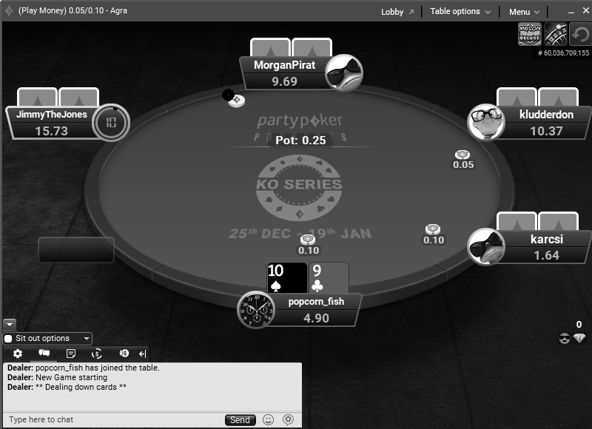

(308,128)

(584,164)

(486,359)

(186,289)

(602,289)

(201,164)

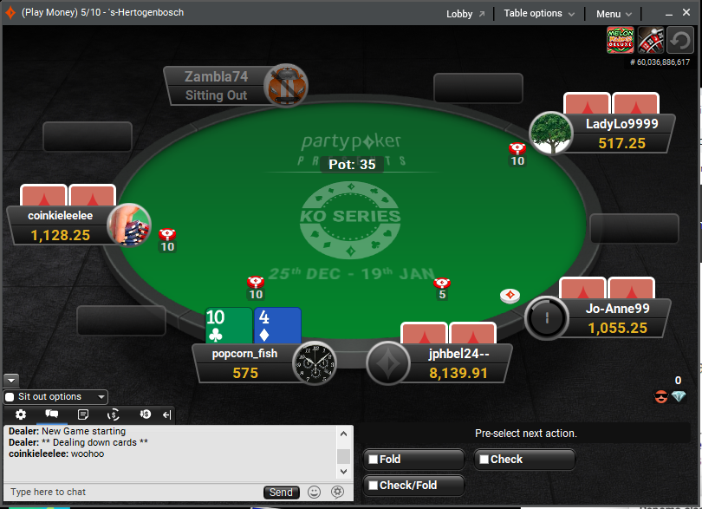

P

9

8

7

6

5

4

3

2

1