**PEROCHE, JOHN MARK 11/07/2023**

**TORREDA, KURT DENVER** BSCS 3-3

**F2F SEATWORK**

**COMP 20133 – APPLICATIONS DEVELOPMENT AND EMERGING TECHNOLOGIES**

**SEATWORK 1:(ALREADY CHECKED ON F2F)**

Package: java fundamentals

**Main.java**

package javafundamentals;

public class Main {

public static void main(String[] args) {

SavingsAccount s = new SavingsAccount(123,"Kurt",5000);

CheckingAccount c = new CheckingAccount(12345,"John Mark",100000);

s.display();

c.display();

s.deposit(150);

s.display();

c.withdraw(20500);

c.display();

}

}

**BankAccount.java**

package javafundamentals;

public class BankAccount {

public int accountNumber;

public String accountName;

public String accountType;

public int initialBalance;

public BankAccount(int accountNumber, String accountName, int initialBalance) {

this.accountNumber = accountNumber;

this.accountName = accountName;

this.initialBalance = initialBalance;

};

public int deposit(int cash) {

return initialBalance += cash;

};

public int withdraw(int cash) {

return initialBalance += cash;

};

}

SavingsAccount.java

package javafundamentals;

public class SavingsAccount extends BankAccount{

SavingsAccount(int accountNumber, String accountName, int initialBalance){

super(accountNumber, accountName,initialBalance);

};

void display() {

System.***out***.println("Account Number = " + accountNumber);

System.***out***.println("Account Name = " + accountName);

System.***out***.println("Account Number = Savings Account");

System.***out***.println("Initial Balance = " + initialBalance + "\n");

};

};

CheckingAccount.java

package javafundamentals;

public class CheckingAccount extends BankAccount{

CheckingAccount(int accountNumber, String accountName, int initialBalance){

super(accountNumber, accountName,initialBalance);

};

void display() {

System.***out***.println("Account Number = " + accountNumber);

System.***out***.println("Account Name = " + accountName);

System.***out***.println("Account Number = Checking Account");

System.***out***.println("Initial Balance = " + initialBalance + "\n");

};

}

OUTPUT

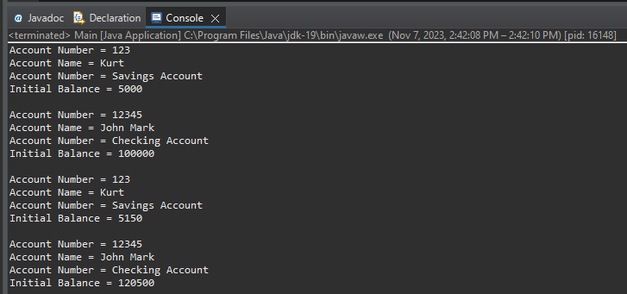

**SEATWORK 2**

Goal: Add class within package that access deposit and Withdraw remove all public identifier