Screenshot Documentation
GroupProject_01 — Indianapolis Colts 2026 Season Manager
CSC-151 — Module 2 Group Project
Sarah Ayres — Main GUI/Menu
This document contains screenshots of my individually authored code (MainMenu.java, Player.java, PlayersGUI.java) as committed to the group's shared GitHub repository, followed by screenshots of the completed application running locally, demonstrating that the Main GUI/Menu correctly launches and navigates between the Coaches, Players, and Support Staff sections built by my teammates.

Part 1 — Source Code (GitHub Repository)

MainMenu.java
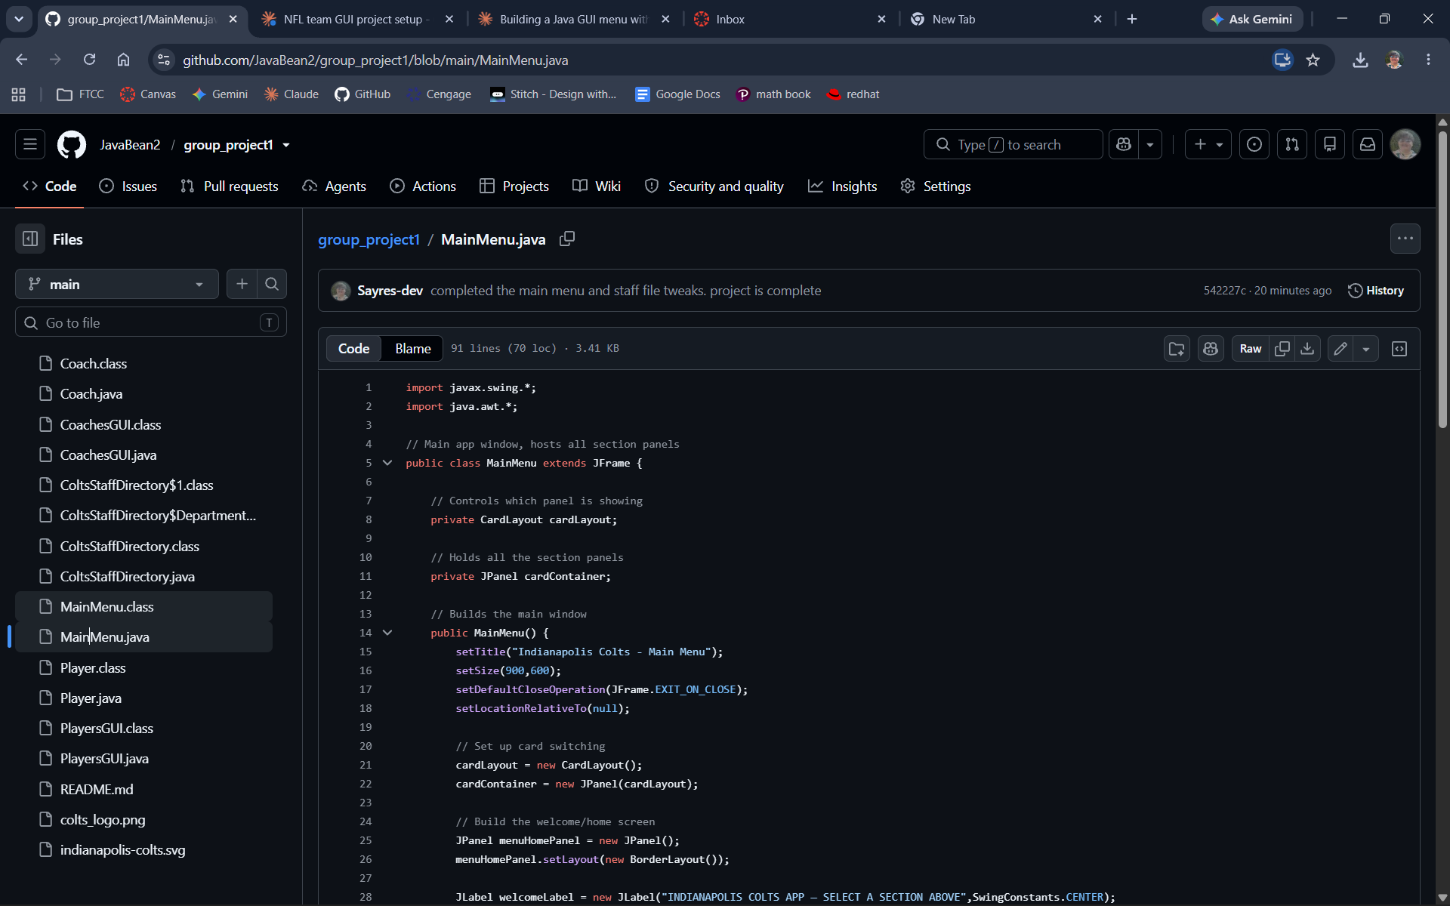
MainMenu.java, lines 1–28 — imports, class declaration, fields, and the start of the constructor.
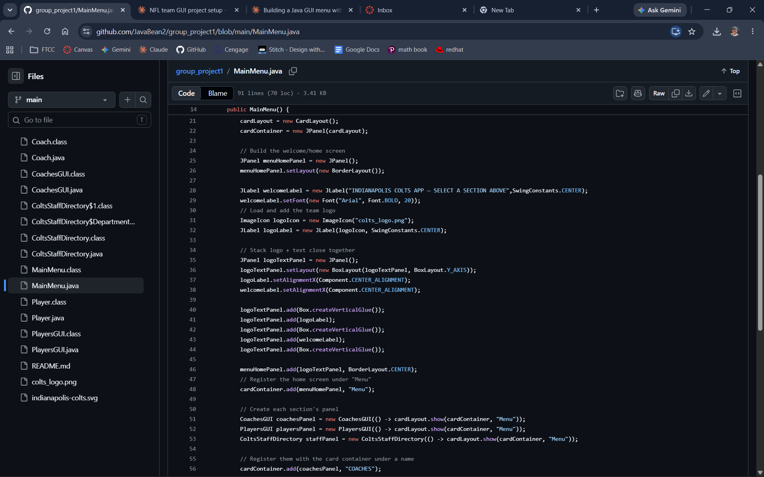
MainMenu.java, lines 14–56 — card layout setup, the welcome/home screen, and the team logo.
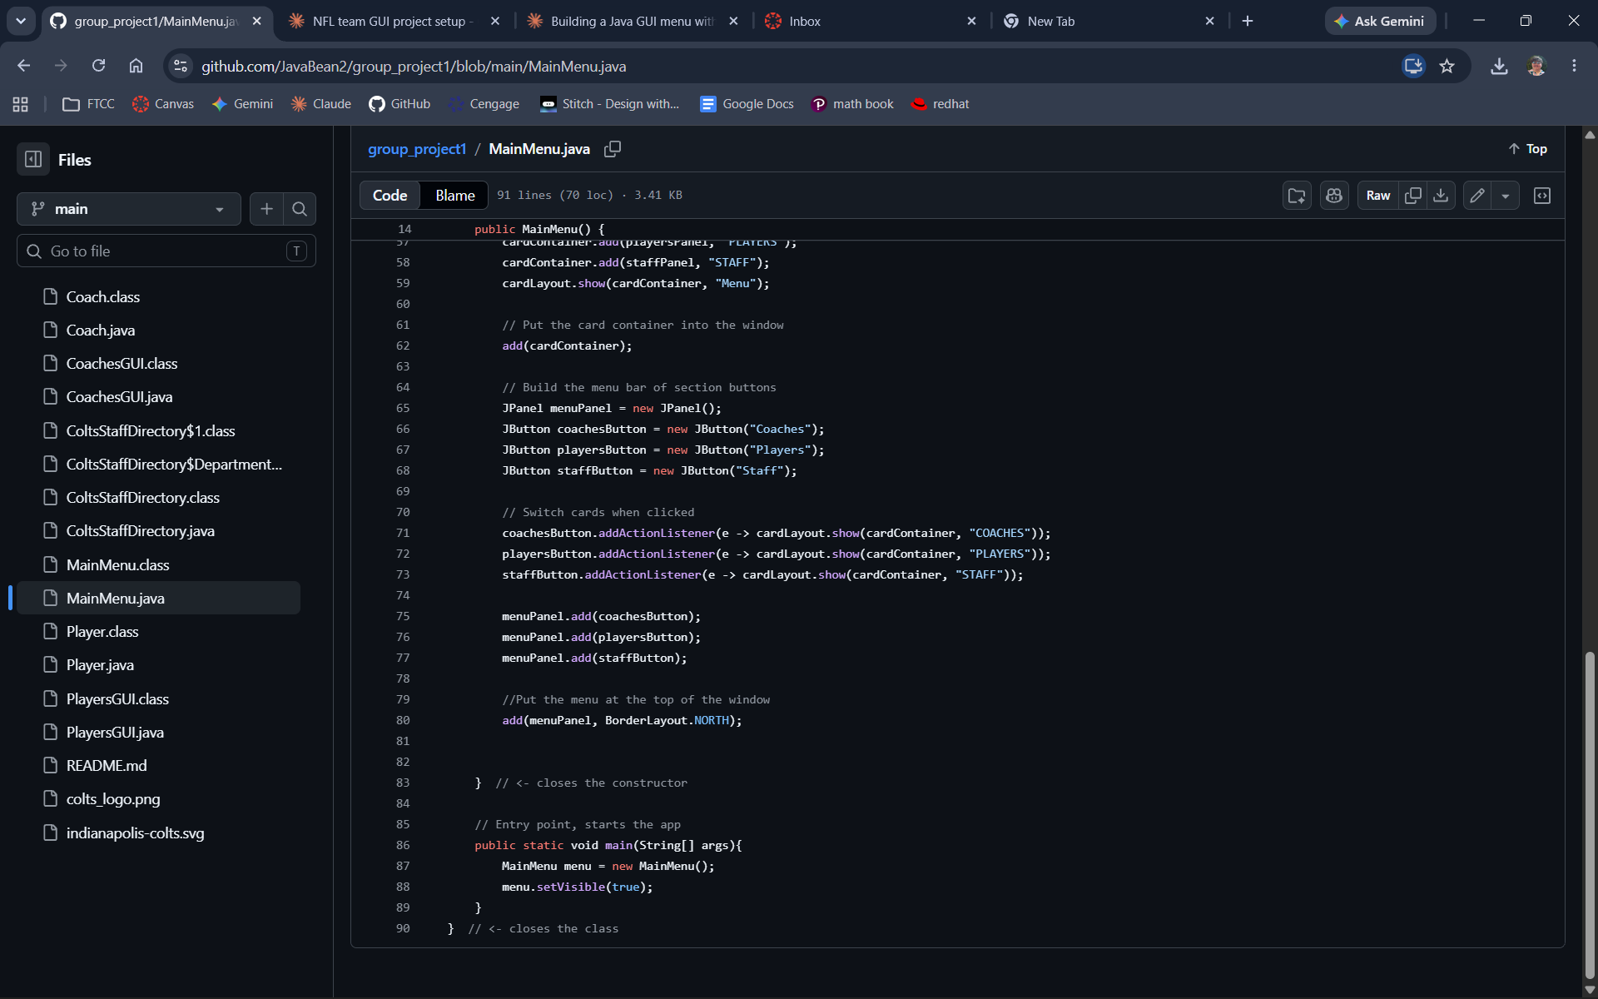
MainMenu.java, lines 57–90 — registering all three section panels, the top navigation bar, and the main() entry point.

Player.java
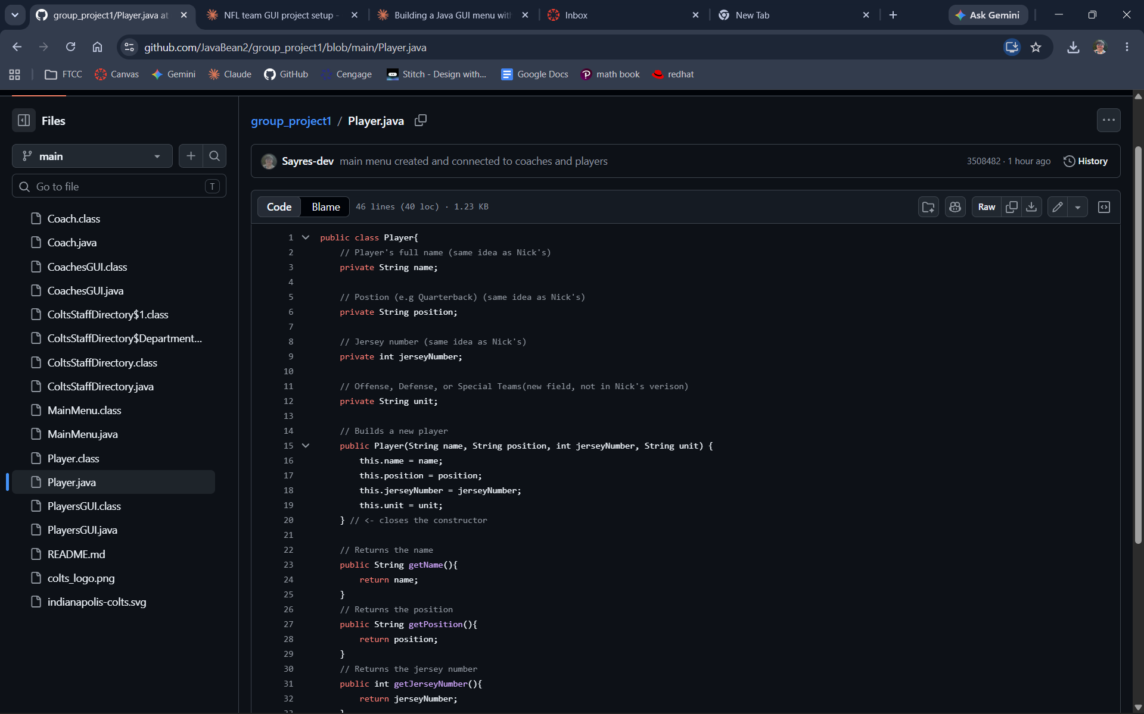
Player.java, lines 1–33 — fields (with attribution comments) and constructor.
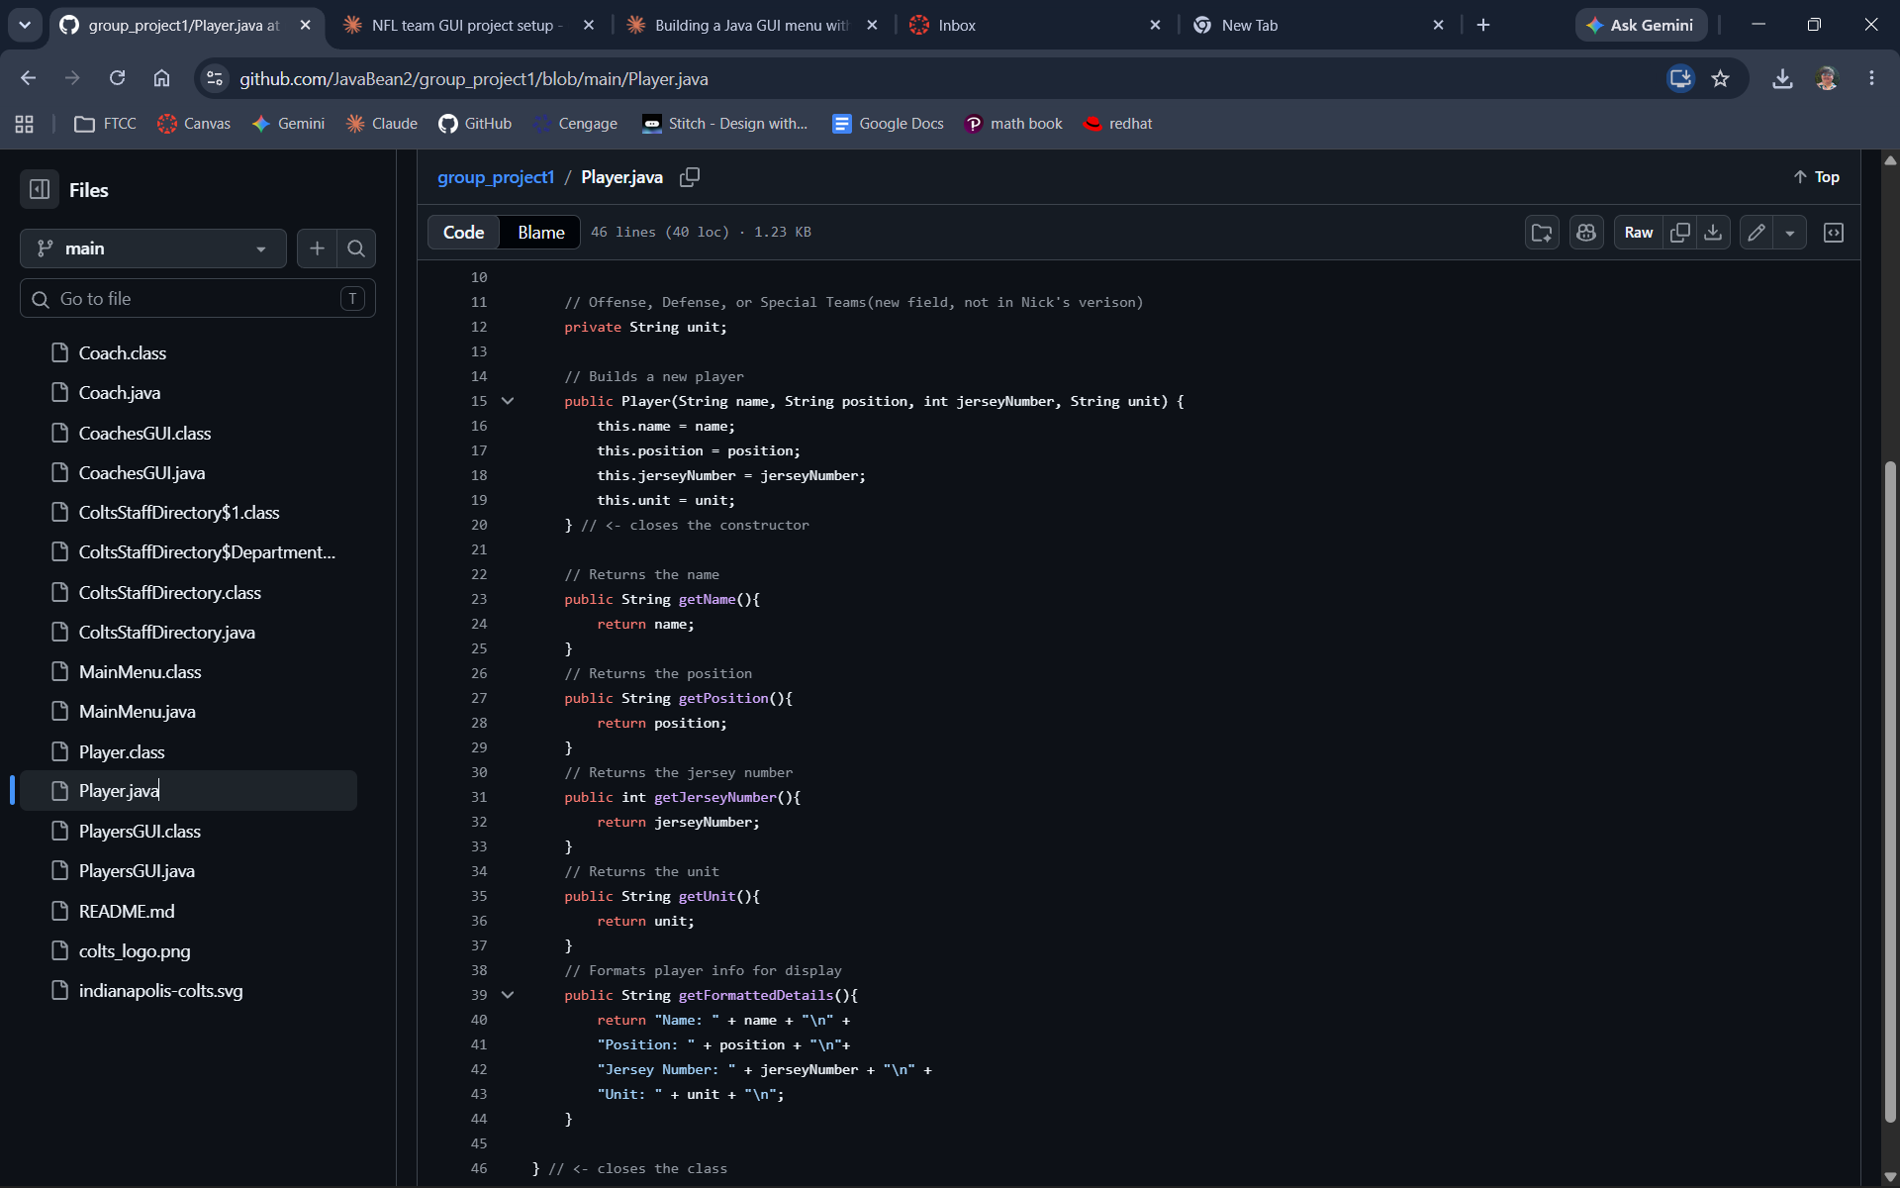
Player.java, lines 10–46 — constructor, getters, and getFormattedDetails().

PlayersGUI.java
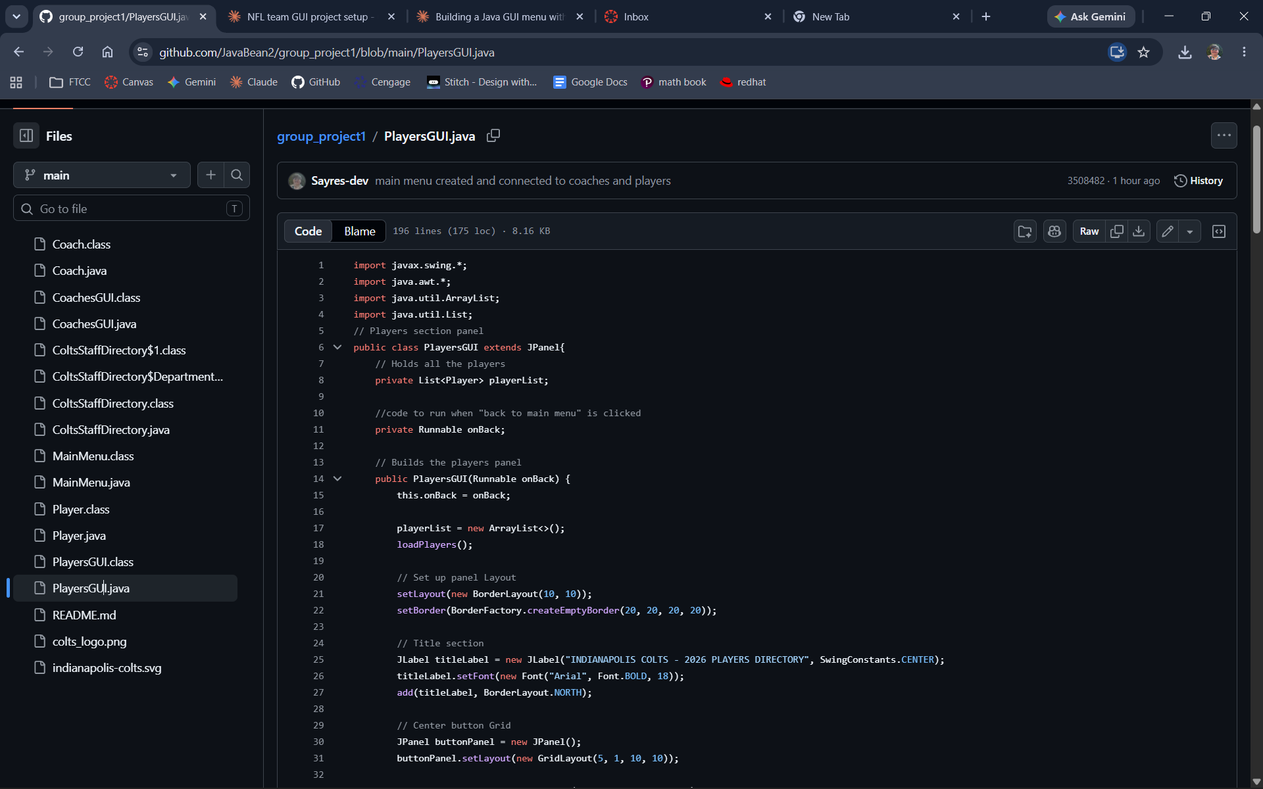
PlayersGUI.java, lines 1–32 — imports, class declaration, constructor, and title section.
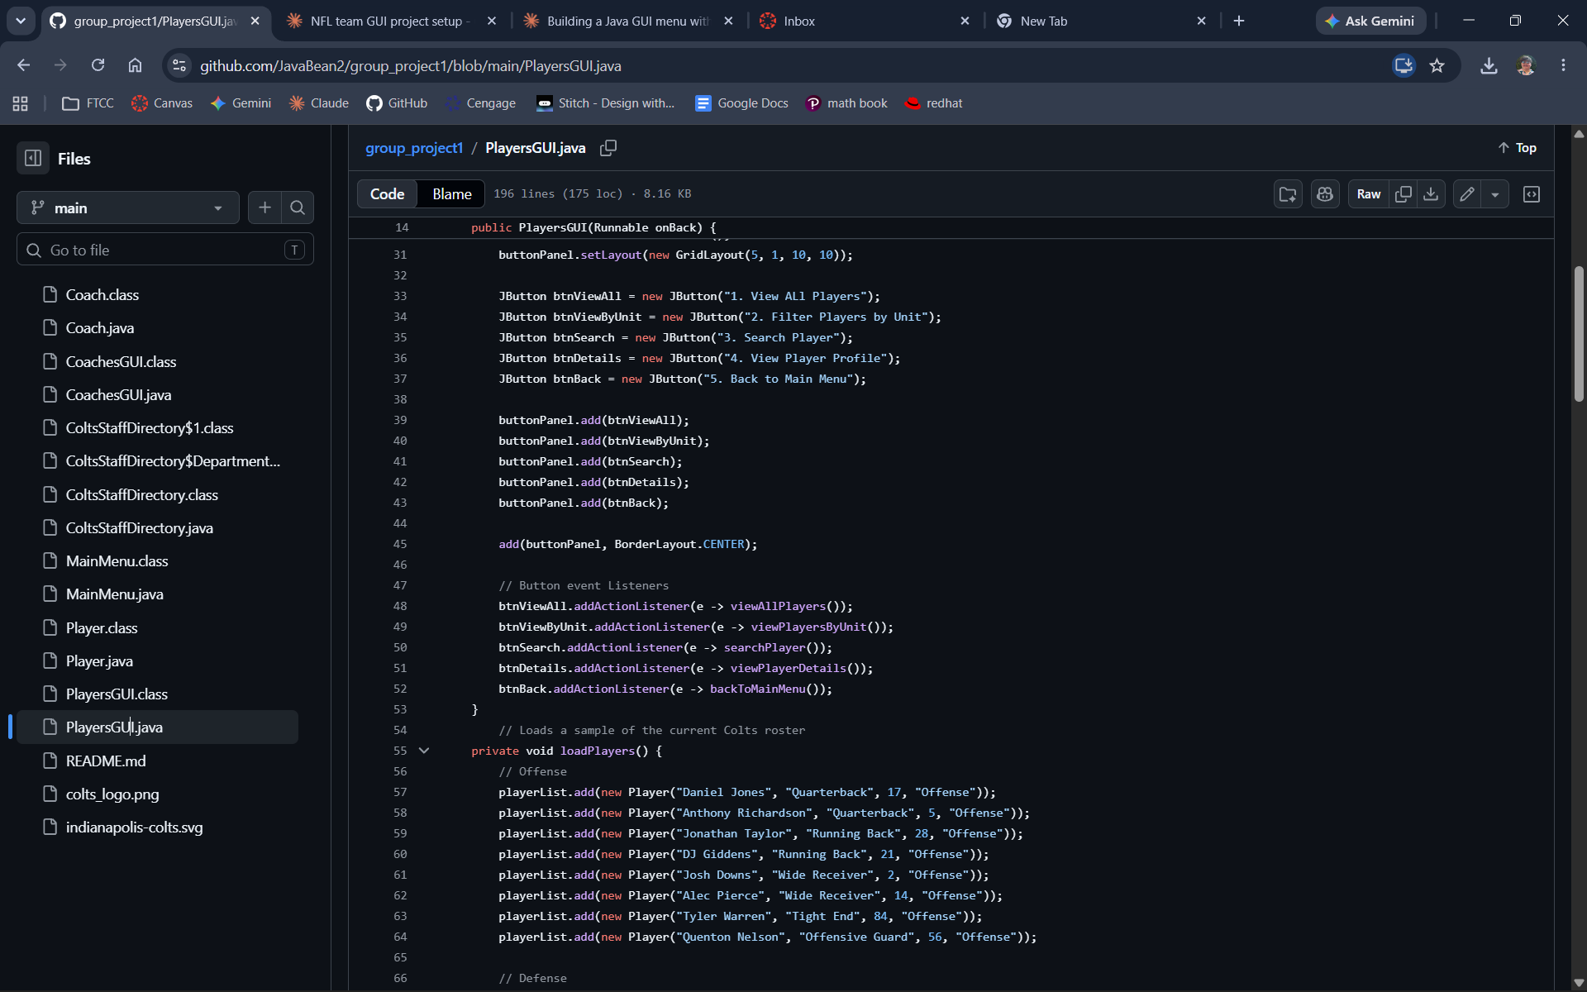
PlayersGUI.java, lines 14–66 — the five-button grid, event listeners, and start of loadPlayers().
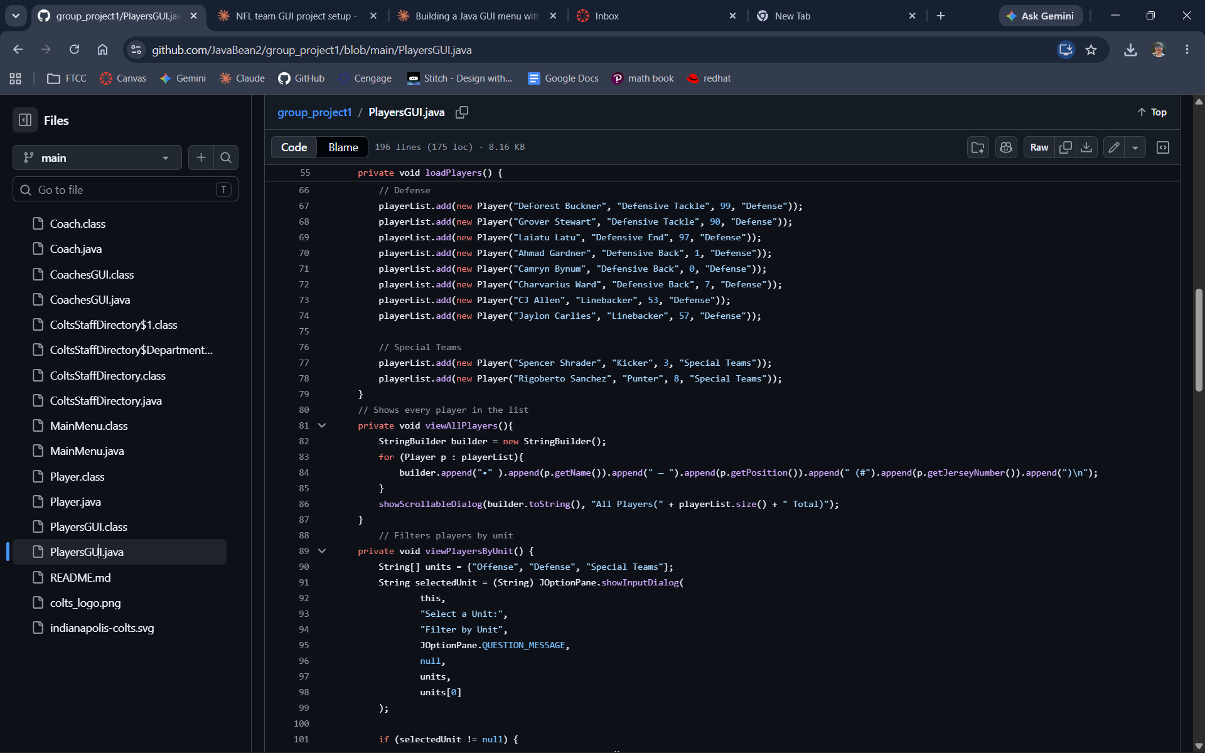
PlayersGUI.java, lines 55–101 — loadPlayers() populated with the real 2026 Colts roster, and viewAllPlayers().
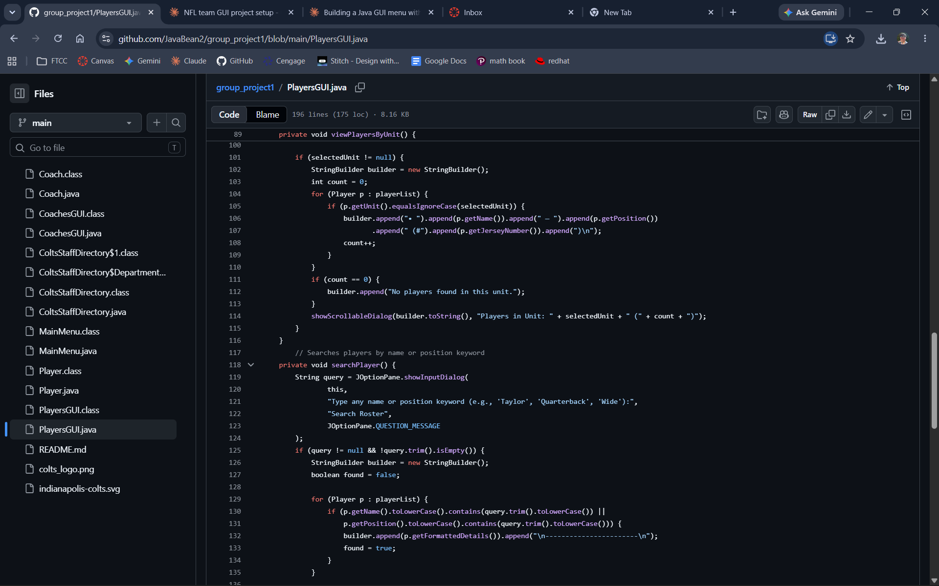
PlayersGUI.java, lines 89–136 — viewPlayersByUnit() and the start of searchPlayer().
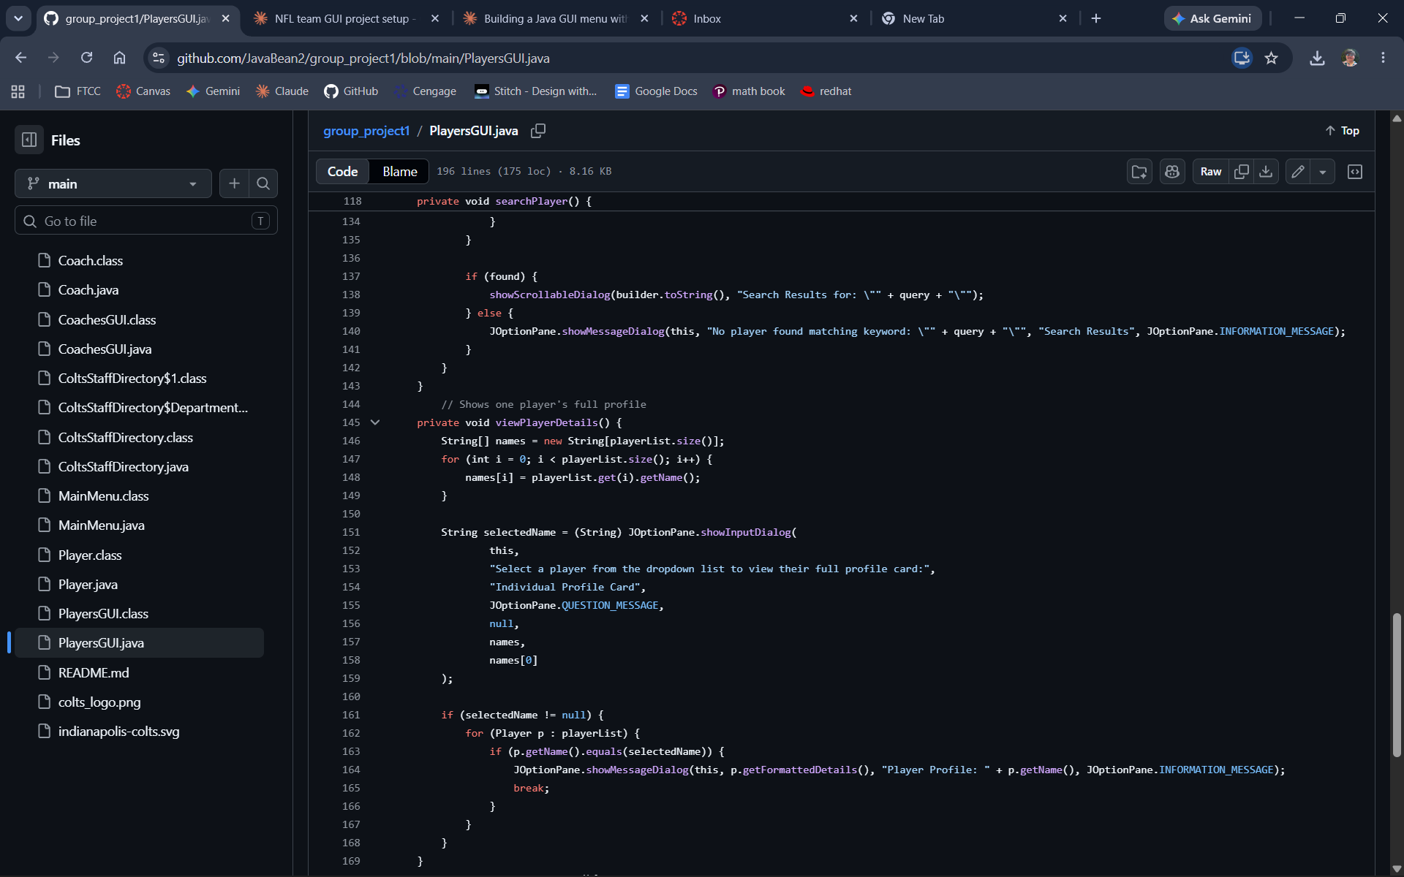
PlayersGUI.java, lines 118–169 — searchPlayer() and viewPlayerDetails().
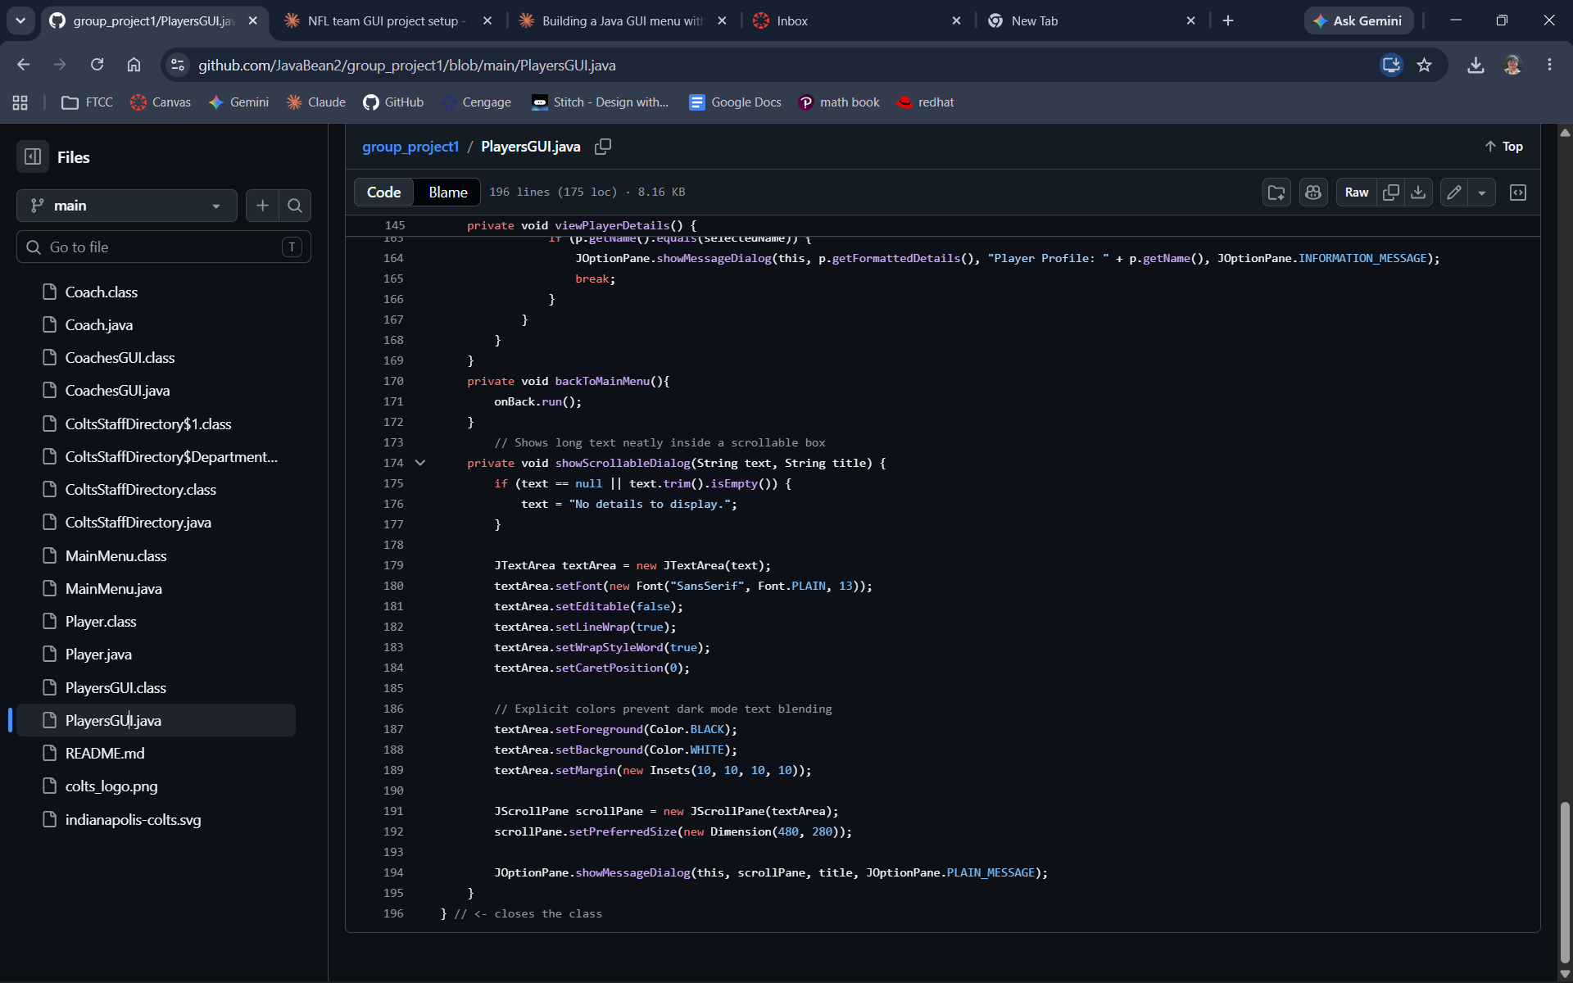
PlayersGUI.java, lines 145–196 — viewPlayerDetails(), backToMainMenu(), and the showScrollableDialog() helper (end of file).

Part 2 — Application Screenshots (Running Program)

Home Screen
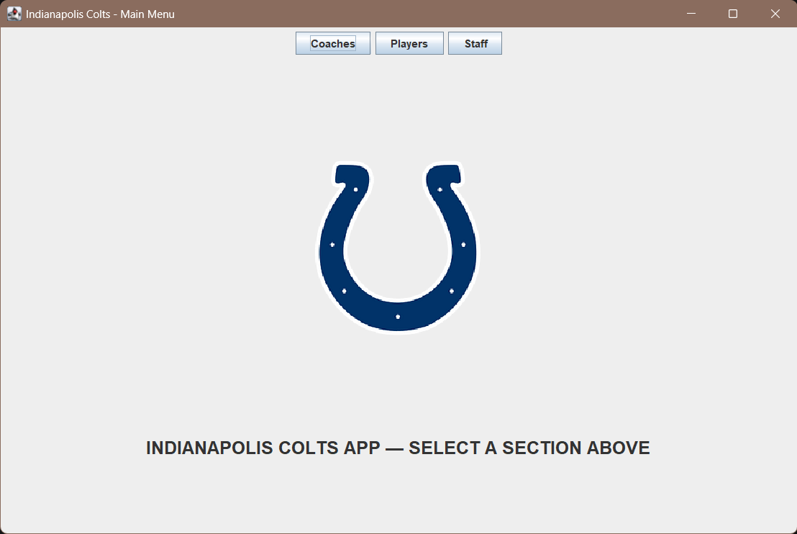
The Main Menu home screen, with the Colts logo and persistent top navigation bar.

Coaches Section
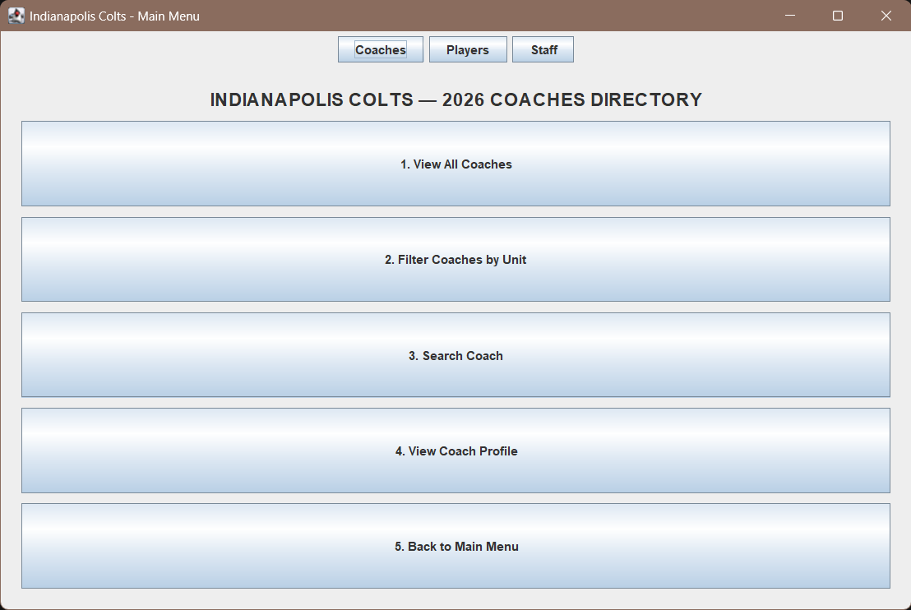
The Coaches panel (built by Ashley Mitchell), launched from the Main Menu.
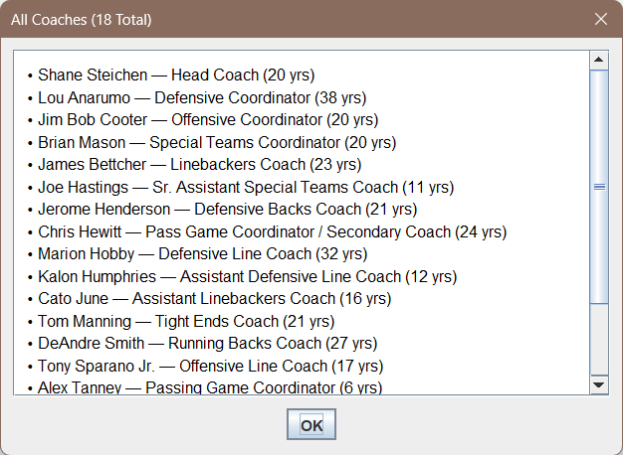
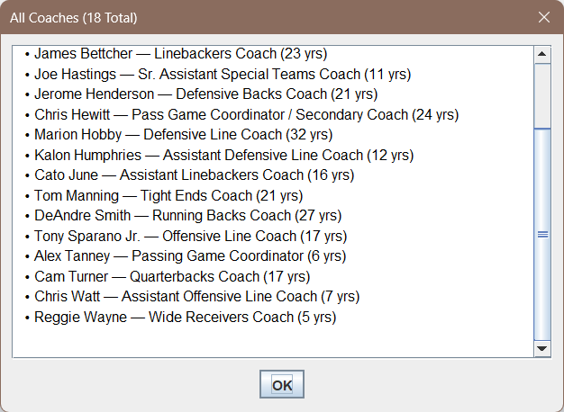
“View All Coaches” result — all 18 coaches listed, shown scrolled to top and bottom.
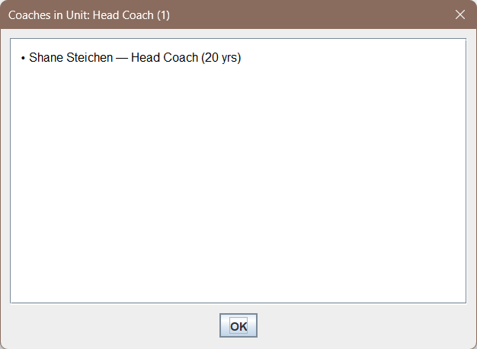
“Filter Coaches by Unit” result, filtered to the Head Coach unit.

Players Section
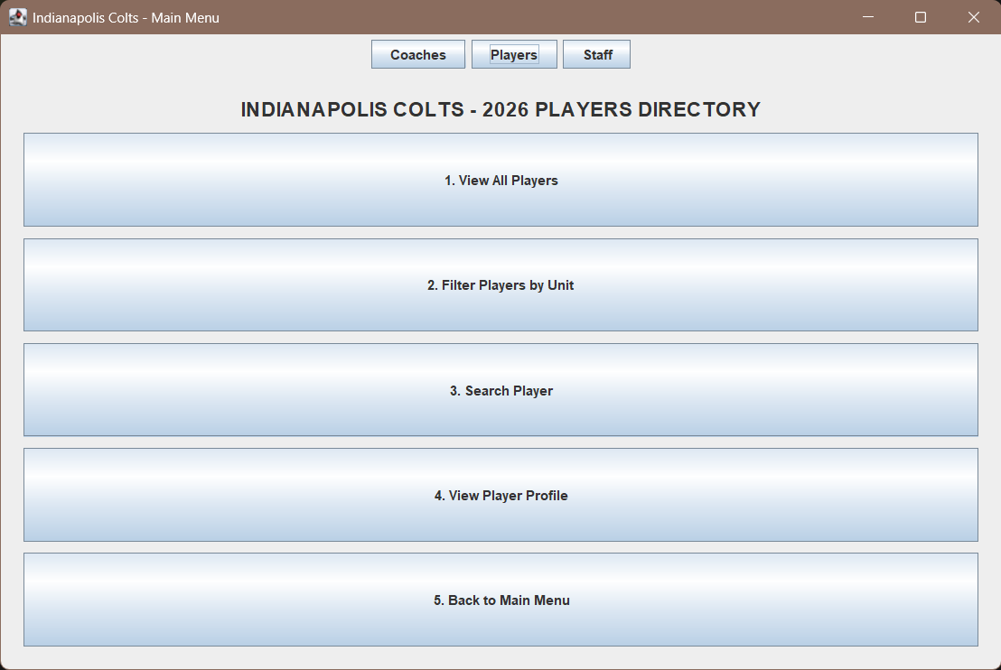
The Players panel, built from scratch to mirror the Coaches panel's pattern, with the real 2026 Colts roster.
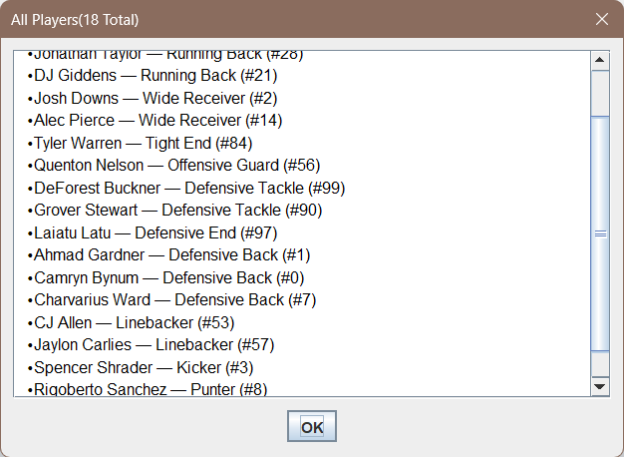
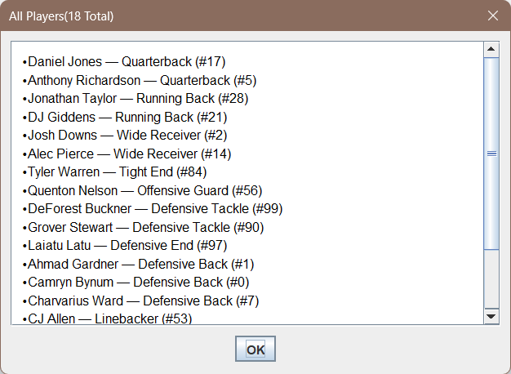
“View All Players” result — all 18 roster entries listed, shown scrolled to top and bottom.

Support Staff Section
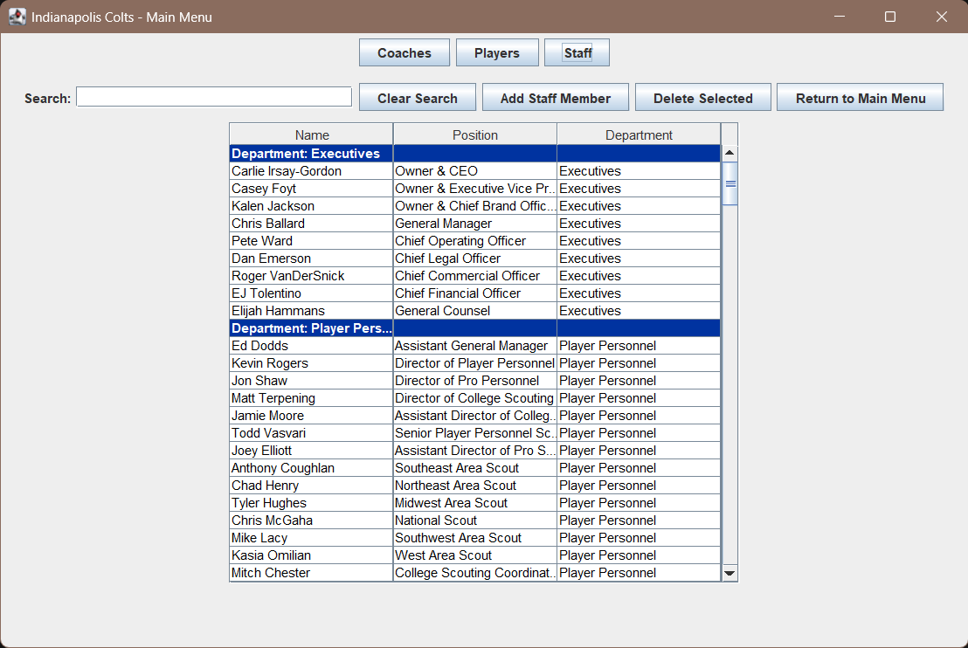
The Support Staff panel (originally built by David Irvin as a standalone window; converted to a JPanel to integrate with the Main Menu), showing the searchable staff directory table.

Back-to-Main-Menu Navigation
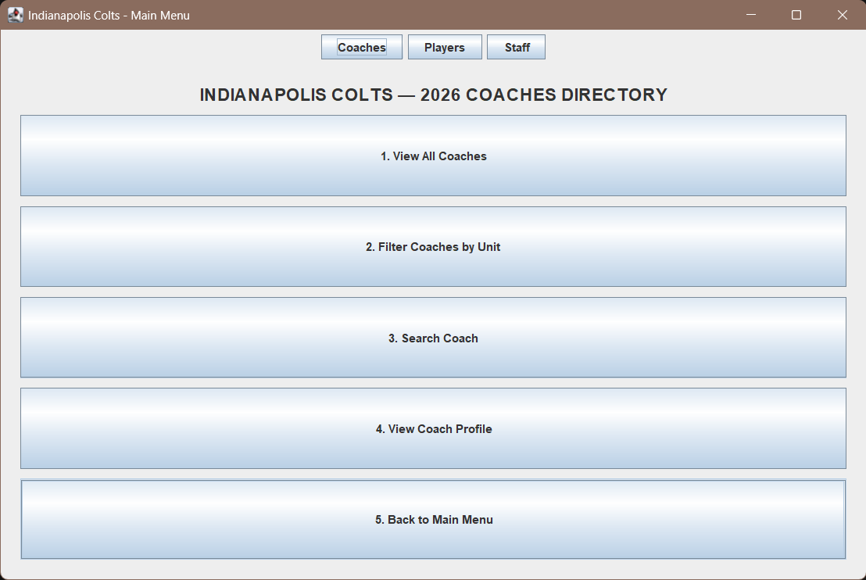
Clicking “5. Back to Main Menu” from within the Coaches panel...
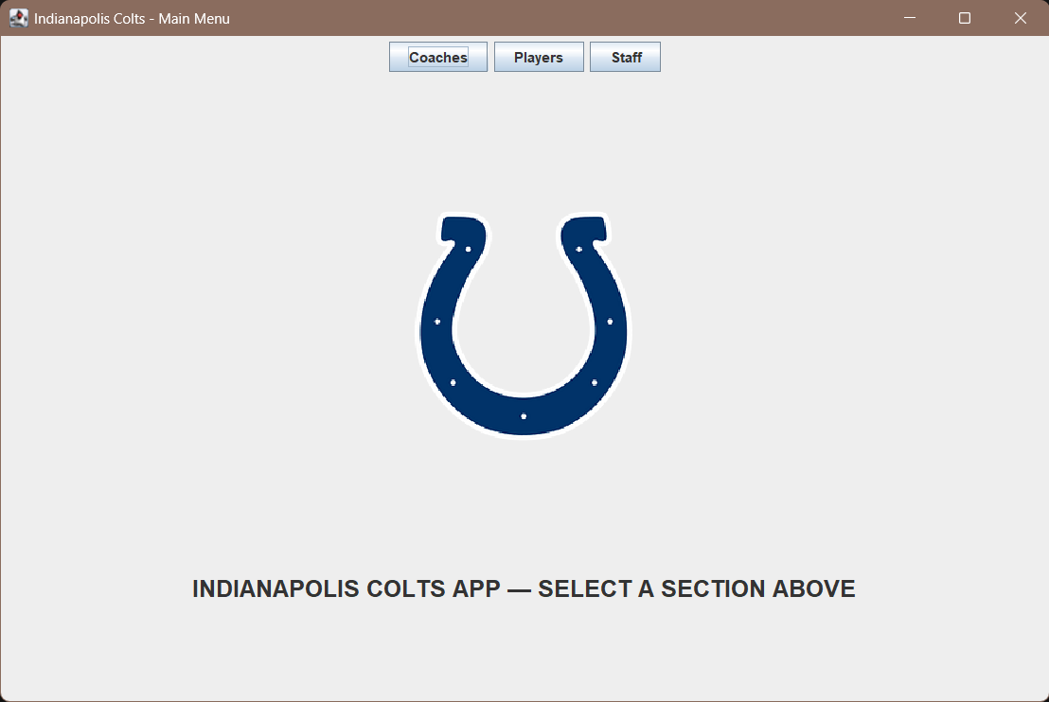
...correctly returns to the Main Menu home screen, confirming the onBack callback navigation works across all three sections.

