1. Create Data Source Pool On GlassFish Server. I have created mySqlPool

Resources>>JDBC>>JDBC Connection Pool>>New

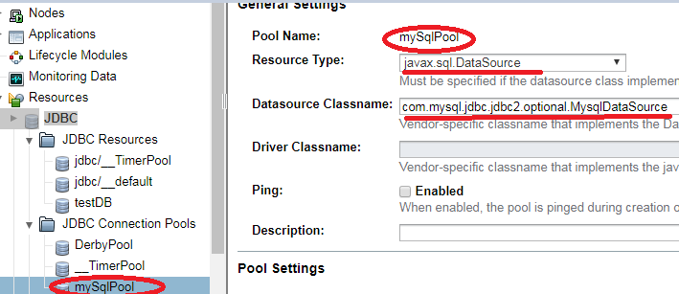

Don’t miss to modify property of DB pool as below so that It can connect the database using below credential.

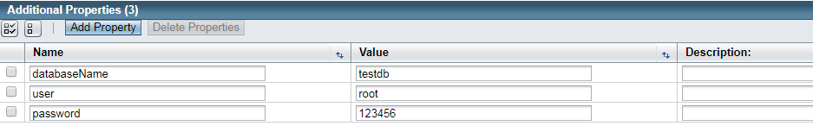

1. **Create Connection Factory**

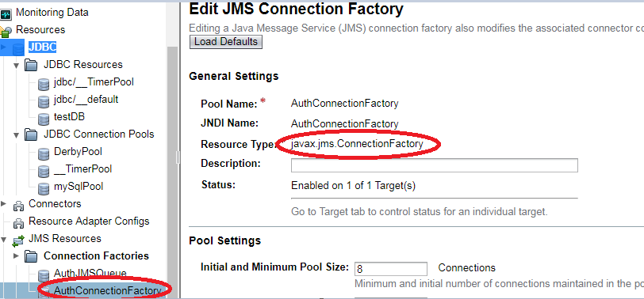

1. Create Queue under Destination Resource

