1. **Create Connection Factory**

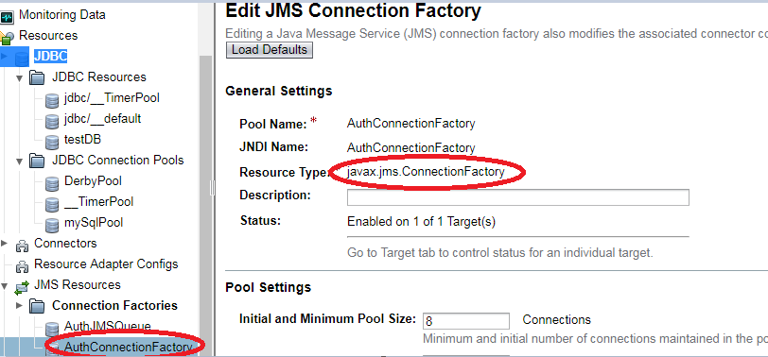

1. Create Queue under Destination Resource

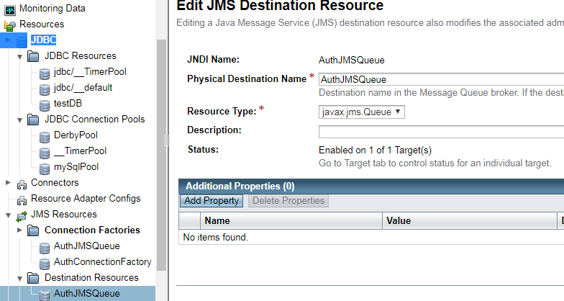

Use JNDI name created in EJB Code