|  |  |  |  |  |  |  |
| --- | --- | --- | --- | --- | --- | --- |
| Main functionality and Requirement realization | | | | | | |
| Reader Requirements | | | | | | |
| Requirements | Implementation | | | Comments | | |
| Organized journal | Totally | | | Several distinct journals presented by each year on index page. Changing year tab on the left of the page, journal list will change dynamically. | | |
| Publish four quarterly numbers per year | Totally | | | Different edition of each journal are shown under each journal name, publish date and edition will shown as follow. Clicking edition will jump into article list of this journal. | | |
| a clear master index to the volumes and numbers | Hardly | | | Misunderstand the requirement and structure the page structure in another way | | |
| search for a particular paper by title, or by author(s) name(s), or by date interval, or by a subject keyword search | Totally | | | Can search article by constraints of requirement | | |
| Clicking on the title of an article should take details and could download PDF | Totally | | | A download link was shown at bottom of article detail page | | |
| Readers should be able to register for email notification . | None | | |  | | |
| Sending email to editor to discuss certain article. | None | | |  | | |
| Author Requirements | | | | | | |
| Prospective authors should be able to navigate to a guide page which shows arm of the website the how to update articles | | Totally | | | A clear “guide ” button one the navigation bar. Click it will enter guide pages with links. | |
| Detailed submission guidelines, including document style templates | | Partly | | | Only one style template | |
| Download document style templates, create their article offline using and upload their articles in PDF. | | Totally | | | Perspective author could download document type template at guide pages, and upload their article by clicking upload button at navigation bar. | |
| The information supplied with any article | | Totally | | | Full required information could fill in form and save on SQL database. | |
| Successful submission should be acknowledged by a web page, and an email sent to the main contact author, giving details of their login ID and password | | Totally | | | Following upload process,a message will be showed on web page, and ID and password will send to author by email, and email address will be the ID for authors to review other articles and check status of they own article. | |
| Login IDs and passwords relate to the unique email address of the contact author, which is maintained in a persistent database | | Totally | | | All IDs and passwords of each user (author , reviewer, editor) are store in SQL database. | |
| The same person may use the same login ID for later submitted articles, but access to the journal website will always be restricted to the (tracking; or reviewing) functions that this person is currently expected to perform | | Totally | | | Authors who had got ID and password before, could tracking their previous upload status. | |
| Revise the article, and submit a revised PDF, with an accompanying special form | | Totally | | | Could implement this requirement. | |
| At least 3 peer-reviews must be completed for each submitted paper, ; and 5 reviews are sufficient | | Totally | | | Could implement this requirement. | |
| The author’s article may eventually be accepted by the reviewers and the editors; but the author must still complete three peer-reviews of other work | | Totally | | | Could implement this requirement. | |
| Reviewer Requirements | | | | | | |  |
| There should be a part of the website available only to reviewers, giving clear instructions regarding how to peer-review pending articles, describing what qualities are sought and how to complete the review form | | | None | | |  |
| A reviewer must login with his (or her) ID and password to obtain access to the part of the website containing unpublished articles that are awaiting peer-review | | | Totally | | |  |
| Eventually, three articles must be chosen explicitly and peer-reviewed | | | Totally | | |  |
| If certain articles have been awaiting review for a long time, the system may force the reviewer to select one or more of these, in preference to any other more recent submissions to the journal | | | Partly | | |  |
| A reviewer may browse pending articles but initially may only read their abstracts, before deciding whether to review the article, by checking a box next to that article. | | | Totally | | |  |
| Until the articles are downloaded, the reviewer may change his (or her) mind about which articles to review | | | Totally | | |  |
| The system will keep track of how many articles the reviewer has selected so far for review, and will display these titles to the reviewer, along with their review status | | | Totally | | |  |
| Periodically, it will send an email reminder to the reviewer, to select more articles, or to submit reviews for chosen articles | | | None | | |  |
| Once the reviewer has selected one to three articles for review, he (or she) may download the draft PDF versions of those articles, after which he (or she) is committed to review those articles and may not choose to go back, in favour of some other article | | | Totally | | |  |
| they must submit their review(s) of article(s) using a particular review form | | | Totally | | |  |
| The review form should contain: an overall judgement , the relevant expertise level of the reviewer (on 3-point scale: expert, knowledgeable, outsider); a summary of the content and novel contribution of the article (as proof that the reviewer has understood it and believes in its good points) | | |  | | |  |
| a structured criticism of any bad points (issues that the authors must explicitly  address in their revision). Each substantive criticism should be described in a separate section of the form, to help editors track authors’ responses to the same criticisms. | | | None | | |  |
| a detailed list of small errors should be provided for the authors | | | Partly | | |  |
| The review form should also contain an optional section, allowing the reviewer to send secret comments to the editors | | | None | | |  |
| Successful review submission should be acknowledged by a web page and an email sent to the reviewer, detailing the content of the review | | | None | | |  |
| A reviewer should be able to track reviews submitted, and submit a revised review (within a limited time period – say one week), after which the review can no longer be changed, and it is forwarded by the system to the author(s) | | | Totally | | |  |
| each reviewer will receive from the authors (via the system) a list of detailed corrections describing how he (or she) addressed each of the criticisms highlighted in the review. The reviewer may choose to accept, or reject these changes, by checking off those criticisms that were successfully addressed. | | | Partly | | |  |
| If accepting, the reviewer may revise the overall judgement on the paper (according to the champion/detractor model). If rejecting, they must explain why the revision is not adequate, and may explicitly highlight further bad points to address in a form. | | | Totally | | |  |
| A reviewer will not expect to have to go round the corrective and confirming cycle more than twice. If he (or she) still rejects the article after two attempts, it is likely that the article should be rejected overall | | | Totally | | |  |
| Reviewer Requirements | | | | | | |  |
| The editors are the people who are nominally in charge of running the journal and who host the electronic journal on a website. They must login with their ID and password, which grants them access to the whole site as editors. Their ID identifies them as a current editor | | | Totally | | |  |
| There will be at least one, and possibly many, editors. Any editor may choose to retire, or appoint another person as an editor, so long as at least one editor still exists. | | | Totally | | |  |
| The editor(s) decide upon the title of the journal, its academic aims and goals, and the styles and templates to be adopted for publication | | | Totally | | |  |
| They have an interface which allows these sections of the website to be populated with this standard information. | | | Totally | | |  |
| The editor(s) have access to all the articles; and all the reviews for each article, and to each review form with criticisms, and each author-response to a review. The system must track these, so that it is possible to see the revision history of an article | | | Partly | | |  |
| The editor may choose to reject a reviewer’s choice of paper to peer-review. In this case, the reviewer must select a different paper to review | | | Partly | | |  |
| The editor may choose to reject an overly brief, hurried review. In this case, the reviewer must resubmit the review and put proper effort into i | | | None | | |  |
| The editor may choose to reject an author’s revision to an article, which only pretends to include the changes listed in the response to the reviewer(s) | | | None | | |  |
| The editor may choose to review an article that has been awaiting review for a long time, just to move it through the journal system | | | None | | |  |
| If the paper is publishable according to the champion/detractor model, then the editor may publish it officially (as part of the current volume/number of the journal) | | | Partly | | |  |
| The editor(s) may add published letters to the end of any edition (number) of the journal | | | Partly | | |  |

**User guide**

**Reader**

Users is the default role at the beginning. After open this system in browser the index page will shown as figure 1. On the top of the page there are three button, “Login” for author and editor, “guide” will enter guide page, “upload “to execute upload process.

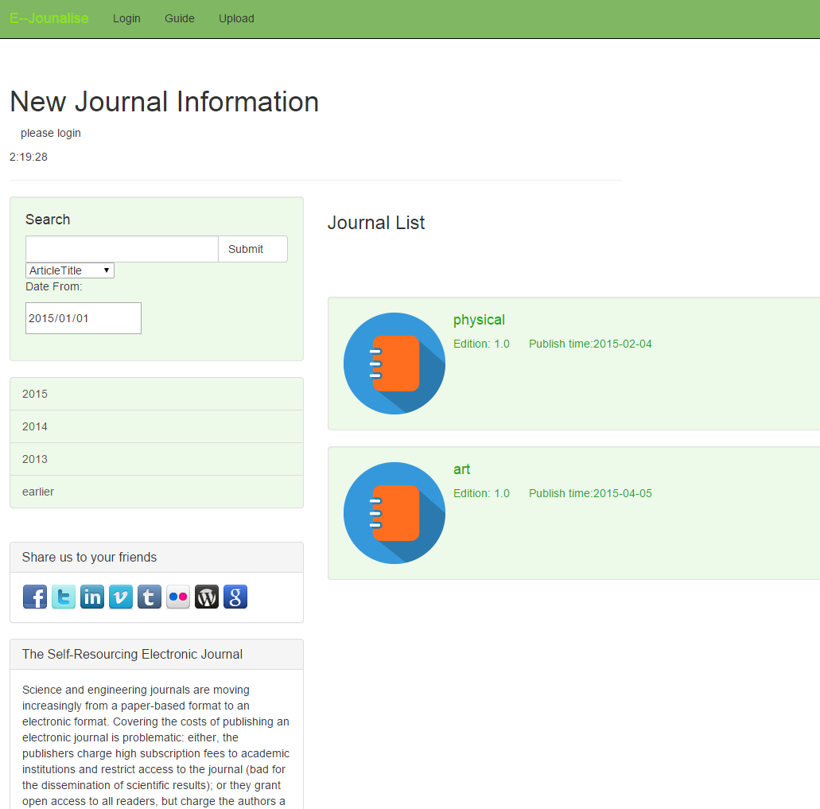

A search bar (figure 2) is one the left of index page which provide search function to get published articles. Reader could search articles by input certain type of search, for instance article title, key

Figure 1 web index page words , journal name and Domain (figure 3)from selected date (figure 4). Research by article name using fuzzy check.

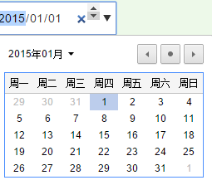

Figure 2 search bar Figure4 select date

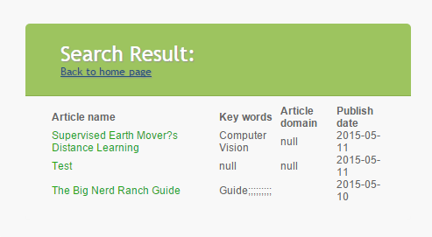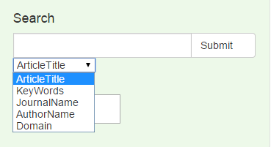

figure 3 different search type Figure 5 article list



Figure 6 article detail