*[remote sensing](http://www.mdpi.com/journal/remotesensing)*



*Article*

**New Downscaling Approach Using ESA CCI SM Products for Obtaining High Resolution Surface Soil Moisture**

# Jovan Kovacˇevic´ *, Željko Cvijetinovic´, Nikola Stancˇic´, Nenad Brodic´ and Dragan Mihajlovic´

Faculty of Civil Engineering, University of Belgrade, Bulevar kralja Aleksandra 73, 11000 Belgrade, Serbia; [zeljkoc@grf.bg.ac.rs](mailto:zeljkoc@grf.bg.ac.rs) (Ž.C.); [nstancic@grf.bg.ac.rs](mailto:nstancic@grf.bg.ac.rs) (N.S.); [nbrodic@grf.bg.ac.rs](mailto:nbrodic@grf.bg.ac.rs) (N.B.); [draganm@grf.bg.ac.rs](mailto:draganm@grf.bg.ac.rs) (D.M.)

**\*** Correspondence: [jkovacevic@grf.bg.ac.rs](mailto:jkovacevic@grf.bg.ac.rs)

Received: 18 February 2020; Accepted: 30 March 2020; Published: 1 April 2020

[←he←k for](https://www.mdpi.com/2072-4292/12/7/1119?type=check_update&version=2)

**[updates](https://www.mdpi.com/2072-4292/12/7/1119?type=check_update&version=2)**

**Abstract:** ESA CCI SM products have provided remotely-sensed surface soil moisture (SSM) content with the best spatial and temporal coverage thus far, although its output spatial resolution of 25 km is too coarse for many regional and local applications. The downscaling methodology presented in this paper improves ESA CCI SM spatial resolution to 1 km using two-step approach. The ﬁrst step is used as a data engineering tool and its output is used as an input for the Random forest model in the second step. In addition to improvements in terms of spatial resolution, the approach also considers the problem of data gaps. The ﬁlling of these gaps is the initial step of the procedure, which in the end produces a continuous product in both temporal and spatial domains. The methodology uses combined active and passive ESA CCI SM products in addition to in situ soil moisture observations and the set of auxiliary downscaling predictors. The research tested several variants of Random forest models to determine the best combination of ESA CCI SM products. The conclusion is that synergic use of all ESA CCI SM products together with the auxiliary datasets in the downscaling procedure provides better results than using just one type of ESA CCI SM product alone. The methodology was applied for obtaining SSM maps for the area of California, USA during 2016. The accuracy of tested models was validated using ﬁve-fold cross-validation against in situ data and the best variation of model achieved RMSE, R2 and MAE of 0.0518 m3/m3, 0.7312 and 0.0374 m3/m3, respectively. The methodology proved to be useful for generating high-resolution SSM products, although additional improvements are necessary.

**Keywords:** soil moisture; downscaling; random forest; ESA CCI SM

# Introduction

Soil moisture is a crucial component in Earths’ system with great impact on interactions between the land surface and the atmosphere [1]. Consequently, using soil moisture information is critical to many applications such as hydrogeological monitoring [2,3], meteorology [4] and water resource management [5,6]. Soil moisture also plays an important role in evapotranspiration process [7], which subsequently inﬂuences precipitation occurrences [8]. Soil moisture also indirectly affects environment where its relationship with forest ﬁres has been recognized [9]. Importance of soil moisture has also been recognized institutionally as it is listed as one of the 50 Essential Climate Variables within the Global Climate Observing System (GCOS) [10,11].

Soil moisture can be deﬁned as a mass or volume of water stored between the earth particles in the upper unsaturated soil layer. It is usually distinguished as the surface soil moisture (SSM), which represents the topsoil water content (0–5 cm depth), and the root zone soil moisture (RSM), which accounts for water available to the plants’ root system (<2 m depth) [12,13]. Soil moisture

*Remote Sens.* **2020**, *12*, 1119; doi:[10.3390/rs12071119](http://dx.doi.org/10.3390/rs12071119) [www.mdpi.com/journal/remotesensing](http://www.mdpi.com/journal/remotesensing)

content is traditionally measured using ground instruments and techniques based on: (1) sampling and drying; (2) electrical resistance; (3) neutron scattering; (4) gamma-ray absorption; or (5) time-domain reﬂectometry [12]. This way, both SSM and RSM can be obtained in a form of point measurements and their spatiotemporal characteristics over the wider area have to be modeled, usually using geostatistical methods [14–16]. With the advancements of the satellite remote sensing, an alternative method for the retrieval of the soil moisture came to attention. Satellite observations provided a way of obtaining soil moisture content over the regional and global scales with the temporal resolution in a matter of days. Based on the part of the electromagnetic spectrum being used, the following satellite sensors proved to be useful for soil moisture mapping: (1) microwave (active and passive); (2) optical; and (3) thermal [1]. Unfortunately, due to the penetration depth of the electromagnetic waves through the soil, only SSM can be obtained from the satellite remote sensing [17], while RSM has to be obtained through vertical extrapolation [18]. Very comprehensive and recent reviews on possibilities of generating SSM from the satellite remote sensing data were done by Sabaghy et al. [19] and Peng et al. [20].

Numerous microwave remote sensing sensors have been developed and used for mapping soil moisture content. These include the Advanced Microwave Scanning Radiometer—Earth Observing System (AMSR-E) [21], Soil Moisture and Ocean Salinity (SMOS) satellite [22], Soil Moisture Active Passive (SMAP) mission [23], the Advanced Scatterometer (ASCAT) [24], ESA Sentinel-1 satellites [25] and many more. To achieve the optimal temporal and spatial coverage and to produce the long time series of soil moisture data, all these sources need to be synchronized and merged in the data assimilation process. During this procedure, the differences in operational, spatial, temporal and retrieval algorithm aspects of the used sources must be taken into account. The European Space Agency (ESA) produces such merged microwave soil moisture products as part of the Climate Change Initiative (CCI)—ESA CCI SM [26]. Although the ESA CCI SM product provides very good spatial coverage, there are still data gaps in some places. Another disadvantage is that the product has coarse spatial resolution of 0.25o (s25 km), which is insufficient for many regional and local applications.

Several studies have aimed at improving the spatial resolution and ﬁlling the data gaps of coarse resolution SSM products [27–29]. Machine learning (ML) techniques proved to be a very useful tool for such purpose [30,31]. Studies have shown that Random Forest (RF) is one of the many available ML techniques that yields very good results in downscaling and ﬁlling data gaps thanks to its ﬂexibility through randomization and ensemble approach [32]. This study successfully implemented a two-step approach to produce SSM product without missing data and with high spatial resolution (1 km). The ﬁrst step is used as a data engineering tool and its output is used as the input for the second step. Bilinear interpolation and random forest model are considered as data engineering tools in the ﬁrst step, and, in the second step, additional random forest regression is used. The methodology was tested over the study area of California, USA for the year 2016. ESA CCI SM products, together with the auxiliary products (Normalized Difference Vegetation Index (NDVI), Land Surface Temperature (LST), NWS Precipitation, and Köppen–Geiger climate classiﬁcation map), were used within the prediction model. The approach described in this paper is novel in a method that considers the synergic use of multiple ESA CCI SM products instead of a single one in order to obtain high resolution SSM maps.

# Materials

* 1. *Study Area*

The study area covers 423,967 km2—the complete state of California, USA (Figure 1). The area’s relief is dominated by the Central Valley, which runs 725 km through the state between the Coast Ranges to the west and the Sierra Nevada to the east and bounded by the Cascades in the north and Tehachapi Mountains to the south. California’s land cover is diverse, where forests cover almost half of the state’s area and with barren plains in the northern and desert area in the east-central parts. Climate conditions in California vary from polar to subtropical. The biggest part of the state has a Mediterranean climate and in the northeastern part the temperate climate is present. The climate

also changes rapidly with elevation, where the alpine climate can be found in the higher mountains. Different parts of the state receive various amount of precipitation, which ranges from more than 4300 mm in the northwest to small traces in the southeastern desert. Coastal areas are different too, where moderate temperatures and moderate rainfall prevail.

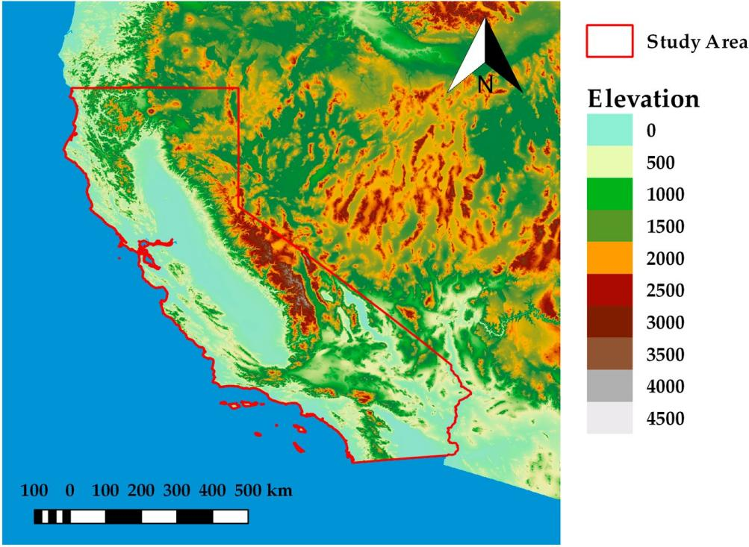

**Figure 1.** The study area—the state of California, USA.

The state is a major agriculture contributor accounting for over 13% of the USA’s total agricultural value in 2018. It produces more than 400 commodities, with more than a third of the country’s vegetables and two-thirds of the country’s fruits and nuts being grown in California [33]. Such extensive agriculture production requires careful and smart water management, which can beneﬁt signiﬁcantly from high quality soil moisture maps.

* 1. *European Space Agency Soil Moisture Products - ESA CCI SM*

ESA CCI SM products are generated using soil moisture observations from active (ERS1-2 SCAT and MetOp ASCAT A-B) and passive (SMMR, SSM/I, TMI, AMSR-E, WindSat, AMSR2 and SMOS) microwave satellite sensors. Three groups of soil moisture products are generated in the assimilation process: active (ESA CCI SM A), passive (ESA CCI SM P) and combined (ESA CCI SM C). The active soil moisture products are generated from the C-band scatterometers using the change detection algorithm. The passive products are handled using the Land Parameter Retrieval Model (LPRM), which successfully translates the microwave observed land surface brightness temperature (Tb) to the soil moisture content. The combined product is obtained through the assimilation process of the previous two, with the appropriate weights assigned to each source [26]. All products provide daily global coverage with the spatial resolution of 0.25o (s25 km). Active soil moisture products are expressed in the percentage of saturation (%), whereas passive and combined soil moisture products are expressed in volumetric units (m3/m3). In the latest version of ESA CCI SM products (04.5), the temporal range has been extended and covers 1978–2018. In this research, all three types of products (passive, active and combined) for 2016 were obtained from the ESA data archive (<https://www.esa-soilmoisture-cci.org/>).

* 1. *PBO_H2O in Situ Soil Moisture Observations*

PBO_H2O, a project that was operational from 2004 to 2017, implemented GPS interferometric reﬂectometry for the measurement of SSM. The observations represent volumetric soil moisture

content in the topsoil layer (0–5 cm) with spatial scale of ~1 km2 and accuracy of 0.04 m3/m3 [34]. PBO_H2O data can be obtained from the International Soil Moisture Network (ISMN) data archive (<https://ismn.geo.tuwien.ac.at/en/>), as it was done for the whole 2016. The complete dataset consists of 159 stations with hourly measurements. For each station, the observations were ﬁrstly aggregated to obtain the mean daily value. In the next step, the locations with the multiple sensors (same latitude and longitude) were averaged. ﬁfty-six were stations left after cropping locations to the study area (Figure 2a), with a total of 18,307 daily surface soil moisture observations (Figure 2b).

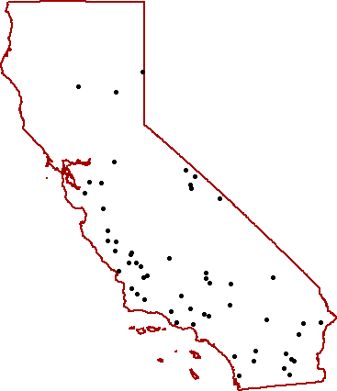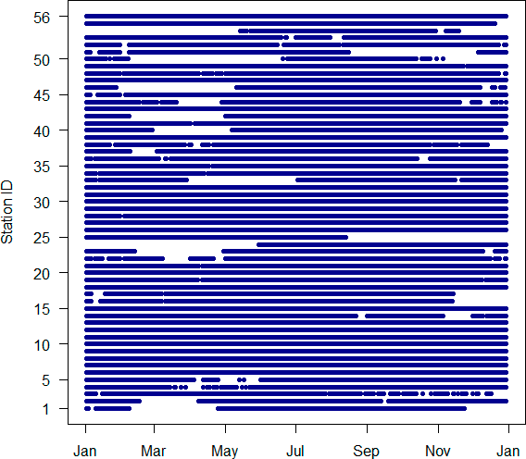

* + 1. (**b**)

**Figure 2.** (**a**) Spatial distribution of the PBO_H2O soil moisture stations in the study area; and (**b**) soil moisture observations per station during the 2016.

* 1. *Auxiliary Data*
     1. Normalized Difference Vegetation Index (NDVI) and Land Surface Temperature (LST)

The connection between land water content and NDVI and LST has been widely used for downscaling coarse resolution remotely-sensed soil moisture [35–38]. The main advantage of using such data for downscaling is their ﬁne spatial resolution, good temporal coverage and the many available satellite missions that collect them. However, the cloud contamination is a big problem for all optical sensors, making these products unavailable in certain places [1]. Moderate Resolution Imaging Spectroradiometer (MODIS) is one of the most commonly used sources for such products and therefore it was chosen as the provider of NDVI and LST.

NDVI was taken from MODIS Vegetation Indices 16-day Level 3 Global 1 km Version 6 products, from both Terra (MOD13A2) and Aqua (MYD13A2) satellites. The temporal coverage of NDVI included 2016 and 2017 with 46 Terra and 46 Aqua products. Each product was generated in WGS84 coordinate reference system. The data coverage was extended to include 2017 because it was necessary for generating and later improving daily NDVI products.

The LST data were induced from MODIS Land Surface Temperature/Emissivity Daily L3 Global 1km Version 6 products from both Terra (MOD11A1) and Aqua (MYD11A1) satellites. LSTDAY and LSTNIGHT land surface temperature maps in the form of rasters in WGS84 coordinate reference system were generated for each satellite and for each date of 2016 (ideally, four rasters for each date). In the next preprocessing step, for each date, Terra and Aqua products were merged by taking average of corresponding pixels, so that, in the end, single LSTDAY and LSTNIGHT rasters were produced for each

date of 2016. Since the data for Terra products DOY 50-58 were missing, only the Aqua products were used for producing LSTDAY and LSTNIGHT rasters during these days.

* + 1. NWS Precipitation Data

As a part of the natural water cycle, atmospheric water is transferred to the land through precipitation. The correlation between precipitation and soil moisture spatial and temporal patterns has been observed by many studies [2,8]. Since precipitation datasets are of higher spatial resolution, it has been used in the process of downscaling coarse resolution soil moisture [32,39].

National Weather Service (NWS) produces daily precipitation estimate maps for the whole USA from the combined sensor inputs: radar and rain gauge. The data represent 24-h accumulation and they are disseminated in the Hydrologic Rainfall Analysis Project (HRAP) grid coordinate system. Although the spatial resolution of the data is considered roughly s4 km over continental USA, the spatial resolution of the product over the study area is closer to s5 km due to the characteristics.of.the.HRAP.grid..After.obtaining.the.data.for.2016(<https://water.weather.gov/precip/>), each ﬁle was preprocessed to s0.05o (s5 km) in WGS84 coordinate reference system. Each HRAP grid point was assigned to the closest WGS84 pixel during the preprocessing.

* + 1. Köppen–Geiger Climate Classiﬁcation Map

Climate types are deﬁned using average weather conditions over a long time. The certain climate type is directly or indirectly related to the precipitation amount, the dominant vegetation density/types and the land surface temperature [2]. Therefore, it can be expected that it can be useful for the downscaling procedure. To the authors’ knowledge, no other studies used climate data for downscaling soil moisture.

Köppen–Geiger climate classiﬁcation map is the most frequently used climate classiﬁcation map created by Wladimir Köppen and it was presented in its latest version in 1961 by Rudolf Geiger. In this research, the updated and re-analyzed Köppen–Geiger map produced by Climate Change & Infectious Diseases was used [40]. The spatial resolution of the map is 5’ and it can be obtained from the group’s website (<http://koeppen-geiger.vu-wien.ac.at/>). The climate classiﬁcation map was additionally reclassiﬁed to ﬁrst level of classiﬁcation scheme with ﬁve different climate groups: A (Tropical), B (Arid), C (Temperate), D (Continental) and E (Polar).

Methods

* 1. *Bilinear Interpolation*

Bilinear interpolation is a widely popular two-dimensional interpolation method that uses the values of four closest points in order to estimate an output value [41]. The interpolation function that is used to ﬁt a bilinear surface through these four points is given by the equation:

*z* = *f* (*x*, *y*) = *a*0 ‡ *a*1*x* ‡ *a*2*y* ‡ *a*3*xy*. (1)

When applied to a raster image, this interpolation method considers the known values of the four nearest pixels located in diagonal directions from the position of a new pixel. A new pixel value is calculated as a weighted average of these four pixel values from the original image. This resampling method can be used both as an aggregation or disaggregation raster tool. In this research, it was considered as a disaggregation tool used for downscaling remote sensing products from coarse to ﬁner spatial resolution. Due to its vast popularity, the bilinear interpolation was taken for comparison purposes, that is, to compare its results with the results of the methods that are more sophisticated.

* 1. *Random Forest Regression*

Random forest is an ensemble approach machine learning technique which can be applied for both regression and classiﬁcation problems. The technique proposed by Breiman [42] uses multiple decision trees built during the training phase from which mean prediction is taken as an output of the model. Each tree is built from the bootstrap sample created from some portion of the input training data, while the remaining data are used for the performance evaluation of each tree. This feature (also known as bootstrap aggregation) provides powerful tool for modeling nonlinear relationships while reducing the chance of overﬁtting and improving generalization [42].

In this study, random forest regression implemented in ranger R package was used [43]. The number of trees was set to 200 because a larger number did not produce signiﬁcant error improvement, but increased the computation time. The split rule was set to “MaxStat” instead of the more usual default “Variance” split rule. All other parameters were left to their default values.

# Methodology

The methodology used in this research consists of several steps (Figure 3). First, the input datasets were processed to ﬁll gaps in the data in both temporal and spatial domains. Next, the created datasets were used to downscale coarse resolution ESA CCI SM products to high spatial resolution of 1 km (Data engineering). Since downscaled products still have large bias against the in situ soil moisture observations, additional processing was necessary. This was covered in the ﬁnal step (Random forest), where all previously created downscaled datasets in congregation with in situ data were used to produce output SSM maps of high spatial resolution. The following sections describe all these steps in detail.



**SSM**

**in situ**

# References

1. Srivastava, P.K.; Petropoulos, G.P.; Kerr, Y.H. Satellite soil Moisture Retrieval: Techniques and Applications; Elsevier: Amsterdam, The Netherlands, 2016; ISBN 978-0-12-803388-3.
2. Seneviratne, S.I.; Corti, T.; Davin, E.L.; Hirschi, M.; Jaeger, E.B.; Lehner, I.; Orlowsky, B.; Teuling, A.J. Investigating soil moisture–climate interactions in a changing climate: A review. Earth-Sci. Rev. 2010, 99, 125–161. [[CrossRef](http://dx.doi.org/10.1016/j.earscirev.2010.02.004)]
3. Corradini, C. Soil moisture in the development of hydrological processes and its determination at different spatial scales. J. Hydrol. 2014, 516, 1–5. [[CrossRef](http://dx.doi.org/10.1016/j.jhydrol.2014.02.051)]
4. Entekhabi, D.; Rodriguez-Iturbe, I.; Castelli, F. Mutual interaction of soil moisture state and atmospheric processes. J. Hydrol. 1996, 184, 3–17. [[CrossRef](http://dx.doi.org/10.1016/0022-1694(95)02965-6)]
5. Osenga, E.C.; Arnott, J.C.; Endsley, K.A.; Katzenberger, J.W. Bioclimatic and soil moisture monitoring across elevation in a mountain watershed: Opportunities for research and resource management. Water Resour. Res. 2019, 55, 2493–2503. [[CrossRef](http://dx.doi.org/10.1029/2018WR023653)]
6. Srivastava, P.K. Satellite soil moisture: review of theory and applications in water resources. Water Resour. Manag. 2017, 31, 3161–3176. [[CrossRef](http://dx.doi.org/10.1007/s11269-017-1722-6)]
7. Vivoni, E.R.; Moreno, H.A.; Mascaro, G.; Rodriguez, J.C.; Watts, C.J.; Garatuza-Payan, J.; Scott, R.L. Observed relation between evapotranspiration and soil moisture in the North American monsoon region. Geophys. Res. Lett. 2008, 35. [[CrossRef](http://dx.doi.org/10.1029/2008GL036001)]
8. Nagler, P.L.; Glenn, E.P.; Kim, H.; Emmerich, W.; Scott, R.L.; Huxman, T.E.; Huete, A.R. Relationship between evapotranspiration and precipitation pulses in a semiarid rangeland estimated by moisture ﬂux towers and MODIS vegetation indices. J. Arid Environ. 2007, 70, 443–462. [[CrossRef](http://dx.doi.org/10.1016/j.jaridenv.2006.12.026)]
9. Bartsch, A.; Balzter, H.; George, C. The inﬂuence of regional surface soil moisture anomalies on forest ﬁres in Siberia observed from satellites. Environ. Res. Lett. 2009, 4, 045021. [[CrossRef](http://dx.doi.org/10.1088/1748-9326/4/4/045021)]
10. World Meteorological Organization (WMO); United Nations Educational, Scientiﬁc and Cultural Organization; United Nations Environment Programme; International Council for Science. GCOS, 138. Implementation Plan for the Global Observing System for Climate in Support of the UNFCCC; WMO: Geneva, Switzerland, 2010.
11. World Meteorological Organization (WMO); United Nations Educational, Scientiﬁc and Cultural Organization; United Nations Environment Programme; International Council for Science. GCOS, 154. Systematic Observation Requirements for Satellite-based Products for Climate Supplemental details to the satellite-based component of the Implementation Plan for the Global Observing System for Climate in Support of the UNFCCC; WMO: Geneva, Switzerland, 2011.
12. Hillel, D. Introduction to Environmental Soil Physics; Elsevier: Amsterdam, The Netherlands, 2003; ISBN 978-0-12-348655-4.
13. Zhu, H.; Liu, T.; Xue, B.; Wang, G. Modiﬁed Richards’ equation to improve estimates of soil moisture in two-layered soils after inﬁltration. Water 2018, 10, 1174. [[CrossRef](http://dx.doi.org/10.3390/w10091174)]
14. Moran, M.S.; Peters-Lidard, C.D.; Watts, J.M.; McElroy, S. Estimating soil moisture at the watershed scale with satellite-based radar and land surface models. Can. J. Remote Sens. 2004, 30, 22. [[CrossRef](http://dx.doi.org/10.5589/m04-043)]
15. Kumar, K.; Arora, M.K.; Hariprasad, K.S. Geostatistical analysis of soil moisture distribution in a part of solani river catchment. Appl. Water Sci. 2016, 6, 25–34. [[CrossRef](http://dx.doi.org/10.1007/s13201-014-0202-x)]
16. Kathuria, D.; Mohanty, B.P.; Katzfuss, M. A nonstationary geostatistical framework for soil moisture prediction in the presence of surface heterogeneity. Water Resour. Res. 2019, 55, 729–753. [[CrossRef](http://dx.doi.org/10.1029/2018WR023505)]
17. Wagner, W.; Blöschl, G.; Pampaloni, P.; Calvet, J.-C.; Bizzarri, B.; Wigneron, J.-P.; Kerr, Y. Operational readiness of microwave remote sensing of soil moisture for hydrologic applications. Hydrol. Res. 2007, 38, 1–20. [[CrossRef](http://dx.doi.org/10.2166/nh.2007.029)]
18. Reichle, R.H.; Crow, W.T.; Koster, R.D.; Sharif, H.O.; Mahanama, S.P.P. Contribution of soil moisture retrievals to land data assimilation products. Geophys. Res. Lett. 2008, 35. [[CrossRef](http://dx.doi.org/10.1029/2007GL031986)]
19. Sabaghy, S.; Walker, J.P.; Renzullo, L.J.; Jackson, T.J. Spatially enhanced passive microwave derived soil moisture: Capabilities and opportunities. Remote Sens. Environ. 2018, 209, 551–580. [[CrossRef](http://dx.doi.org/10.1016/j.rse.2018.02.065)]
20. Peng, J.; Loew, A.; Merlin, O.; Verhoest, N.E.C. A review of spatial downscaling of satellite remotely sensed soil moisture: Downscale satellite-based soil moisture. Rev. Geophys. 2017, 55, 341–366. [[CrossRef](http://dx.doi.org/10.1002/2016RG000543)]
21. Kawanishi, T.; Sezai, T.; Ito, Y.; Imaoka, K.; Takeshima, T.; Ishido, Y.; Shibata, A.; Miura, M.; Inahata, H.; Spencer, R.W.; et al. The advanced microwave scanning radiometer for the earth observing system (AMSR-E), NASDA’s contribution to the EOS for global energy and water cycle studies. IEEE Trans. Geosci. Remote Sens. 2003, 41, 184–194. [[CrossRef](http://dx.doi.org/10.1109/TGRS.2002.808331)]
22. Kerr, Y.H.; Waldteufel, P.; Wigneron, J.-P.; Delwart, S.; Cabot, F.; Boutin, J.; Escorihuela, M.-J.; Font, J.; Reul, N.; Gruhier, C.; et al. The SMOS Mission: New Tool for Monitoring Key Elements of the Global Water Cycle. Proc. IEEE 2010, 98, 666–687. [[CrossRef](http://dx.doi.org/10.1109/JPROC.2010.2043032)]
23. Entekhabi, D.; Njoku, E.G.; O’Neill, P.E.; Kellogg, K.H.; Crow, W.T.; Edelstein, W.N.; Entin, J.K.; Goodman, S.D.; Jackson, T.J.; Johnson, J.; et al. The Soil Moisture Active Passive (SMAP) Mission. Proc. IEEE 2010, 98, 704–716. [[CrossRef](http://dx.doi.org/10.1109/JPROC.2010.2043918)]
24. Figa-Saldaña, J.; Wilson, J.J.W.; Attema, E.; Gelsthorpe, R.; Drinkwater, M.R.; Stoffelen, A. The advanced scatterometer (ASCAT) on the meteorological operational (MetOp) platform: A follow on for European wind scatterometers. Can. J. Remote Sens. 2002, 28, 404–412. [[CrossRef](http://dx.doi.org/10.5589/m02-035)]
25. Bauer-Marschallinger, B.; Cao, S.; Schauﬂer, S.; Paulik, C.; Naeimi, V.; Wagner, W. 1km Soil Moisture from Downsampled Sentinel-1 SAR Data: Harnessing Assets and Overcoming Obstacles. Geophys. Res. 2017, 19, 17330.
26. Dorigo, W.; Wagner, W.; Albergel, C.; Albrecht, F.; Balsamo, G.; Brocca, L.; Chung, D.; Ertl, M.; Forkel, M.; Gruber, A.; et al. ESA CCI soil moisture for improved earth system understanding: State-of-the art and future directions. Remote Sens. Environ. 2017, 203, 185–215.