Refer to this read me document for instructions to execute this program.

Navigate to the location where the java file CalculateFactorial.java is located and compile the program using the **javac** command as seen in the below screenshot

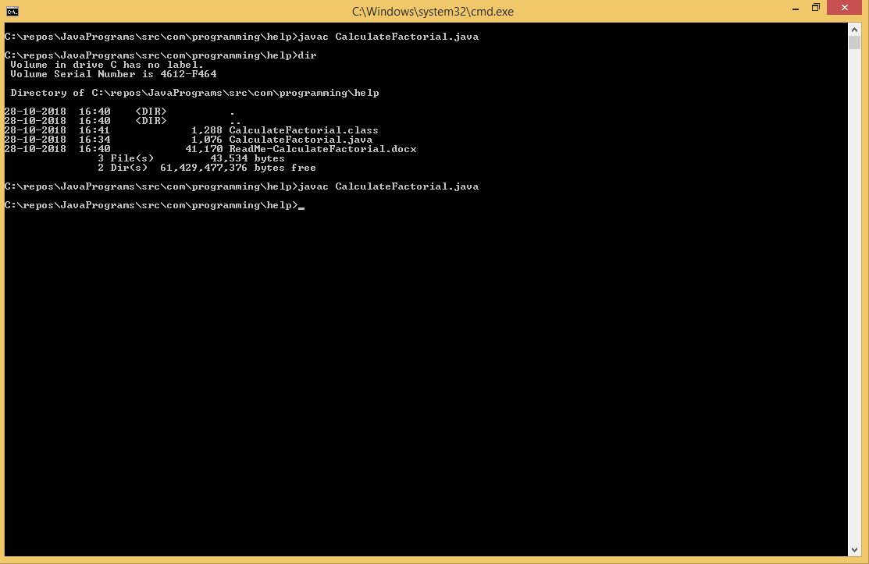

* Execute the program using **java** command
* The screenshot shows all possible execution scenarios for various kinds of inputs and how the program deals with it.
* Take special care of how you either set the CLASSPATH as an environment variable or explicitly use it in the command line like it’s done here. Reach out to me if you need help in terms of setting the CLASSSPATH and understand how it works.

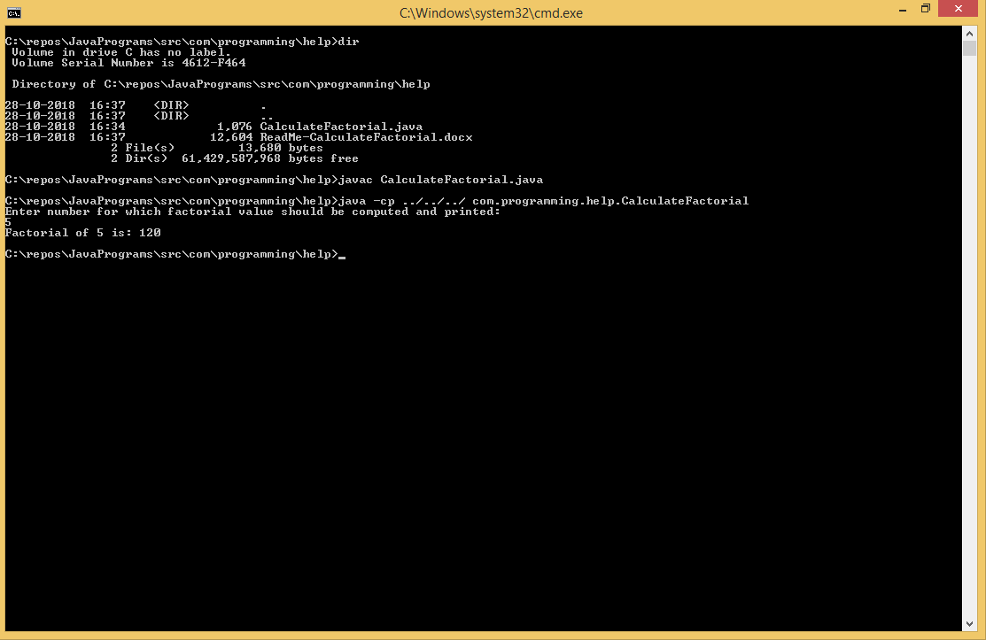

You can reach me on javahomeworkhelper@gmail.com