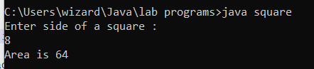

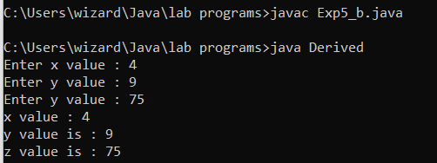

Enter side of a square : 3

Area of square : 9.0

Enter length and breadth of a Rectangle: 4

Area of Rectangle : 8.0

Enter len1, len2 and hight

4 8 7

Area of Trapezim = 16.5