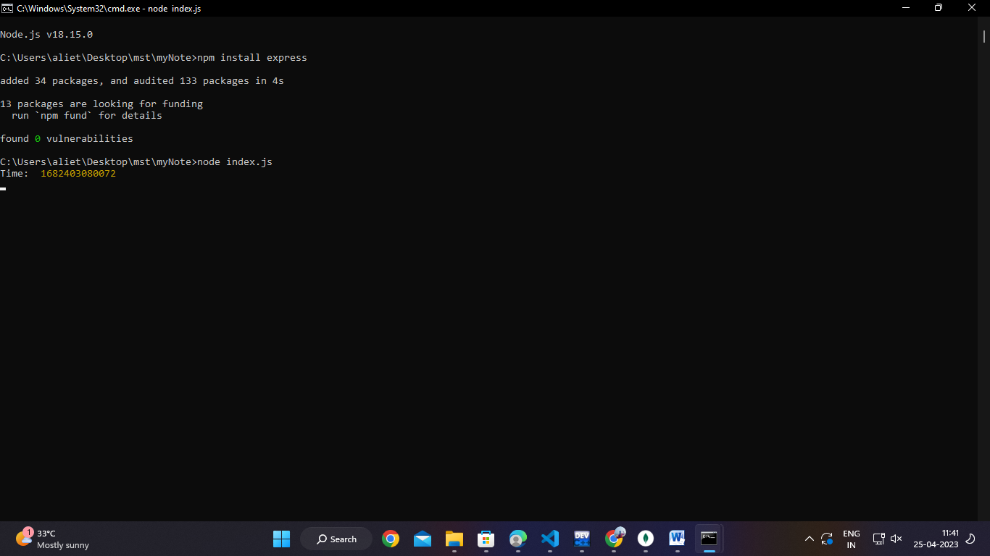

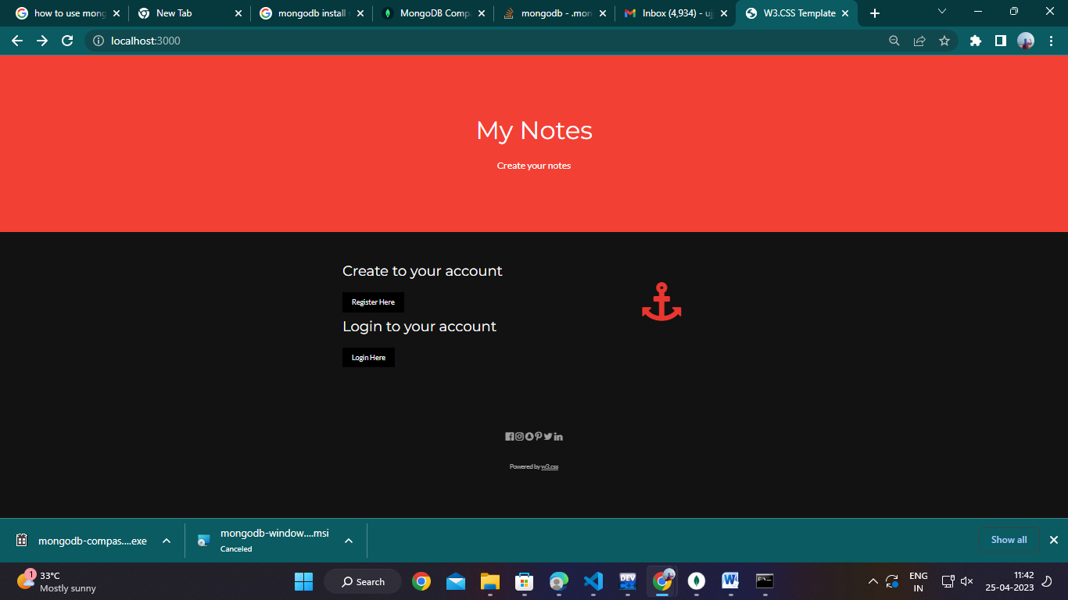

**exp-8(Mynotes)**

models-notes.js

const mongoose = require('mongoose')

const NoteSchema = new mongoose.Schema({

    title:{type: String, required: true},

    note: {type: String, required: true},

    user: {type: mongoose.Schema.Types.ObjectId, ref:'user'},

    cdate: {type: Date, default: Date.now}

    })

  const NoteModel = mongoose.model('Note',NoteSchema)

  module.exports = NoteModel

models-user.js

const mongoose = require('mongoose')

const UserSchema = new mongoose.Schema({

    user:{ type: String, required: true} ,

    password:{ type: String, required: true}

    })

  const UserModel = mongoose.model('User',UserSchema)

  module.exports = UserModel

**public-createnote.html**

<!DOCTYPE html>

<html lang="en">

<head>

<title>W3.CSS Template</title>

<meta charset="UTF-8">

<meta name="viewport" content="width=device-width, initial-scale=1">

<link rel="stylesheet" href="https://www.w3schools.com/w3css/4/w3.css">

<link rel="stylesheet" href="https://fonts.googleapis.com/css?family=Lato">

<link rel="stylesheet" href="https://fonts.googleapis.com/css?family=Montserrat">

<link rel="stylesheet" href="https://cdnjs.cloudflare.com/ajax/libs/font-awesome/4.7.0/css/font-awesome.min.css">

<style>

body,h1,h2,h3,h4,h5,h6 {font-family: "Lato", sans-serif}

.w3-bar,h1,button {font-family: "Montserrat", sans-serif}

.fa-anchor,.fa-coffee {font-size:200px}

</style>

</head>

<body>

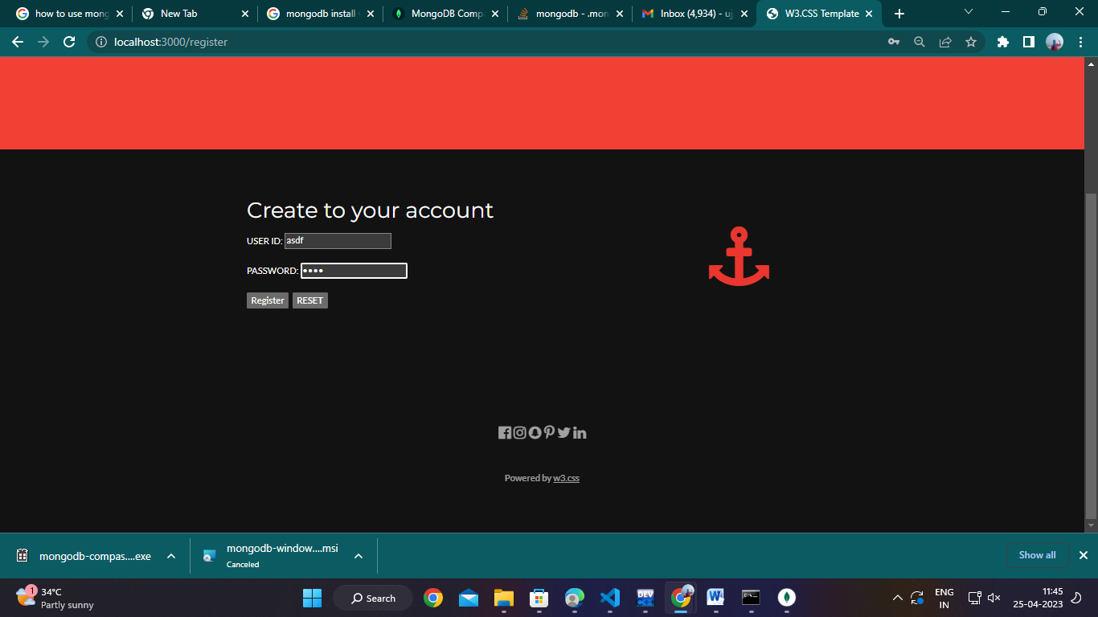

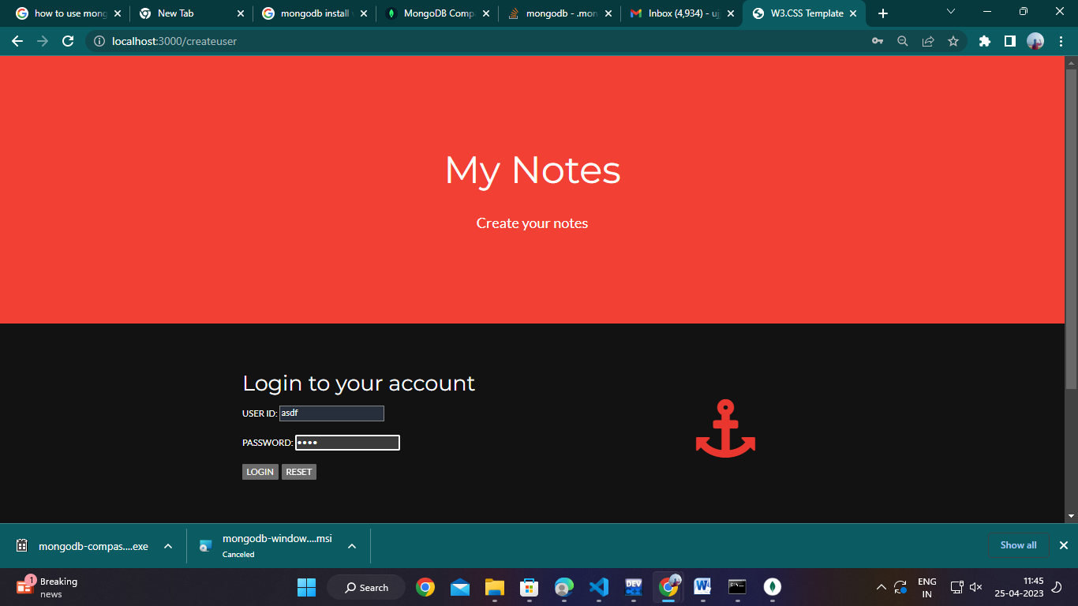

<!-- Header -->

<header class="w3-container w3-red w3-center" style="padding:128px 16px">

  <h1 class="w3-margin w3-jumbo">My Notes </h1>

  <p class="w3-xlarge">Create your notes</p>

</header>

<!-- First Grid -->

<div class="w3-row-padding w3-padding-64 w3-container">

  <div class="w3-content">

    <div class="w3-twothird">

    <form>

      <input type="text" name="title" placeholder="title"><br>

      <textarea name="note" class="w3-text-grey" placeholder="type here"></textarea><br>

      <input type="submit"></input>

    </form>

      </div>

    <div class="w3-third w3-center">

      <i class="fa fa-anchor w3-padding-64 w3-text-red"></i>

    </div>

  </div>

</div>

 <div class="w3-container w3-black w3-center w3-opacity w3-padding-64">

    <h1 class="w3-margin w3-xlarge">Quote of the day: live life</h1>

</div>

<!-- Footer -->

<footer class="w3-container w3-padding-64 w3-center w3-opacity">

  <div class="w3-xlarge w3-padding-32">

    <i class="fa fa-facebook-official w3-hover-opacity"></i>

    <i class="fa fa-instagram w3-hover-opacity"></i>

    <i class="fa fa-snapchat w3-hover-opacity"></i>

    <i class="fa fa-pinterest-p w3-hover-opacity"></i>

    <i class="fa fa-twitter w3-hover-opacity"></i>

    <i class="fa fa-linkedin w3-hover-opacity"></i>

 </div>

 <p>Powered by <a href="https://www.w3schools.com/w3css/default.asp" target="_blank">w3.css</a></p>

</footer>

<script>

</script>

</body>

</html>

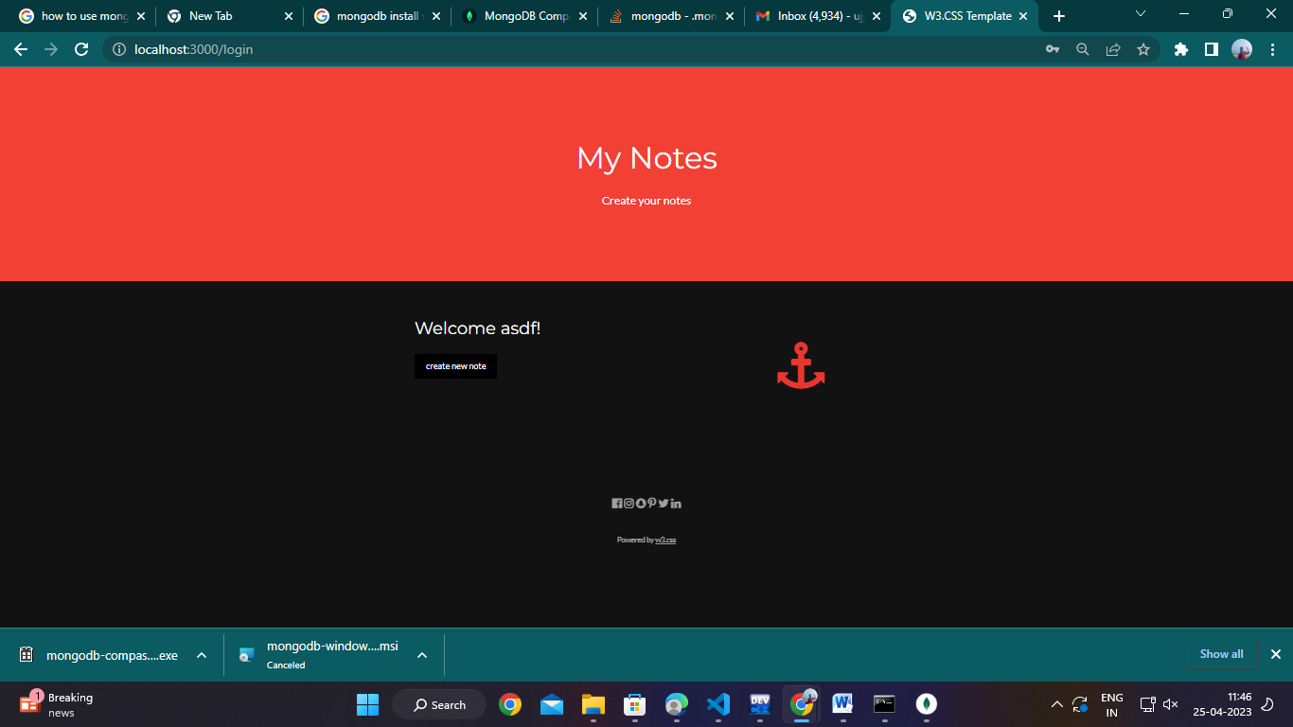

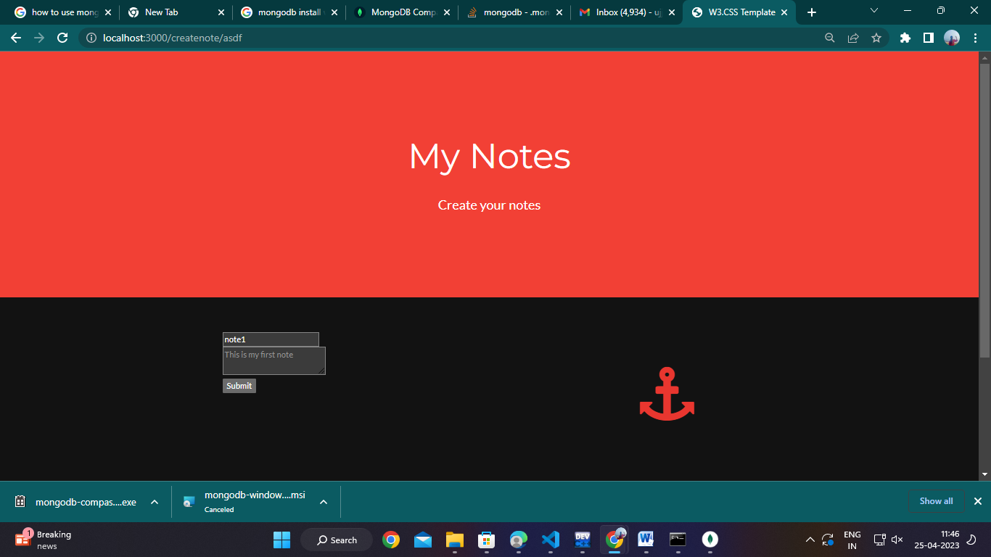

**public-home.html**

<!DOCTYPE html>

<html lang="en">

<head>

<title>W3.CSS Template</title>

<meta charset="UTF-8">

<meta name="viewport" content="width=device-width, initial-scale=1">

<link rel="stylesheet" href="https://www.w3schools.com/w3css/4/w3.css">

<link rel="stylesheet" href="https://fonts.googleapis.com/css?family=Lato">

<link rel="stylesheet" href="https://fonts.googleapis.com/css?family=Montserrat">

<link rel="stylesheet" href="https://cdnjs.cloudflare.com/ajax/libs/font-awesome/4.7.0/css/font-awesome.min.css">

<style>

body,h1,h2,h3,h4,h5,h6 {font-family: "Lato", sans-serif}

.w3-bar,h1,button {font-family: "Montserrat", sans-serif}

.fa-anchor,.fa-coffee {font-size:200px}

</style>

</head>

<body>

<!-- Header -->

<header class="w3-container w3-red w3-center" style="padding:128px 16px">

  <h1 class="w3-margin w3-jumbo">My Notes </h1>

  <p class="w3-xlarge">Create your notes</p>

</header>

<!-- First Grid -->

<div class="w3-row-padding w3-padding-64 w3-container">

    <div class="w3-content">

      <div class="w3-twothird">

        <h1>welcome !</h1>

        <h5 class="w3-padding-32">note1. &nbsp;&nbsp;&nbsp;<i class="fa fa-pencil">&nbsp;&nbsp;&nbsp;</i>  <i class="fa fa-trash"></i></h5>

        <h5 class="w3-padding-32">note2. &nbsp;&nbsp;&nbsp;<i class="fa fa-pencil">&nbsp;&nbsp;&nbsp;</i>  <i class="fa fa-trash"></i></h5>

        <h5 class="w3-padding-32">note3. &nbsp;&nbsp;&nbsp;<i class="fa fa-pencil">&nbsp;&nbsp;&nbsp;</i>  <i class="fa fa-trash"></i></h5>

          <button class="w3-button w3-black w3-padding-large w3-large w3-margin-top">create new note</button>

      </div>

      <div class="w3-third w3-center">

        <i class="fa fa-anchor w3-padding-64 w3-text-red"></i>

      </div>

    </div>

  </div>

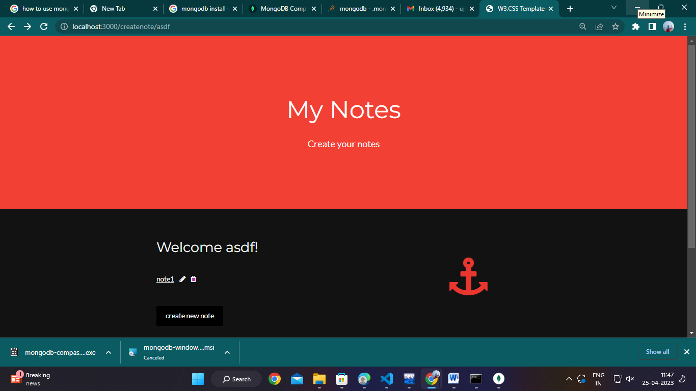

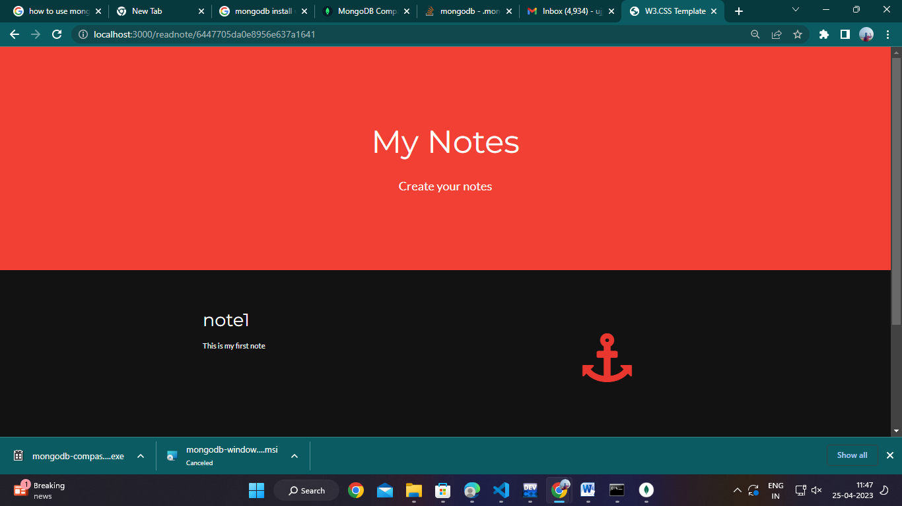

<div class="w3-container w3-black w3-center w3-opacity w3-padding-64">

    <h1 class="w3-margin w3-xlarge">Quote of the day: live life</h1>

</div>

<!-- Footer -->

<footer class="w3-container w3-padding-64 w3-center w3-opacity">

  <div class="w3-xlarge w3-padding-32">

    <i class="fa fa-facebook-official w3-hover-opacity"></i>

    <i class="fa fa-instagram w3-hover-opacity"></i>

    <i class="fa fa-snapchat w3-hover-opacity"></i>

    <i class="fa fa-pinterest-p w3-hover-opacity"></i>

    <i class="fa fa-twitter w3-hover-opacity"></i>

    <i class="fa fa-linkedin w3-hover-opacity"></i>

 </div>

 <p>Powered by <a href="https://www.w3schools.com/w3css/default.asp" target="_blank">w3.css</a></p>

</footer>

<script>

</script>

</body>

</html>

**public-login.html**

<!DOCTYPE html>

<html lang="en">

 <div class="w3-container w3-black w3-center w3-opacity w3-padding-64">

    <h1 class="w3-margin w3-xlarge">Quote of the day: live life</h1>

</div>