Exception propagation : An exception is first thrown from the top of the stack and if it is not caught, it drops down the call stack to the previous method.
After a method throws an exception, the runtime system attempts to find something to handle it. The set of possible “somethings” to handle the exception is the ordered list of methods that had been called to get to the method where the error occurred. The list of methods is known as the call stack and the method of searching is Exception Propagation.
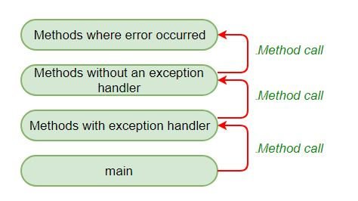
Exception Propagation in Unchecked Exceptions

when an exception happens, Propagation is a process in which the exception is being dropped from to the top to the bottom of the stack. If not caught once, the exception again drops down to the previous method and so on until it gets caught or until it reach the very bottom of the call stack. This is called exception propagation and this happens in case of Unchecked Exceptions.
In the example below, exception occurs in m() method where it is not handled, so it is propagated to previous n() method where it is not handled, again it is propagated to p() method where exception is handled.
Exception can be handled in any method in call stack either in main() method, p() method, n() method or m() method.
Note : By default, Unchecked Exceptions are forwarded in calling chain (propagated)

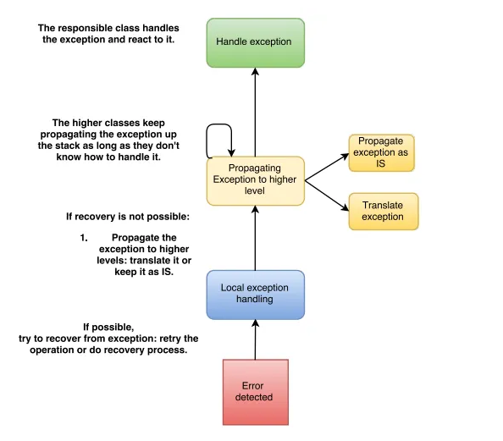
- Error detection: At the bottom of the strategy is the error detection, this is where the exception occurs, it is either detected manually by the program or thrown by some external party call.
- Local exception handling: At the second level is the local exception handling, the class which detects an error tries to recover from it locally e.g. send the request to a backup server or wait X seconds and try again, etc… if the exception couldn’t be recovered, then it is propagated to the higher level.
- Propagate exception to higher levels: when local error handling doesn’t work, the class gathers all the information necessary to diagnose, reproduce and report the error, and then propagates the exception up the stack. If the detected exception is not low level dependent (dependent on low-level implementation) then it is thrown as is , otherwise it is translated to a custom exception in order to achieve decoupling between components.
- Keep propagating if nothing to do with the exception: the higher classes keep propagating the exception up the stack as long as they have nothing to do with it while closing any resources on the way up (like files, network connections, freeing allocated buffers etc.) and adding any contextual information which may be useful in determining the cause and severity of the error.
- Handle exception: at this stage, the exception reaches a class which is responsible for handling it, all the error information carried by the exception are logged here and based on the severity of the exception, the class either recovers from it or shut down the application gracefully.

