**What this project does?**

**This project demonstrates how scriptlets and expression works in JSP.**

**We do not have any servlet in this project.**

**We have only one jsp file viz. 'ScripletJSP.jsp' containing a variable count, which is displayed using scriptlet and expression.**

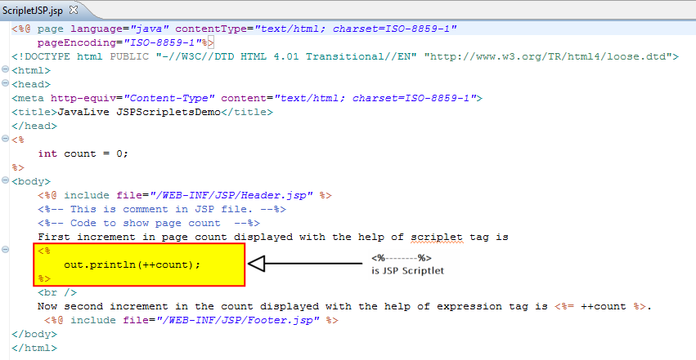

**How to create this project??**

**This is non maven 'Dynamic web project'.**

Refer file 'CreatingDynamicWebProjectForServletJSPInEclipse.docx' in 'ServletDemo' project folder for getting more details about how to create 'Dynamic web project' in eclipse.

**This project is pure xml based i.e. elements are mapped in web.xml file.**

**Carefully study the project structure of this project (i.e. 'Dynamic Web Project')**