Before getting started, please go through MVC design pattern carefully.
What this project does??
This project is basic one which is responsible for demonstrating basic structure of 'Dynamic Web Project' and how servlet and jsp works. It also explains how we map servlets and various another things in deployment descriptor file viz. web.xml
How to create the project??
This is non maven 'Dynamic web project'.
Refer file 'CreatingDynamicWebProjectForServletJSPInEclipse.docx' in this project folder for getting more details about how to create 'Dynamic web project' in eclipse.
This project illustrates basic structure and functioning of servlet and jsp project.
This project is pure xml based.
First of all carefully study the project structure of this project (i.e. 'Dynamic Web Project')
Especially src folder, Web Content folder(where welcome files are stored, jsp folder in web-inf folder and web.xml file. Their location and structure.)
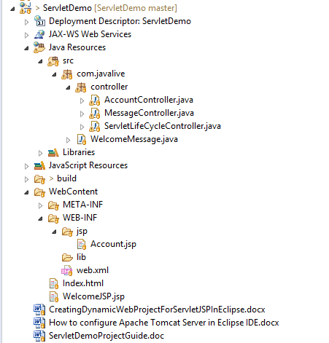
Study following files very carefully:
1. web.xml: This is deployment descriptor file for the given project. Study it to understand how welcome file defined, how servlet mapped etc.
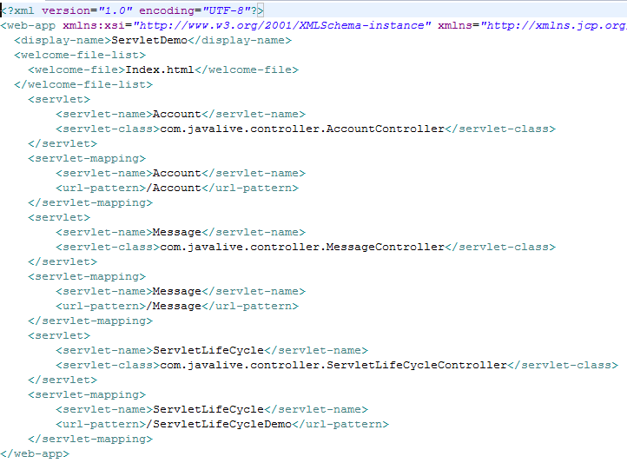
2. All servlets of this projects are included in 'com.javalive.controller' package.
a) 'AccountController' is the basic servlet, which on getting requested displays particular view.
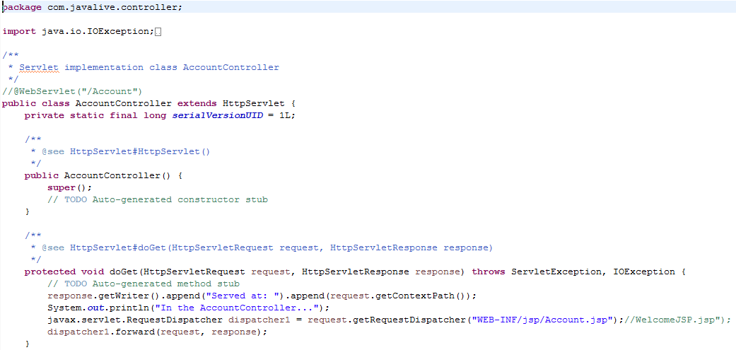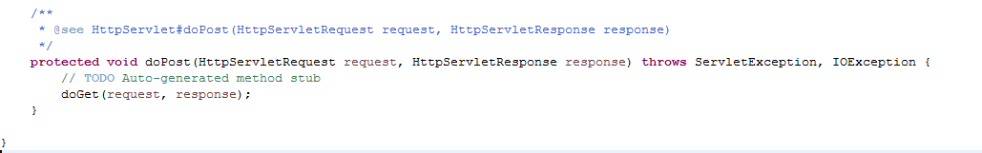
b) 'MessageController' servlet demonstrates how we handle business logic from other java file in servlet.

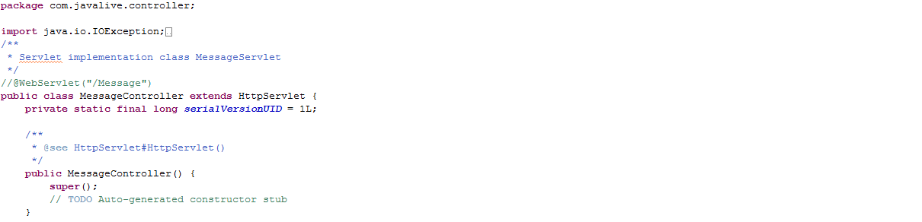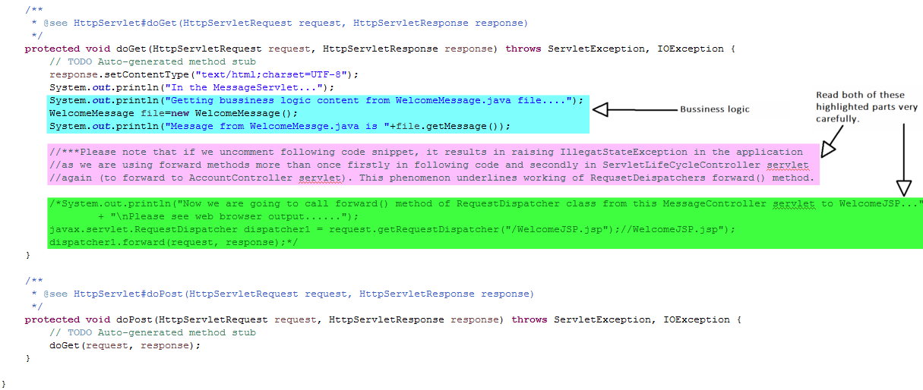
c) 'ServletLifeCycleController' servlet's get() method contains include() and forward() method of RequestDistacher interface. Please study them carefully.
It also contains response.sendRedirect() method.
Study all three methods carefully and difference between them
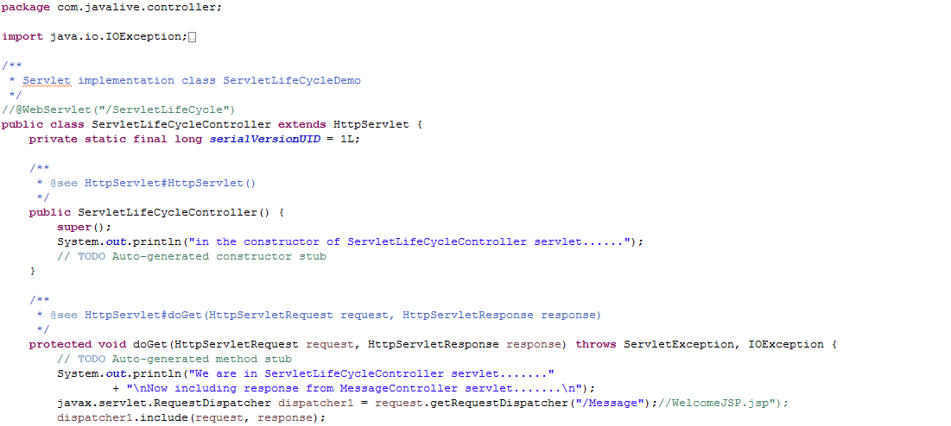
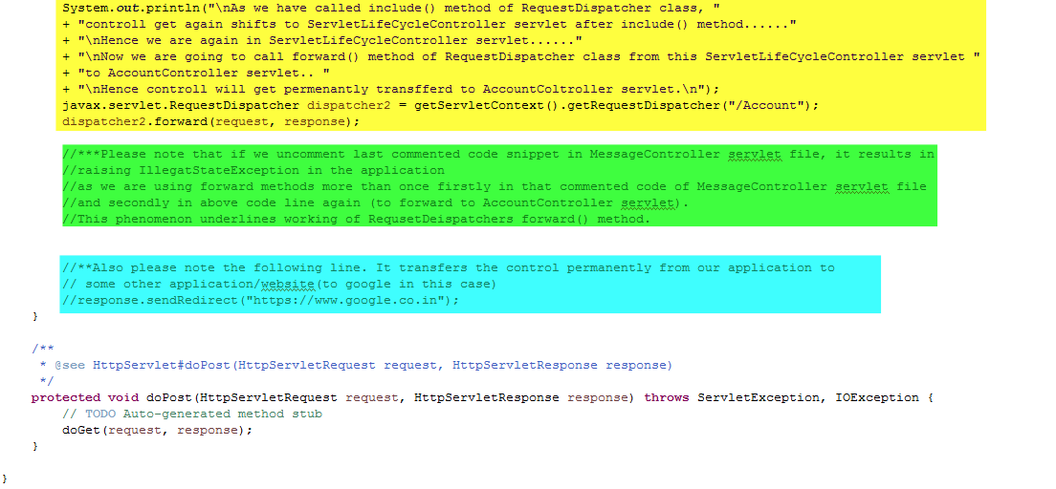
Read highlighted portion very carefully.
3. JSP files viz. Account.jsp and WelcomeJSP.jsp
Now to run this application please follow below steps:
Right click on the project->Run As-> Run On Server
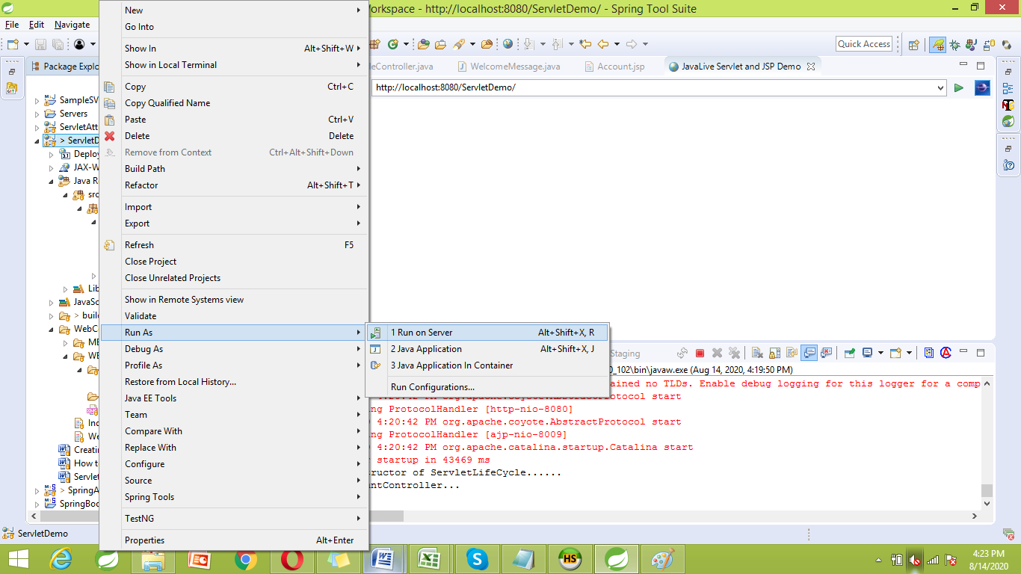
Select the server
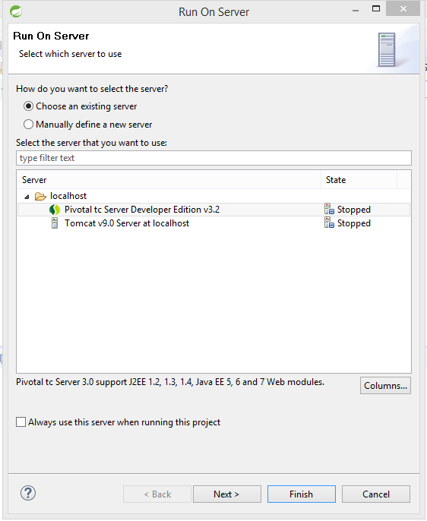

Select this project and remove other projects from configured list and click 'Finish':
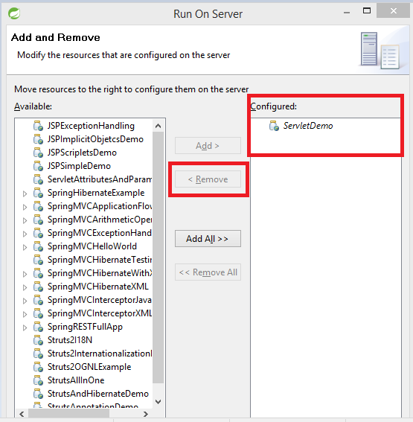

Now you will get following server screen:
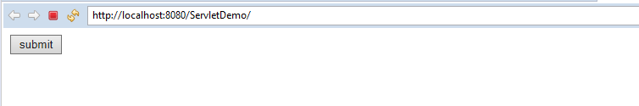

Click 'submit' button.
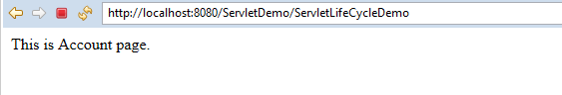
Please study console output also.
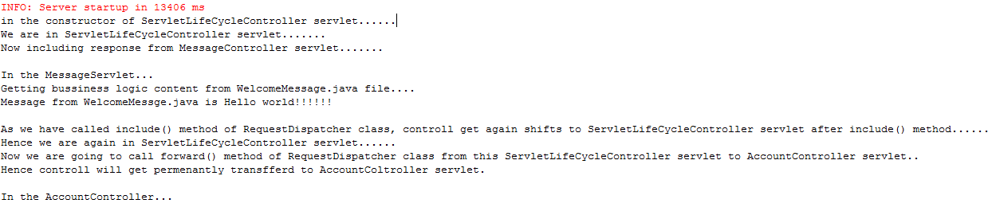

Now we re-run the application by un commenting last code snippet in MessageController servlet (it is highlighted green in below screen shot). Also read other highlighted portion in below screen shot.
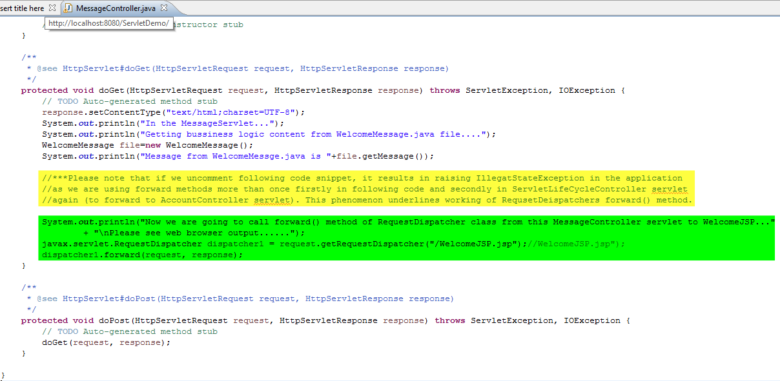
Now following is result of running the application again:
Click 'submit' button.
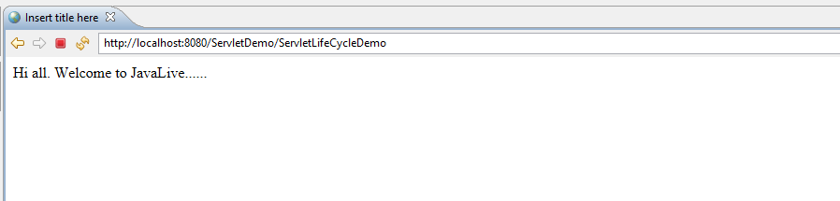
Following is console output:
